Atlantis/Alvin Cruise #15-66
Cruise Prospectus

General Cruise Schedule:
Mob in SF June 11, 2010
Dep SF: June 13 AM
Arrive on Station: June 15 pm (~677 nm or 2.5 days @ 11 kts)
Dive Days: June 16 through June 29 or 30 (short)
Dep Station: June 30
Arrive Astoria: July 1
DeMob: July 3, 2010

At sea: 19 days (~18.04 days); Total Days: 23 days (includes in port; 3 (~2.5) days transit SF to Station; 2 (20 hrs) days transit Station to Astoria; 14 (14 + short) dive days)

Projects:
1. Microbial Ecology (MO); James Cowen UH; MCB0604014; 8 dives; NSF-BIO-MCB
2. Large-scale, Long term Tracer transport; Andy Fisher UCSC; OCE0727952; 6 dives; NSF-OCE-ODP

***Action Alerts***: Please read thoroughly
- Personnel form: Pls fill out fully the ‘Personnel_Form_4’. This will be sent to you in a separate message by Cowen. Return to Barbara Costello by May 13 (notify Cowen that you have submitted the form to Barbara)
- Hazardous Materials: You must fill out the form (fully) at this website: www.whoi.edu/sbl/liteSite.do?litesiteid=7092&articleId=10875; pls read form carefully. All chemicals must be removed in Astoria (i.e., nothing left on board). You must bring Material Safety Data Sheets (MSDS) for each chemical. Note that you are responsible for supplying all necessary spill kits including any neutralizing substances. Please Submit Haz Material Inventory Form on-line AND send copy to Tina Lin. (hueiting@hawaii.edu). Must do this no later than May 28.
- Saftey: Pls read Safety Policies @ www.whoi.edu/page.do?pid=10115 ; Note that Safety shooes are required on deck if you will be involved in moving heavy equipment or any over the side work.
- Alvin in-hull equipment: If you need to have any equipment or device (e.g., camera, computer) in the sphere during a dive, it must be tested back in WHOI for the release of toxic chemicals. A ‘sniff’ test is being arranged now; you will be notified of the test dates soon. (Note that ALVIN cameras (still and video) are available in hull—no not real need to have personal cameras in hull.)

Dive Sites: 1026B, 1301A, 1301B, 1027C, 1024C; 1025C, 857D,

1026B Cascadia Basin 47º45.759’N (47.7627); 127º45.552’W (127.7592); 2658 m
1301A Cascadia Basin 47°45.209’N (47.7535); 127°45.833’W (127.7639); 2658 m
1301B Cascadia Basin 47º45.229’N (47.7538); 127º45.826’W (127.7638); 2658 m
1027C Cascadia Basin 47º45.387’N (47.7565); 127º43.867’W (127.7311); 2656 m
1024C Cascadia Basin 47º54.531’N (47.9089); 128º45.005’W (128.7501); 2612 m
1025C Cascadia Basin 47º53.247’N (47.8875); 128º38.919’W (128.6487); 2606 m
857D Middle Valley 48º26.517’N (48.4420); 128º42.651’W (128.7109); 2432 m

Additonal Sites (potential Night Operations): Endeavour Segment (Main Endeavour Field)
47º 56.872’ N, 129º 05.94’ W (MEF, S&M mound)

Ports of Call
Departure Port: San Francisco, CA; Depart June 13, 2010
Return Port: Astoria, OR; Arrive July 1, 2010
Stay aboard Atlantis: Two nights prior to departure from SF (nights of June 11 and 12) and the night of return to Astoria (night of July 1)

Agents and Shipping Information: Note special addresses (see below) for shipping of packages and equipment.

Agent (San Francisco):
Vasile Tudoran
Contact: Vasile Tudoran
Phone: (562) 882-5590
Fax: (562) 434-9800
Email: vtudoran@aol.com

For Mail only (SF):
Master R/V Ship Name
Attn: Scientist's Name
c/o Vasile Tudoran Transport
819 Ohio Ave.
Long Beach, CA 90804

**ALL packages and larger items (SF),:**
(Please notify Vasile Tudoran, vtudoran@aol.com, and dispatch@marineexpress.us in advance of all shipments)

Send all packages directly to
R/V Ship Name
Attn: Scientist's Name
c/o Marine Express, Inc.
2900 Main St.
Alameda, CA 94501
Contact: Troy Esch, Marine Express Operations Manager
Phone: (510) 523-8900
Fax: (510) 523-6466
Note: Agent and WHOI contacts should be copied on all communications. It is requested that shipment information of any equipment be communicated to the Agent and WHOI contacts.

Agent (Astoria, OR):
Master R/V Ship Name
Attn: Scientist's Name
Inchcape Shipping Services
2323 NW Suffolk Street
Portland, OR 97210
Mailing Address:
Suite 200,
PO Box 5307
Portland, OR 97228-5307
Phone: +1 503 226 3093 begin_of_the_skype_highlighting +1 503 226 3093 end_of_the_skype_highlighting (24 Hrs)
Fax: +1 503 525 6040
Telex: 3774438 isswcoast
Email: iss.portland@iss-shipping.com
Website: ISS Portland OR Microsite
Contact: Gary Martinke
Tel: +1 503 525-6026 begin_of_the_skype_highlighting +1 503 525-6026 end_of_the_skype_highlighting
Fax: +1 503 525-6040
Mobile: +1 503 780-4295 begin_of_the_skype_highlighting +1 503 780-4295 end_of_the_skype_highlighting
Email: iss.portland@iss-shipping.com

Other Important Contacts:
Jim Cowen (Chief Scientist): jcowen@soest.hawaii.edu; (808) 956-7124 work; (808)391-3921 cell)
Liz Caporelli: Marine Operations Coordinator Woods Hole Oceanographic Institution 38 Water Street, MS #37 Woods Hole, MA 02543; ecaporelli@whoi.edu; (508) 289-2277
Barbara Costello: bcostello@whoi.edu;
Andy Fisher: afisher@ucsc.edu; 831-459-5598
Geoff Wheat: wheat@mbari.org; 831-633-7033
Jim Jolly: jjolly@hawaii.edu; 808-956-2488
Dave Copson: copson@hawaii.edu;
Mike Rappe: rappe@hawaii.edu; 808-295-6593

Scientist Participant List:
1 | James Cowen (Chief Scientist) | U. of Hawaii | jcowen@soest.hawaii.edu | 808-956-7124
2 | Brian Glazer | U. of Hawaii | glazer@hawaii.edu | 808-342-9059
3 | Huei-Ting (Tina) Lin | U. of Hawaii | hueiting@hawaii.edu | 808-225-5809
4 | Alberto Robador | U. of Hawaii | arobador@ifa.hawaii.edu | 808-469-6453
5 | Sean Jungbluth | U. of Hawaii | seanpj@hawaii.edu | 808-352-0233
6 | Michael Matzinger | U. of Hawaii | mtmatzinger@gmail.com
7 | Ryan Matsumoto | U. of Hawaii | rsmatsum@hawaii.edu | 808-779-1949
8 | Jennifer Murphy | U. of Hawaii | jlmurphy@hawaii.edu
9 | Chih-Chiang (Oliver) Hsieh | U. of Hawaii | oliver.hakka@gmail.com
10 | Natalie Hamada | U. of Hawaii | nahamada@hawaii.edu | 808-956-7124
11 | Teacher TBN | Hawaii
12 | Teacher TBN | Hawaii
13 | Katherine Inderbitsen | U. of Miami | kinderbitzen@rsmas.miami.edu
14 | Sam Hulme | U. of Hawaii
15 | Fabien Kenig | U. Illinois, Chicago | fkenig@uic.edu | 312-996-3020
16 | Jackie Mueller | U. of Hawaii | jackie.a.mueller@gmail.com | 808-956-8629
17 | Katrina Edwards | USC | kje@usc.edu | 508-326-9870
18 | Henny Becker | MAST Academy, Miami
19 | Michelle Heinecke | U. of Hawaii | mjh24@hawaii.edu

Potential Work Site Conflicts (e.g., submeribles/ships in area): none known at this time

NEPTUNE Issues:
Cruises to NP09 area: no apparent scheduling conflicts!!
- May 6-25, 2010; CCGS Tully; to ‘NEPTUNE Observatories’
- July 24 to Aug 21, 2010; R/V Thompson (Delaney to JdFR)
- Sept 11 to Oct 2, 2010; R/V Thompson; to ‘NEPTUNE Canada’
- General
- JASON cruises: none (closest cruise: July 10-Aug 22 (Delaney et al on R/V Thompson)
- ROPOS cruises: none (closest cruise are May 6 to May 25 (Neptune-Tully) and July 5 to August 13 (Halifax, NW Atlantic-Hudson)
- R/V Thomas G. Thompson: none (closest cruise is June 10 to July 11 (Bering Sea; David Shull)

NEPTUNE Seafloor Hazards:
- www.neptunecanada.ca; use the quicklink for dive viewer, then select ODP1027 dives.
- See map below of NEPTUNE network at JdFR Flanks:
- Observations from NEPTUNE website dive videos: cable runs along seafloor from junction box (47.76275, -127.75884; depth 2659 m) to 1026B (47.7627, -127.75918; depth 2655 m); at 1026B cable runs to platform and then up to top of CORK; cable seems to sit nicely on sediments right up to CORK platform, from which it loops up to top (vertical portion of cable appears to be w/in ~1 m from CORK body)

NEPTUNE Contact:
PO Box 1700 STN CSC
Victoria, BC V8W 2Y2 Canada
mmrbest@uvic.ca
tel: (250) 721-7209/472-5400
cel: (250) 812-1575 Dr. Mairi M.R. Best
Associate Director - Science
NEPTUNE Canada
University of Victoria

fax: (250) 472-5370
mmrbest@uvic.ca
www.neptunecanada.ca
www.seos.uvic.ca

Relevant Maps/Diagrams:

Maps
Figure 1. General map of Juan de Fuca Ridge and Cascadia Basin showing all work sites, and primary ship track from San Francisco to Work Sites to Astoria Port.
Figure 2. Close up Primary work sites (CORK boreholes).
Figure 3. Close up of Middle Valley with Work Site 857D.
Figure 4. Bathymetry for Secondary Work Site (night ops, water column only) of Endeavour Segment.
Figure 5. Close up of Endeavour showing main hydrothermal vent fields.

Cartoons:
Figure 1: Borehole CORKS at Middle Valley
Figure 2: Canadian NEPTUNE infrastructure in vicinity of 1027C and 1026B

Figure 1. Juan de Fuca Ridge and Cascadia Basin map, showing general location of work sites (borehole CORKs 857C, 1024C, 1025C, 1026B, 1027C, 1301A, and 1301B, plus secondary night op station Main Hydrothermal Field, Endeavour Segment).

Figure 2. Close up of primary dive sites (CORKs 857D, 1024C, 1025C, 1026B, 1027C, 1301A, 1301B).

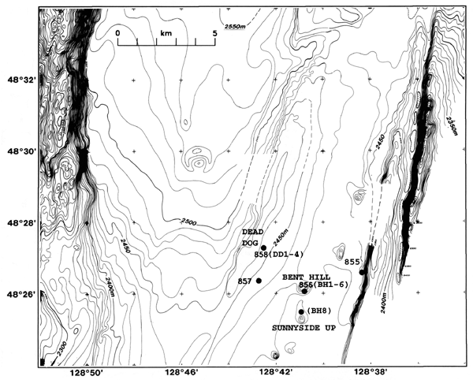
Figure 3. Bathymetery of Midddle Valley (from Davis and Villinger, 1992). Shows position of Borehole CORK 857 with respect to known vent sites (e.g., Dead Dog, Bent Hill). Contours drawn at 10 m intervals. Modified from Mottl, Davis, Fisher and Slack (Eds), 1994.
Figure 4. EM300 map of the Endeavour Segment.

Figure 5. Close up of Endeavour Segment showing five known hydrothermal fields.

Cartoon Figure 2.
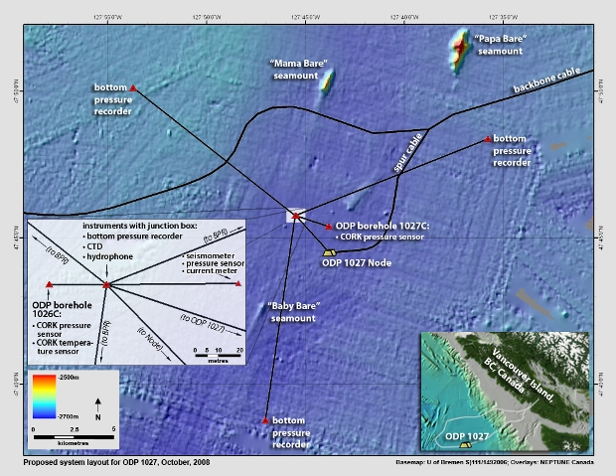
Cartoon Figure 2: Canadian Neptune1027area.jpg

