2015 Davis Strait Pre-Cruise Meeting: BIO Chemistry Programme
- Requirements for setting up Transient Tracer System
- 10ft of bench space close to 20 amp 120V receptacle (see picture below), the GC is sited centrally in the 10ft space and only has about 4 ft of cable
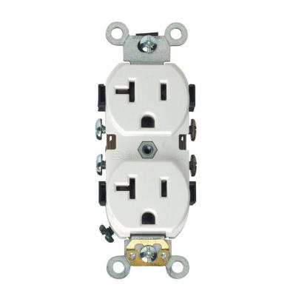
- Somewhere to strap three cylinders of non-flammable compressed gas: 1 nitrogen and 2 compressed air, to supply GC. Could these be near the above-mentioned bench to avoid long runs of tubing?
- Close proximity to walk-in cool room. I propose to store racks of syringes containing water samples in the cool room prior to analysis.
- Site to secure 2 x 40 L Dewars of liquid nitrogen.

- Winkler DO system
- 4 ft of bench space near to sink and milli-Q DI water (Do we need to bring DI water?)

- pCO2 underway sensor
- Location next to sink that has non-contaminated underway seawater supply.
- Small amount of adjacent counter top to secure data logging computer.

- Nutrients
- Approx. 6 cu ft. of space in -80 freezer

- Accommodation during de-mob if cruise is shortened (we’re flying out on 26th September)

- Date for retrieval of gear from Atlantis at WHOI

