Cruise Prospectus
OSNAP "East" Cruise
R/V Neil Armstrong (July 1-30, 2018)

Description of Project: Nature and Objectives

The specific objectives of this cruise are as follows:

- To perform mooring operations along the OSNAP East line between Scotland and Greenland, including servicing (recovery and redeployment) of 15 current meter moorings, recovery of two current meter moorings and 3 sound source moorings, and deployment of 4 additional current meter moorings.
- To conduct standard CTD (Conductivity-Temperature-Depth) and Lowered ADCP (Acoustic Doppler Current Profiler) stations at selected sites along the same mooring line.
- To recover and deploy ocean gliders, as needed, along the section.

This research is part of the U.S. led "Overturning in the Subpolar North Atlantic Program (OSNAP), an effort to determine the strength of the meridional overturning circulation and associated heat and freshwater fluxes in the subpolar North Atlantic. It is a collaborative program with scientists from several nations, including the U.K., the Netherlands, Germany, France, Canada, and China. Scientists from the U.S., the U.K., and the Netherlands will participate in this cruise.

The moorings to be deployed on this cruise are listed in Table 1, and the planned CTD/LADCP stations are listed in Table 2. The mooring locations and planned CTD/LADCP stations are also shown in the attached maps (Figs. 1 and 2). The cruise will depart from, and return to, Reykjavik, Iceland. The order of operations and exact cruise track will depend on weather conditions and other considerations at the time of the cruise.

All of the moorings to be serviced or deployed are taut-wire subsurface moorings. Most of them have multiple instruments, including internally-recording current meters and temperature/salinity/pressure recorders, while three of the moorings have low-frequency sound source used for tracking RAFOS floats that were deployed during the previous 4 years of the OSNAP program.. Ocean gliders are used to monitor the flow and water properties in part of the survey area (over the Rockall/Hatton Bank region), and one or more of these gliders may need to be replaced or redeployed during the cruise depending on their operational status at the time of the cruise.

Table 1. Moorings to be serviced (recovered and/or deployed)

Name Latitude Longitude Depth(m)

U.S. Mooring positions in the Iceland Basin:
M1 58° 52.330' N 30° 31.765' W 1710
D1 58° 44.810' N 30° 07.040' W 1740
D2 58° 32.010' N 29° 27.580' W 2513
D3 58° 18.320' N 28° 49.060' W 2180
M2 58° 02.210' N 28° 01.130' W 2370
D4 58° 00.600' N 26° 58.120' W 2680
D5 58° 00.350' N 25° 40.560' W 2705

Dutch Mooring positions in the eastern Irminger Basin:
IC0 59˚ 13.02’ N 35˚ 07.51’ W 2930
IC1 59˚ 06.26’ N 33˚ 41.20’ W 2494
IC2 59˚ 01.29’ N 32˚ 43.56’ W 1873
IC3 58˚ 57.40’ N 31˚ 57.08’ W 1633
IC4 58˚ 53.38’ N 31˚ 17.90’ W 1471

UK Mooring positions in Rockall Trough and Iceland Basin:
RTADCP1 57° 06.00' N 9° 20.30' W 800
RTEB1 57° 06.00' N 9° 33.78' W 1800
RTWB1 57° 28.20' N 12° 42.25' W 1600
RTWB2 57° 28.20' N 12° 18.60' W 1800
IB3 58° 00.80' N 24° 25.37' W 2850
IB4 57° 59.54' N 21° 08.45' W 2920
IB5 57° 46.02' N 19° 10.36' W 900 (exact location TBD)

WHOI Sound Source moorings:
SS-5 59° 02.33' N 34° 14.17' W 2565
SS-6 58° 01.26' N 27° 49.01' W 2344
SS-7 58° 00.50' N 22° 59.41' W 2991

Table 2. Proposed CTD/LADCP Stations

Sta. Latitude Longitude Depth (m)

1 56° 50.20' N 8° 20.00' W 120
2 56° 53.00' N 8° 30.00' W 125
3 56° 57.00' N 8° 47.00' W 125
4 57° 00.00' N 9° 00.00' W 135
5 57° 03.00' N 9° 13.00' W 350
6 57° 04.50' N 9° 19.00' W 500
7 57° 06.00' N 9° 25.00' W 1050
8 57° 09.00' N 9° 42.00' W 1900
9 57° 14.00' N 10° 03.00' W 2100
10 57° 18.00' N 10° 23.00' W 2300
11 57° 22.00' N 10° 40.00' W 2000
12 57° 24.00' N 10° 52.00' W 800
13 57° 27.00' N 11° 05.00' W 550
14 57° 28.06' N 11° 19.00' W 750
15 57° 29.00' N 11° 32.00' W 2020
16 57° 29.50' N 11° 51.00' W 1800
17 57° 30.50' N 12° 15.00' W 1817
18 57° 32.00' N 12° 38.00' W 1658
19 57° 32.50' N 12° 52.00' W 1000
20 57° 33.00' N 13° 00.00' W 330
21 57° 34.00' N 13° 20.00' W 210
22 57° 35.00' N 13° 38.00' W 130
23 57° 35.60' N 14° 15.96' W 195
24 57° 36.24' N 14° 54.00' W 470
25 57° 36.88' N 15° 31.94' W 1055
26 57° 37.44' N 16° 10.08' W 1170
27 57° 38.13' N 16° 47.92' W 1190
28 57° 38.80' N 17° 25.92' W 1220
29 57° 39.40' N 18° 04.00' W 1060
30 57° 40.00' N 18° 42.00' W 600
31 57° 43.80' N 19° 13.80' W 1050
32 57° 47.50' N 19° 45.00' W 1290
33 57° 50.11' N 20° 08.61' W 1700
34 57° 52.74' N 20° 29.82' W 2360
35 57° 54.88' N 20° 51.37' W 2600
36 57° 57.28' N 21° 12.12' W 2900
37 57° 57.60' N 21° 51.54' W 3000
38 57° 57.60' N 22° 30.96' W 3050
39 57° 57.60' N 23° 10.38' W 3050
40 57° 57.60' N 23° 49.80' W 2900
41 57° 57.60' N 24° 29.35' W 2850
42 57° 57.60' N 25° 07.14' W 2800
43 57° 57.60' N 25° 44.94' W 2700
44 57° 57.60' N 26° 22.74' W 2500
45 57° 57.60' N 27° 00.62' W 2680
46 57° 58.59' N 27° 33.97' W 2520
47 57° 59.70' N 28° 04.41' W 2370
48 58° 05.04' N 28° 20.56' W 2500
49 58° 10.42' N 28° 36.96' W 2300
50 58° 15.70' N 28° 53.06' W 2175
51 58° 20.09' N 29° 05.51' W 2300
52 58° 24.67' N 29° 18.86' W 2100
53 58° 29.40' N 29° 32.10' W 2510
54 58° 33.42' N 29° 44.10' W 2000
55 58° 37.60' N 29° 56.87' W 1850
56 58° 42.03' N 30° 10.31' W 1740
57 58° 45.73' N 30° 22.08' W 1570
58 58° 49.85' N 30° 34.76' W 1710
59 58° 50.19' N 30° 48.27' W 1400
60 58° 50.52' N 31° 02.26' W 1480
61 58° 50.92' N 31° 15.99' W 1470
62 58° 52.31' N 31° 29.68' W 1500
63 58° 53.69' N 31° 43.38' W 1570
64 58° 55.09' N 31° 57.08' W 1670
65 58° 56.65' N 32° 12.52' W 1800
66 58° 58.21' N 32° 27.95' W 1900
67 58° 59.68' N 32° 42.28' W 2040
68 59° 01.34' N 32° 58.85' W 2080
69 59° 02.90' N 33° 14.31' W 2140
70 59° 04.48' N 33° 29.78' W 2260
71 59° 06.04' N 33° 45.26' W 2390
72 59° 07.70' N 34° 01.12' W 2450
73 59° 09.35' N 34° 17.65' W 2600
74 59° 11.00' N 34° 33.85' W 2680
75 59° 12.66' N 34° 50.04' W 2760
76 59° 14.62' N 35° 06.91' W 2860
77 59° 15.97' N 35° 22.43' W 2950
78 59° 17.63' N 35° 38.63' W 3000

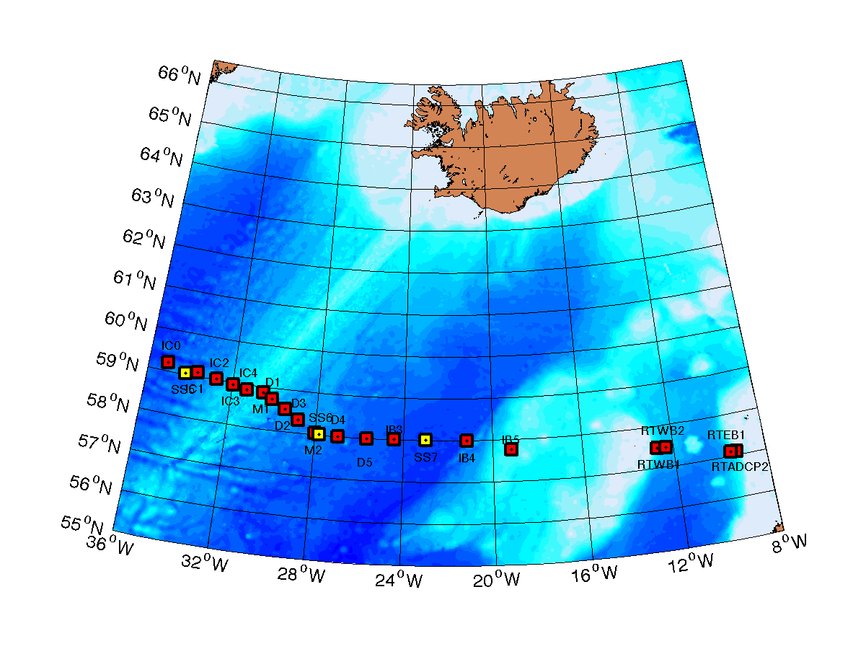
Figure 1. Mooring sites to be serviced (recovered and/or deployed) on the cruise..

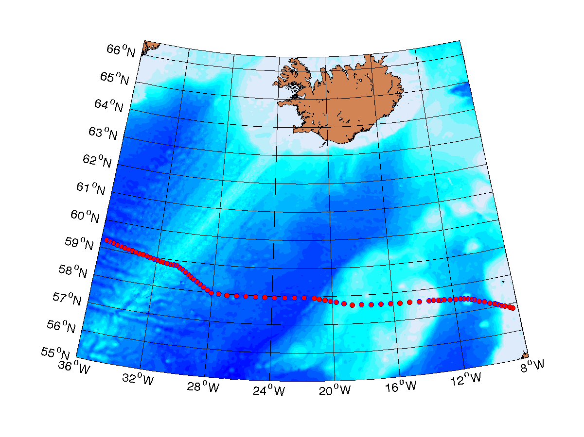
Figure 2. Planned CTD/LADCP stations to be performed during the cruise.

