Chapter 9

Geostrophy, Quasi-Geostrophy
and the Potential Vorticity Equation

9.1 Geostrophy and scaling.

We examined in the last chapter some consequences of the dynamical balances for low frequency, nearly inviscid motions from the point of view of the vorticity equation. It is important to ask what the momentum equations tell us about such synoptic scale dynamics, i.e. motions of the order of several hundred to 1000 km in the atmosphere (weather) and tens to a 100 km in the oceans (synoptic scale eddies).
The momentum equation is:

(9.1.1)

Let’s now estimate the size of the various terms in the equation in terms of characteristic scales (U, L, D, T) representing characteristic horizontal velocities, horizontal length scales of the motion, vertical scales of the motion and the time scale of local changes of the motion respectively. This assumes we can associate one characteristic scale for each. So, it implicitly assumes a clear structure to the phenomenon we wish to investigate and it always has to be seen whether this is a reasonable assertion (in fact it is).
Thus, for example, the first terms on the right hand side of (9.1.1) would be estimated as ,

(9.1.2 a, b)

while the Coriolis acceleration term is of order,

(9.1.3)

Notice that the size of the Coriolis acceleration is independent of the scale of the motion. If you are moving a one meter per second the Coriolis acceleration you experience is exactly the same as experienced by the Gulf Stream. Why then is it so important for the Gulf Stream while it is unnoticeable to you? The answer lies in comparing the relative acceleration terms (9.1.2 a, b) with the Coriolis acceleration (9.1.3) whose ratios are,

(9.1.4 a, b)

For waves, like weather waves, the time scale T can be thought of as the period of the wave. If L is the wave’s wavelength and c = L/T, is its phase speed so that the ratio in (9.1.4 a) can be rewritten as

(9.1.5)
also a Rossby number based on the phase speed. Try calculating the Rossby number based on your walking speed and your length scale to see why you can ignore the Earth’s rotation in your everyday activities.

The friction terms and their ratio with the Coriolis acceleration can be similarly estimated,

(9.1.6)

where E is the Ekman number. Note that the Ekman number is independent of the velocity.
If the Rossby number, based either on the velocity or the phase speed is small, (and this means the time scale of the motion is long compared to a rotation period of the frame) and if the Ekman number is small, (which means the frictional diffusion time scale is long compared to a rotation period) then to lowest order we expect the momentum balance to reduce to:

(9.1.7)

When we apply these ideas to the atmosphere and the ocean we have to keep in mind the geometry. Each fluid is in a thin envelope on the Earth which we will idealize as being spherical of radius r₀ as shown in the Figure 9.1.1.

w
u

θ
r₀

Figure 9.1.1 Our local coordinate frame at latitude θ. The local vertical unit vector is k and the velocity component in that direction is w. The northward velocity is v and the eastward velocity (into the paper in the figure) is u. i and j are unit vectors eastward and northward respectively.

The thin shell of fluid shown in Figure 9.1.1 has a characteristic thickness D which we will assume also characterizes the vertical scale of he motion. At the local origin of coordinates the Coriolis acceleration is,

(9.1.8)
The three components of the momentum equation thus become,

(9.1.9 a, b, c)

in the eastward, northward and vertical directions respectively where is longitude and r is the spherical radius to the fluid element. It is helpful to partition the pressure and density into parts that represent the fields in the absence of motion and perturbations to those fields due to the motion. In the absence of motion (9.1.9) shows the pressure, and hence the density will be functions only of the vertical coordinate, z=r-r₀. Thus,

(9.1.10 a, b)

The subscript s denotes the static fields of pressure. By definition,

(9.1.11)
so that substituting (9.1.10 a, b) into (9.1.9 a, b, c) yields,

(9.1.12 a, b, c)

The motion takes place in the thin shell of Figure 9.1.1. The aspect ratio of the motion is D/L which implies that this is the ratio also of the velocities. That is,

(9.1.13 a, b)
This in turn implies that in (9.1.12 a) the Coriolis acceleration is dominated by the meridional velocity term, by the Coriolis acceleration due to the horizontal velocity.
The gradient of the pressure in the zonal direction in (9.1.12 a) can be estimated in terms of the characteristic horizontal scale L and a characteristic scale for the pressure perturbation P. Thus,

(9.1.14)
or, balancing this against the dominant term in the momentum equation gives us an estimate for the pressure perturbation , i.e. the pressure anomaly from the static pressure, i.e.

(9.1.15)

This allows us to estimate the vertical derivative of the pressure anomaly as,

(9.1.16)
This now allows us to estimate the relative importance of the Coriolis term in the vertical equation of motion. Note that the term depends on the larger horizontal velocity. The ratio of terms is of the order,

(9. 1.17)

It is important to note that the parameter δ = D/L which measures he smallness of the Coriolis term in the zonal equation of motion due to w is the same parameter measuring the smallness of the Coriolis term in the vertical equation of motion due to the zonal velocity u. Neglecting terms of O(δ) means that only the vertical component of the planetary rotation enters the momentum balance. As before we define the Coriolis parameter

(9.1.18)

The remaining term in the vertical momentum equation is just the buoyancy term which balances the vertical pressure gradient, i.e.

(9.1.19)

and this allows us to estimate the density perturbation or density anomaly. From (9.1.19) we can estimate the anomaly as,

(9.1.20)

or the ratio of the density anomaly to the background static density is,

(9.1.21)

The Rossby number, by assumption is very small. How about the other factor? If L is 1,000 km and D is 10 km, typical scales for the atmosphere, then in mid-latitudes ,

(9.1.22)

That is a number less than or equal to one. So, the ratio of the density anomaly to the static density is at least as small as the Rossby number. Since we have already neglected terms of that order in the momentum equation we must, to be consistent also neglect these small terms so that the momentum balance (9.1.12) simplifies to

(9.1.23,a,b c)

The first two equations are a balance, in the plane tangent to the Earth, between the horizontal pressure gradient and the Coriolis acceleration. Because of the thinness of the fluid envelope only the horizontal velocity enters and consequently, only the local vertical component of the Earth’s rotation enters. This approximation is the geostrophic balance. The equation of motion in the vertical direction is a balance between the buoyancy force and the vertical pressure gradient and is the hydrostatic approximation, that is, the vertical pressure gradient, both the static part and the anomaly, can be calculated as if the fluid were at rest. Note also that in the geostrophic approximation the densityis replaced by the background density field that is a function only of z. These equations are valid on the very largest scales of motion and still contain the spherical metric terms in the pressure gradient. It is of interest to calculate the horizontal divergence of the velocity by eliminating the pressure between the two momentum equations. Thus,

(9.1.24)

Now, given the slimness of the atmosphere and ocean, z << r₀ so in (9.1.23) we can replace r by r₀ in all the metric terms. Similarly we can write

(9.1.25a)
as a new latitude variable and as measure of linear distance northward. If the range in latitude is less than the full planetary scale, that is, if Δθ << θ as in Figure 9.1.2,

Δθ

θ₀

Figure 9.1.2 The synoptic scale motion occupies less than the full surface of the sphere.

The eastward distance at any latitude can be written if Δθ <<1,

(9.1.26 a, b)
Both longitude and latitude variables can then be replaced by the Cartesian coordinates x and y. The derivative in longitude can also be rewritten,

(9.1.27)

with an error of Δθ. We can then rewrite the geostrophic, hydrostatic system as,

(9.1.28 a, b, c)
Note that in the first two equations it is no longer necessary to distinguish between the total pressure and the pressure anomaly since the horizontal derivatives of each are identical. In the vertical equation, similarly, the hydrostatic balance is correct for the full density and pressure fields. In the horizontal equations the density is replaced by the static value, only a function of z and this approximation, that we have derived by scaling at small Rossby number , is called the Boussinesq approximation. The variation of the density horizontally is so small that it is negligible in the acceleration terms and is important (very) only in the vertical buoyancy force. In fact, in the oceanic case the variation of the background density, ρ_{s}, is so small that it can be replaced by a constant in the horizontal momentum equations.

9.2 Consequences of geostrophy

Let us examine the derivative of p/f with y,

(9.2.1)
where . The ratio of the second to the first term in (9.2.1) is,

(9.2.2)

Here, again L is the scale length of horizontal variations of the pressure. For synoptic scale motions in both the atmosphere and the ocean the ratio L/r₀ is small so that the variation of f can be neglected to lowest order in L/r₀. We shall see that the variation of f is important but only at next order in L/r₀. Therefore, if we are on the sub-planetary synoptic scale the pressure divided by acts like a streamfunction for the horizontal velocity since,

(9.2.3 a, b, c, d)

At the same time we can calculate the vertical shear of the horizontal velocity using (9.1.28 a, b, c)
(9.2.4 a,b)

where the second equation follows from (9.1.28c) after division by the density and differentiation with x. Combining the two equations and using the fact that the derivative of the total density with z is approximately the derivative of the static density, the resulting equation is,

(9.2.5a)

using the same manipulations we have already seen in the last chapter. Similarly,

(9.2.5 b)
so we have rederived the thermal wind relations , this time directly from the geostrophic approximation to the momentum equations.

Finally, the fact that the horizontal velocity can be represented by a streamfunction implies that to O(L/r₀),

(9.2.6)
i.e. the geostrophically balanced horizontal velocity is non divergent at lowest order in L/r_{o}.

The vertical component of the relative vorticity

(9.2.7)

To summarize:
If the Rossby number is small and if the scale of the motion is sub-planetary so that L/r₀ is small:

- the horizontal velocity is in geostrophic balance, .
- The horizontal velocity is non divergent and derivable from a streamfunction .
- The thermal wind balance applies,
- The relative vorticity is the 2-dimensional Laplacian of the geostrophic streamfunction, .
- Since the motion is nearly non-divergent horizontally, it follows that is small (and smaller than O(D/L).
- The density is given by the hydrostatic relation,
All the variables are derivable from the pressure field. The vertical velocity can be determined from the equation for the conservation of density or potential temperature if the pressure is known. The issue that presents itself is how does one determine the pressure field and how it evolves with time. These lowest order balances are only diagnostic in the sense that if you specify the pressure field the velocities and density are determined but the pressure field is not determined, only the diagnostic relation between the variables of interest and the pressure field. What is needed is a governing equation for the pressure field on the synoptic scale. There is a systematic way of deriving such an equation that you will see in later courses (see also Chapters 3 and 6 of GFD). In the next section we will use a heuristic argument to get to the same result and it is an argument that closely follows the approach of the researchers on the 40’s and 50’s of the last century like Rossby and Charney (especially the later). Previous to those efforts the derivation of a prognostic equation for the pressure was a perplexing challenge and there was considerable confusion on that point. Remarkably, it is Ertel’s theorem, together with the geostrophic and hydrostatic relations that provides us with the needed prognostic equation.

9.3 The quasi-geostrophic potential vorticity equation (qgpve).

Ertel’s theorem describes the evolution (and in some cases the conservation) of the potential vorticity,
(9.3.1)
where λ is a conserved quantity or a thermodynamic variable whose sources and sinks can be represented. For simplicity of the discussion, we will consider the oceanic case where λ is the density ρ. We will also have to explicitly use the conservation statement
(9.3.2)
It is not difficult to consider inhomogeneous terms on the right hand side of (9.3.2) or similar terms pertaining to the non-conservation of q but we will avoid that to concentrate on the basic idea which is the use of potential vorticity to obtain a master, prognostic equation for the pressure.
We write

(9.3.3)
where and using the thin shell approximation, we can ignore the contributions of the vertical velocity to the vorticity since it enters only with horizontal derivatives (you should convince yourself that the neglected terms is O(D/L)² with respect to the retained terms).
Then q is, with that approximation:

(9.3.3 a, b)

where the passage from (9.3.3a) to (9.3.3 b) has used the thermal wind equations. We have also used the fact that and replaced the total density with the static density field where it is not differentiated. The density anomaly is unprimed and the background density is labeled with a subscript s. The Coriolis parameter
(9.3.4 a, b)
The largest factor in the first term, labeled (a) in (9.3.3) is a term independent of x,y and t, namely and is a constant as far as the horizontal advection and time variation is concerned and so is important only insofar as it is advected by the very weak vertical velocity. The vital terms are the small corrections to it that vary in x, y and t, and we must try to estimate their relative importance. Thus the ratio of the terms (b) to (a) can be estimated as,
(9.3.5a)
We have defined here the buoyancy frequency, N from,
(9.3.5 b)
The first factor in the third term is the Rossby number that, by hypothesis, is small for the motions we are considering. The second factor is the ratio of the horizontal length scale of the motion to the scale squared. The scale L_{D} is the so-called Rossby deformation radius. For the ocean, with f = O(10⁻⁴ sec⁻¹), D = 1 km, the buoyancy frequency = N = 5x 10⁻³ sec⁻¹, L_{D} is about 50 km, which is of the order of the horizontal scale of synoptic motions (eddies, meanders). This is not a coincidence as you will learn, but is a reflection of the (instability)dynamics responsible for giving rise to synoptic scale motions. In the atmosphere the analogous scale is based on the potential temperature definition of the buoyancy frequency and the troposphere thickness and is about 500 km, again, and for the same reason, of the order of synoptic scale weather waves. All of which is to say that the second factor on the right hand side of (9.3.5) is order unity and so the ratio of term (b) to term (a) in the calculation of q is of order of the Rossby number and therefore negligible.
In comparing term (c) to term (a) the factors involving only u_{z} will give the same estimate as (9.3.5) and are negligible. We must, however, consider the contribution from the horizontal component of the planetary vorticity. Its contribution to the ratio of the two terms is, (9.3.6)
The last factor on the right hand side is the product of the aspect ration of the motion and the ratio (squared) of L to the deformation radius. Hence the term involving the horizontal component of the Coriolis parameter is, again, negligible due to the smallness of the ratio D/L just as in our consideration of the momentum balance. Of course, that consistency is not fortuitous.
The remaining term to estimate is the relative size of the terms in (a), i.e. and using (9.1.21) to estimate the density anomaly, this ratio, is of the order,

(9.3.7)
and so is order one; so both terms have to be kept. Note that is order one while is small because , i.e. the fractional change of the background density changes only slightly over the depth of the system compared to its mean value.
If we examine term (a) more carefully there is a variable term from the product that is variable due to the small variation of f. That term is and compared with is in the ratio
(9.3.8)
This parameter is O(1) for synoptic scale motions. For the ocean, for example, with L = 50 km , U=5 cm/sec and β =2 10⁻¹³ cm⁻¹ sec⁻¹, the ratio is one. Thus the very largest part, which is a function only of z, plus the dominant variable part in x,y and t of the potential vorticity is

(9.3.9)

where the background density, , can be considered a constant where it appears undifferentiated in the denominator ( equivalent to ignoring its vertical variation in the horizontal equations of motion).
Since the motion to lowest order is horizontally non-divergent (9.2.3), the vertical velocity will be small, even smaller than D/L, if it vanishes (or nearly does) on some z surface. Generally, quasi-geostrophic theory applies only when the slope of the bottom, . This implies that to lowest order the vertical advection of the relative vorticity and the density perturbation can be ignored. However, the vertical advection of the basic state density (the first term in (9.3.9) must be retained.

The total time derivative of q would then be

(9.3.10)

From the equation for the density, (9.3.2), keeping only terms of the same order,

(9.3.11)
which when combined with (9.3.10)

(9.3.12)

where we have taken advantage throughout of the smallness of the derivative of with respect to z.
Using the geostrophic streamfunction ,

(9.3.13)

yields the governing equation,

(9.3.14)

Recall that both u and v are derivable from the stream function so that (9.3.14), written entirely in terms of ψ, is

(9.3.15)

or more compactly,

(9.3.16 a, b)
where J denotes the Jacobian with respect to x and y of the two functions of its argument, i.e.
(9.3.17)

The governing equation for synoptic scale motions (9.3.16) is the potential vorticity equation in which each term is evaluated in terms of the geostrophic streamfunction (i.e. the pressure) as if the fluid were in exact geostrophic balance and in hydrostatic balance. From the geostrophic streamfunction we obtain directly the horizontal velocities and the density field from the x, y and z derivatives.

(9.3.18)

The weak vertical velocity can then be derived from the density equation (9.3.2) which, written in terms of the stream function (and using the fact that the density anomaly is small compared to the background density),

(9.3.19)
For the atmospheric synoptic scale, the potential temperature replaces the density as the conserved (or budgeted) quantity λ and the buoyancy frequency is defined in terms of the vertical derivative of the background potential temperature (see Chapter 6 of GFD for the details). The governing qgpve is almost the same as (9.3.16) except that

(9.3.20)

since the background density changes significantly over the depth of the troposphere. Aside from that minor change the similarity of the governing dynamics of the synoptic scales for both the atmosphere and the ocean means that phenomena of one system are quite likely to find counterparts in the other. It is this that led to the development of Geophysical Fluid Dynamics as a subject that could comprehend both fluid systems.
Indeed, for researchers with a meteorological background it was no surprise that the ocean was full of eddies, dynamically analogous to the long-studied atmospheric cyclone waves. The only surprise for meteorologists was that the oceanographers were surprised to discover the ubiquity of the eddy field in the ocean.
More modern developments of the qgpve start from the momentum equations and expand the momentum equations in an asymptotic series in the Rossby number. The same governing equation that we have found is derived naturally and the interpretation of the equation as the geostrophic form of the potential vorticity equation follows. The fact that the asymptotics must consider terms beyond exact geostrophy, implies that the motion which accelerates by both local rates of change and advective rates of change is not exactly geostrophic but is only nearly, or quasi-geostrophic.

9.4 An example: baroclinic Rossby waves

We have already studied in Section (7.5) a two-dimensional, barotropic model for Rossby waves. In this section we generalize those results to include stratification and the structure of the wave in three dimensions. Let’s consider the motion, governed by the qgpve of a stratified fluid, which for simplicity (although this is easily relaxed) has a constant buoyancy frequency, N. We suppose the fluid is located in a zonal channel of width L and depth D. See Figure 9.4.1

z

L

D
y
x
x

(a) (b)
Figure 9.4.1 The channel containing the fluid. a) Plan view. b) Side view.

The boundary conditions at y=0 and y=L are that the normal velocity to the boundary vanish or, that v=0, e.g. that

(9.4.1)
On the other hand the condition that the vertical velocity vanish at the flat, upper and lower boundaries♦ is, from (9.3.19)

(9.4.2)
while the governing equation is, for constant N,

(9.4.3 a, b).

Wave-like solutions satisfying (9.4.3) and the boundary conditions (9.4.1) and (9.4.2) can be found in the form,

(9.4.4a)

(9.4.4b)

Since
, (9.4.5)

the Jacobian of q and ψ identically vanishes, so the nonlinear terms in the qgpve are identically zero for a simple wave form like (9.4.4). If we succeed in finding a solution it will be an exact, finite amplitude solution of the qgpve. Similarly, it is left to the student to check that (9.4.4) also satisfies the full nonlinear boundary condition on the horizontal boundaries (9.4.2). Substituting (9.4.4) into (9.4.3) yields as a condition for solution,

(9.4.6)

or, finally, the Rossby dispersion relation,

(9.4.7)

Figure 9.4.2 shows the dispersion relation.

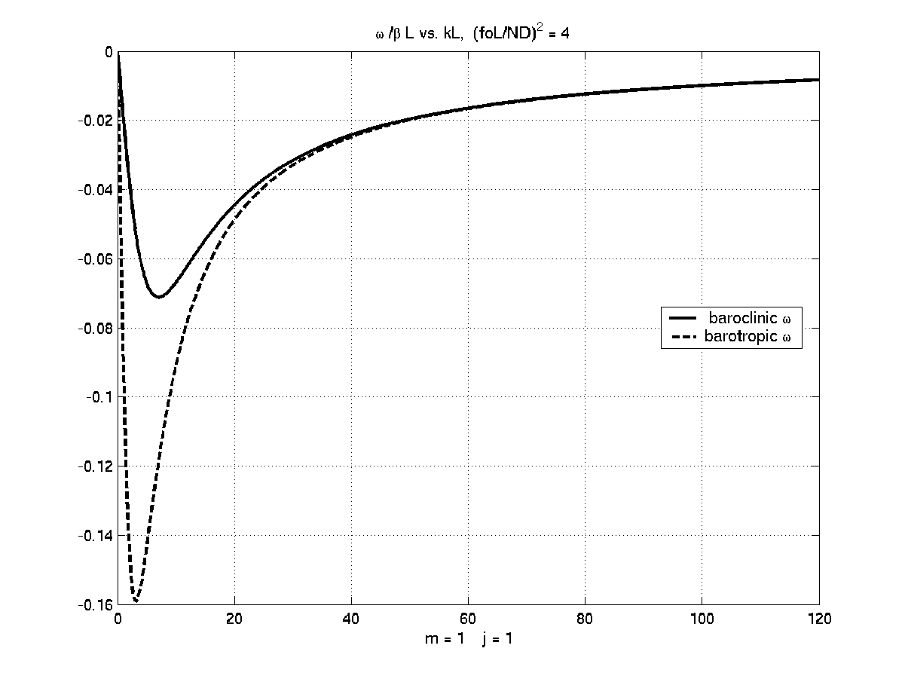

Figure 9.4.2 The Rossby dispersion relation for a baroclinic fluid. The frequency plotted in the figure is scaled with the characteristic frequency βL and the parameter has been chosen to be 4 while both m and j are unity for the baroclinic mode.

Notice that as a function of the x-wavenumber k there is a numerical maximum of the frequency.

If m=0, the geostrophic stream function is independent of z and so the density anomaly in the wave is zero. It follows that in that case the vertical velocity is also zero and so the wave is strictly two-dimensional and is identical to the barotropic wave we found in Chapter 7. We see that the frequency of the barotropic wave is always larger than the frequency for the baroclinic wave and this becomes especially true the larger becomes. Figure 9.4.3 shows the same dispersion relation for the barotropic and the first baroclinic mode (m=1) for = 20.
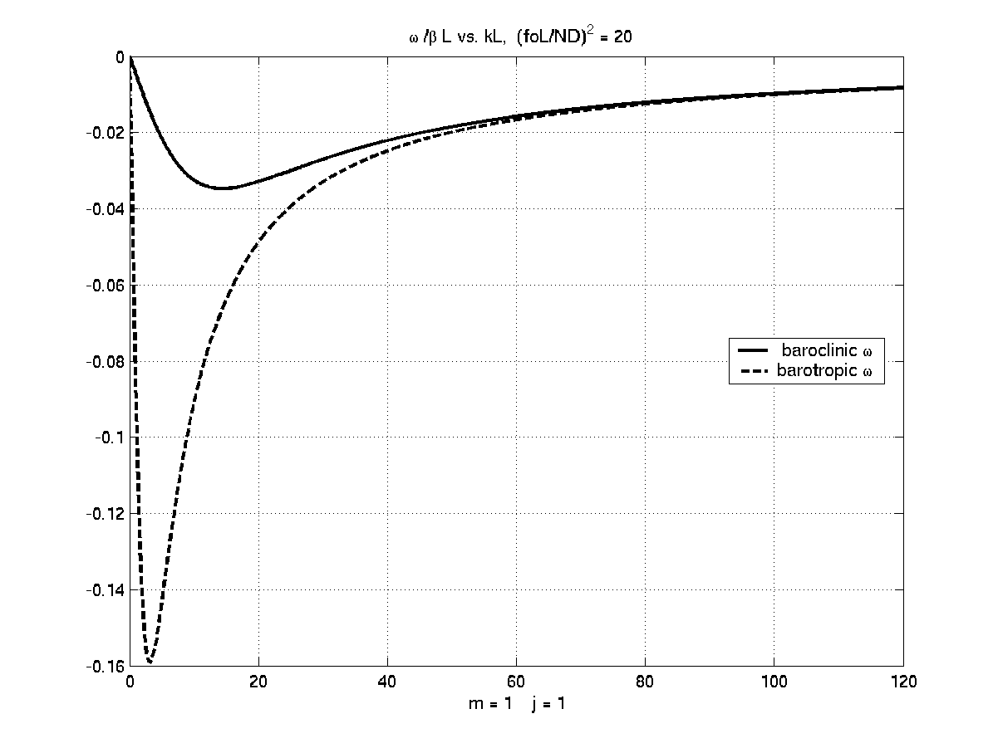
Figure 9.4.3 The Rossby dispersion relation for the barotropic and first (m=1, j=1) baroclinic mode for =20.

Indeed in the limit when becomes very (see figure 9.4.4) large the frequency of the baroclinic modes are

(9.4.8)
and the phase speed c = ω/k becomes,

(9.4.9)
and is independent of wave number while for shorter waves, both for the barotropic and baroclinic modes, the phase speed is different for different wavenumbers. In all cases the phase speed is westward.

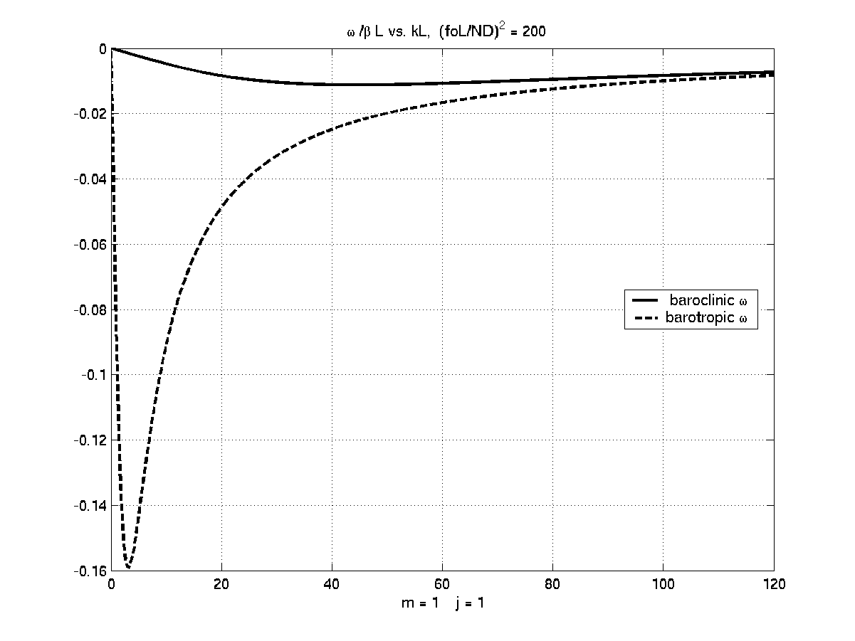
Figure 9.4.4. As in the two earlier figures but now F=200. Note that the baroclinic mode dispersion relation is nearly linear in k unless k is very large. Long baroclinic Rossby waves (wavelengths longer than the deformation radius) have a nearly linear dispersion relation of the form .

 At the equator sinθ vanishes but then other terms neglected in the momentum balance, like the nonlinear terms, become important before the Coriolis term proportional to w.
◻ If the upper surface is the ocean’s surface the condition that w vanish there reflects the fact that the interface between air and water is harder to displace than the interface between the density surfaces internal to the fluid or that .

