Chapter 3
The Stress Tensor for a Fluid and the Navier Stokes Equations
3.1 Putting the stress tensor in diagonal form
A key step in formulating the equations of motion for a fluid requires specifying the stress tensor in terms of the properties of the flow, in particular the velocity field, so that the theory becomes “closed”, that is, that the number of variables is reduced to the number of governing equations. We are going to take up this issue with some care because the same issue arises often, even now, when it is necessary to represent the action of small scale motions and their momentum fluxes in terms of large scale motions. In the formulation we have to be clear about what symmetries of the system need to be respected (for example, the symmetry of the stress tensor itself). So the approach we take here has application beyond the formulation of the basic equations.
In the example of the last chapter we saw that a stress tensor that had only a diagonal component in one coordinate frame would have, in general, off diagonal components in another frame. More generally, since the stress tensor is symmetric , we can always find a coordinate frame in which the stresses are purely normal , i.e. in which the entries in the stress tensor lie along the diagonal.
(3.1.1)
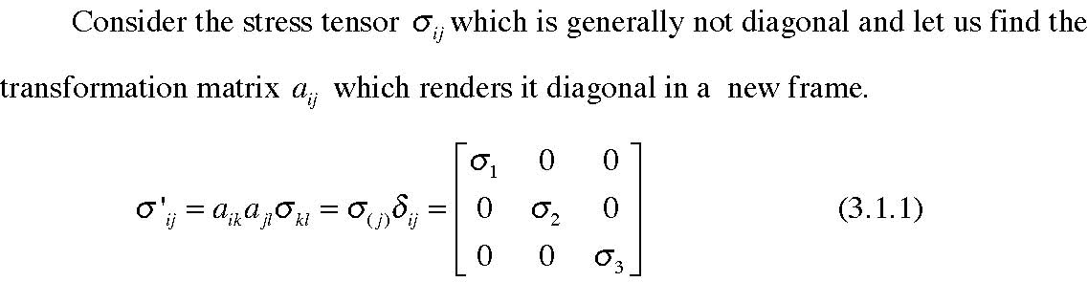
The (j) in the parenthesis indicates that the index is not summed over. To find the transformation matrix that satisfies (3.1.1) we multiply both sides of the equation by aim and carry out the indicated summation
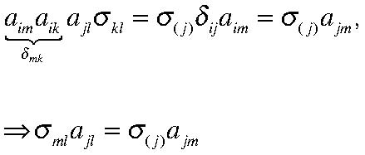
(3.1.2 a, b)
For each j this is an equations for the three components of the vector ajm, m=1,2,3.
To be sure we understand the form of the problem, let’s write out (3.1.2 b) entirely.
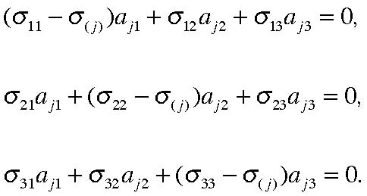
(3.1.3 a, b, c)
and recall that 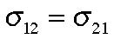 , etc. This yields a simple eigenvalue problem for the 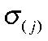 .
There will be three eigenvalues corresponding to the three diagonal elements of the new stress tensor. For each eigenvalue there will be an eigenvector 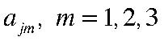. Since the stress tensor is symmetric the eigenvectors corresponding to different eigenvalues are
orthogonal. Thus, for
(3.1.4) and the proof is an elementary one from matrix theory.
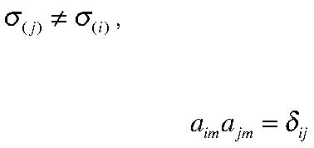
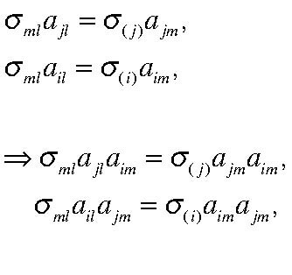
(3.1.5 a, b, c, d)
Subtracting the two final equations yields
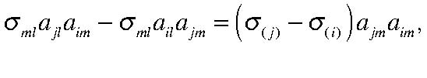
(3.1.6)
In the second term on the right hand side we interchange the dummy summation indices, letting
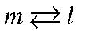 to obtain
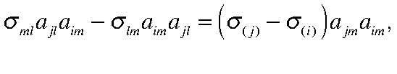
(3.1.7)
but since the stress tensor is symmetric,
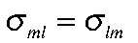 and the left hand side of (3.1.7) is zero and (3.1.4) follows directly. So we can always find a frame in which the stress tensor is diagonal,
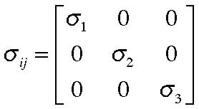
(3.1.8)
3.2 The static pressure (hydrostatic pressure)
Our definition of a fluid is that if it is subject to forces, or stresses that will not lead to a change of volume it must deform and so not remain at rest. It follows that in a fluid at rest the stress tensor must have only diagonal terms. Furthermore, the stress tensor would have to be diagonal in any coordinate frame because, clearly, the fluid doesn’t know which frame we choose to use to describe the stress tensor. As we saw in the last chapter the only second order stress tensor that is diagonal in all frames is one in which each diagonal element is the same. We define that value as the static pressure and in that case the stress tensor is just,
(3.2.1)
This also follows from the easily proven fact that δij is the only isotropic second order tensor, that is , the only tensor whose elements are the same in all coordinate frames. Sometimes p is called the hydrostatic pressure but that misleadingly suggests that it has something to do with a gravitational force balance. Rather it is merely the pressure in a fluid at rest and the fact that the stress tensor is isotropic implies that the normal stress in any orientation is always –p and the tangential stress is always zero. This fact is often called Pascal’s Law. Blaise Pascal (1623-1662) formulated his ideas in a discussion of the hydraulic force multiplier involving pistons of various diameters linked together hydraulically. The isotropy of the pressure was not a result that was accepted immediately by his contemporaries.★ For a fluid at rest the pressure is also the thermodynamic pressure, that is, a state variable determined, say , by the temperature and the density. When the fluid is moving the pressure, defined as the average normal force on a fluid element, need not be the thermodynamic pressure and we will have to consider that in more detail below. The average normal stress is
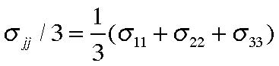
(3.2.2)
this is (mistakenly ) taken to be –p in several otherwise fine texts but it is strictly true only for simple mono atomic gases. In general there is a discrepancy between the average normal stress and the pressure. It is true however, and is left as an exercise for the student, that the trace of the stress tensor
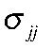 is invariant, i.e. the same in all coordinate
systems. We can always split the stress tensor into two parts and write it
(3.2.3)
★ Rouse, H. and S. Ince. 1957 History of Hydraulics. Dover Publications , New York pp269
where 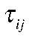 is called the deviatoric stress. It is simply defined as the difference between the pressure and the total stress tensor and our next task is to relate it to the fluid motion. Note that if we define the pressure as the average normal stress then the trace of the deviatoric stress tensor,
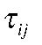 is zero. If the pressure is so defined we can then not guarantee it is equal to the thermodynamic pressure and we will have to represent the difference of
the two of them also in terms of the fluid motion. If, on the other hand, we define the pressure as the thermodynamic pressure then the trace of 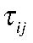 is not zero. Of course, since it is a matter of our choice which we do, the final equations will be the same.
3.3 The analysis of fluid motion at a point.
We are going to try to relate the stress tensor to the fluid motion, i.e. to some property of that motion. In almost all cases of interest to us, that relationship will be a local one (this is an important property true for simple fluids). So we first need to analyze the nature of the flow in the vicinity of an arbitrary point and discover what aspects of that motion will determine the stress. Again, it is unfortunate that many texts go wrong here and so let us be especially careful in our development.
Consider the motion near the point xi. Within a small neighborhood of that point, and using the continuous nature of fluid motion, we can represent the velocity in terms of a Taylor Series. For small neighborhoods of the point, only the first term is important, hence,
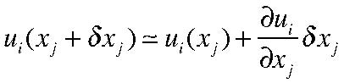
(3.3.1)
Since both the velocity and the displacement 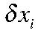 are vectors it follows that 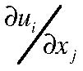 is
a second order tensor. We are going to discuss this tensor in some detail because we will show how the stress tensor depends on this deformation tensor. Thus, if we write the
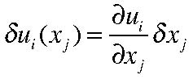
(3.3.2)
We can rewrite the velocity deviation
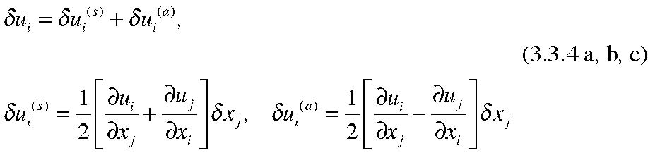
So that one part of the velocity deviation is represented by a symmetric tensor
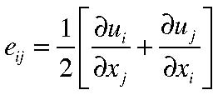
(3.3.5 a)
called the rate of strain tensor (we will see why shortly) and an antisymmetric part,
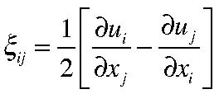
(3.3.6 b)
and it is important to note that the antisymmetric part has only three nonzero entries. Thus, the total velocity deviation is
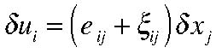
(3.3.7)
We will discuss each contribution separately. It may come as no surprise that the (symmetric) stress tensor is proportional to the symmetric eij but that is something we have to demonstrate.
3.4 The vorticity
The three components of the antisymmetric tensor ,
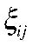 are
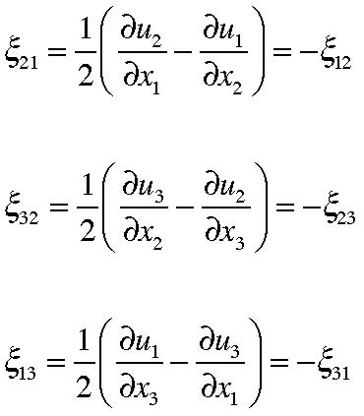
(3.4.1)
and these are the three components of the vector
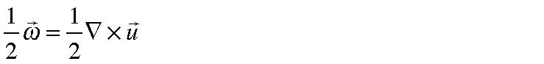 (3.4.2)
where
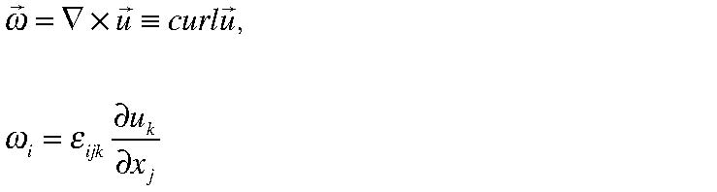 (3.4. 3)
are all representations of the vorticity . The relationship between
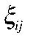 and the vorticity is
straight forward, for example,
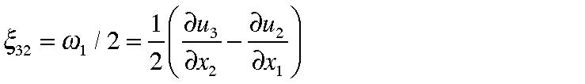 (3.4.4)
with the other components following cyclically, In general,
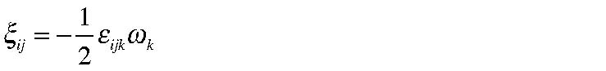 (3.4.5)
which follows from
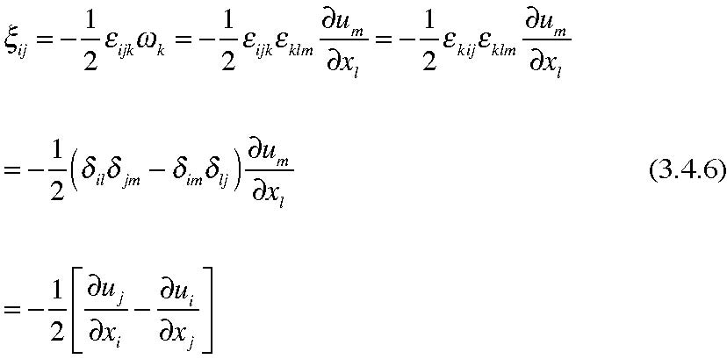
The velocity deviation proportional to the antisymmetric tensor is then,
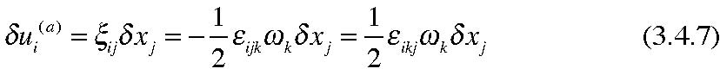
which may be more recognizable written in vector form,
(3.4.8)
Figure 3.4.1 The relation between the vorticity, the position vector (relative to an arbitrary origin) and its contribution to the relative displacement velocity which is perpendicular to the first two.
Thus, 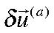 represents the displacement velocity due to a pure rotation at a rotation rate which is half the local value of the vorticity. We recognize that it is a pure rotation because the associated velocity vector is always perpendicular to the displacement and so that there is no increase in the length of 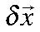 , only a change in direction. The vorticity
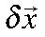
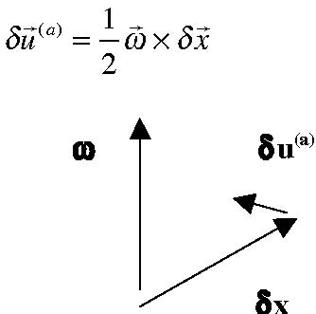
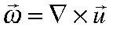 is twice the rotation rate. The vorticity , as we shall see, occupies a central place in the dynamics of atmospheric and oceanic phenomena and we see that it is one of the fundamental portions of the general decomposition of fluid motion.
3.5 The rate of strain tensor
Now let’s consider the contribution of the symmetric tensor
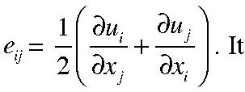
is called the rate of strain tensor. To see why, consider two differential line element vectors, 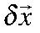 and 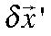 at the same point separated by an angle θ.
δx’
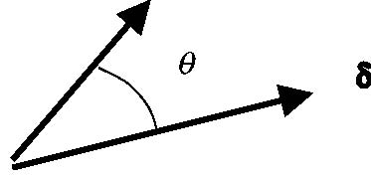
Figure 3.5.1 Two displacement vectors with an angle θ between them.
Let their respective lengths be
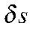 and
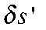 respectively. Now, following the fluid, each displacement vector will change depending on the difference between the position of the origin and the position of the tip of the vector. Thus,
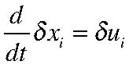
(3.5.1)
where | , by definition, is that velocity difference. Now let’s consider the inner product
,
 | (3.5.2)

The rate of change of this product is
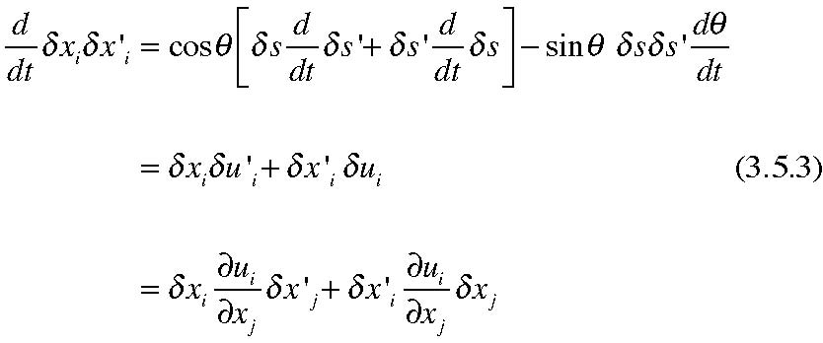
Note that the deformation tensor 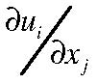 acts on both line elements since they share the same origin. Interchanging the i and j dummy indices the last term in the above equation yields,
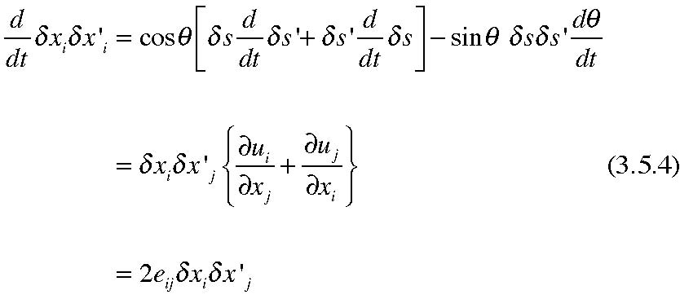
dividing both sides of (3.5.4) by
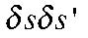 yields,
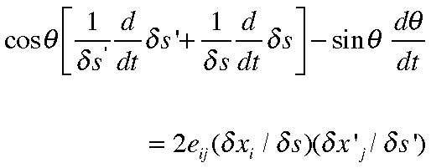
(3.5.5)
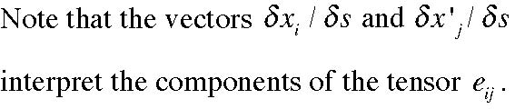
Note that the vectors are unit vectors. We can now use (3.5.5) to
Example 1.
Let 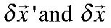 coincide so that θ =0 and let 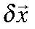 lie along the x1 axis. Then . We then have from (3.5.5)
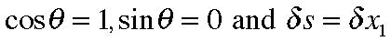
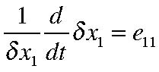
(3.5.6)
so that the diagonal elements of the rate of strain tensor represent the rate of stretching of a fluid element along the corresponding axis.. e22
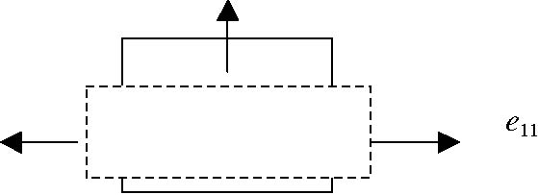
Figure 3.5.2 The rate of strain along the axes due to the diagonal components of eij. In the case shown, e22 is negative.
Example 2.
to lie along the x1 and the x2 axes respectively. So now,
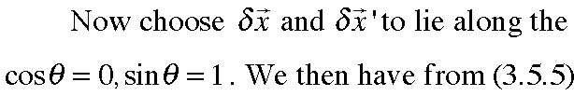
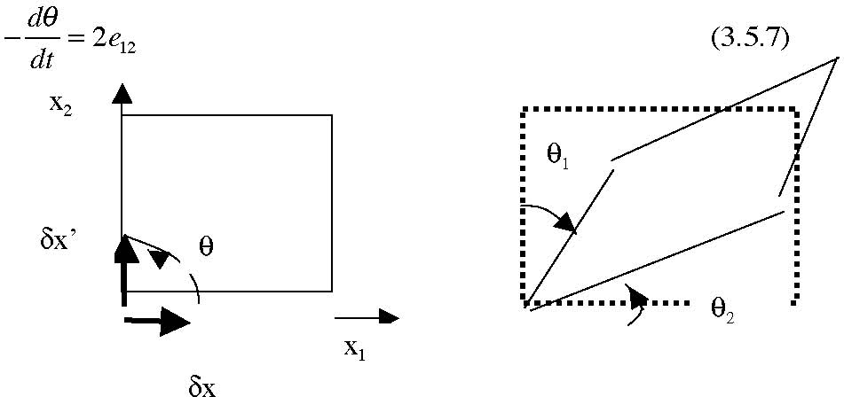
Figure 3.5. 3 The distortion of the original right angle by the off diagonal element of the rate of strain tensor.
This has a simple interpretation, since a little geometry shows that
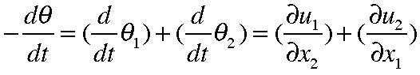
(3.5.7)
since, for example,
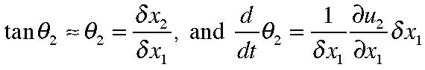
The off diagonal element of the rate of strain tensor therefore represent the rate of shearing strain of a fluid element.
3.6 Principal strain axes and the decomposition of the motion.
As in the case of the stress tensor, the rate of strain tensor can also be diagonalized, so that we can always find a coordinate frame in which ,
(3.6.1)
In this frame the velocity associated with the symmetric part of the deformation tensor
represents a pure strain along the principal axes so that lines parallel to the coordinate
axes are strained but not rotated
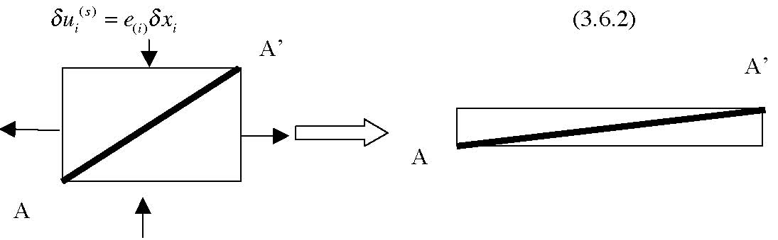
Figure 3.6.1 A fluid element reacting to the application of pure strain along its principal axes. Note that the diagonal line element AA’ rotates as well as stretches.
Although lines parallel to the principal axes are only extended or contracted, other lines such as the line AA’ in the figure are also rotated as the element is sheared. This is analogous to the production of shear stresses by pure normal stresses along an element’s diagonal that we saw in the last chapter. There is, of course, no rotation of lines parallel to the principal axes. Note also that since,
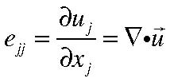
(3.6.3)
which is the rate of volume expansion, we can write the rate of strain tensor, in the principal axes system as, a pure strain without volume change plus a pure volume change,
i.e.
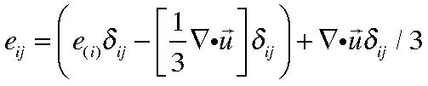
(3.6.4)
The first bracket in (3.6.4) then represents a pure strain without any change in volume and the last term represents a pure volume change.
Putting the results of the last three sections together we see that we can represent the motion of a fluid element in terms of three basic parts: 1) a pure translation, 2) a pure strain along the principal axes and 3) a rotation (associated with the vorticity). This fact was demonstrated by Helmholtz (1853)•
translation pure strain rotation
•
This is noted in a wonderful, if somewhat old fashioned book, well worth some study, ArnoldSommerfeld’s , Mechanics of Deformable Bodies, Lectures on Theoretical Physics Vol II. 1950 Academic Press. pp396.
Figure 3.6.2 The motion of each fluid element can be decomposed into a pure translation, strain, and rotation.
Example:
Consider a simple shear flow for which the velocity is
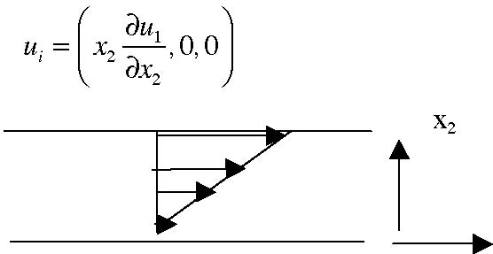
(3.6.5)
x1
Figure 3.6.3 A linear shear flow
For this example the strain tensor has only two non zero components,
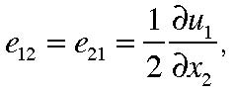
(3.6.6)
so the equations to determine the principal axes and strain rates are,
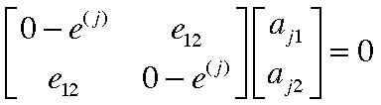
(3.6.7)
so that the condition for the vanishing of the determinant o f the 2X2 matrix in (3.6.7) yields,
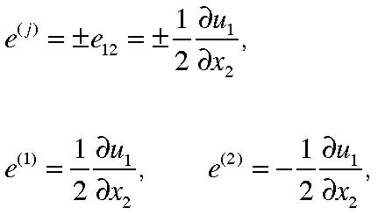
(3.6.8 a,b,c)
For
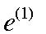 we have,
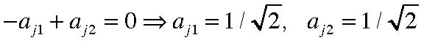
(3.6.7 a, b, c)
after normalizing the vectors to have unit length. For
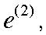
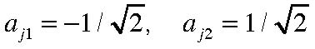
(3.6.8 a,b)
The components of the vorticity are
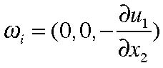
(3.6.9)
The rate of strain along the principal axes, the associated velocities, and the velocity associated with the vorticity(rotation) are shown in Figure 3.6.4 and demonstrate the decomposition of the relative velocity into a strain and a rotation.
δu(s)
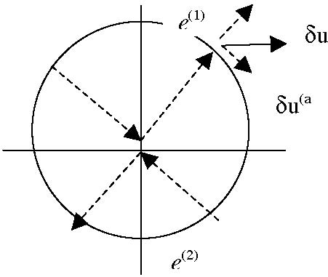
Figure 3.6.4 The directions of the principal axes (dashed) and the rates of strain for the shear flow example. The short vectors represent the velocity due to the strain and rotation and the full vector is their sum.
3.7 The relation between stress and rate of strain.
We need to find a relation between the nine independent components of the stress tensor
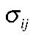 and the fluid velocity and it is here for the first time that we use the particular properties of a fluid rather than a general continuum. As we saw, in a fluid at rest
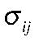 is isotropic and depends on the single scalar, p, the fluid pressure, which is determined
thermodynamically from some state equation of the form 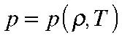 ( although for
seawater with the presence of salt this relation is much more complex).
In a moving fluid we have to make certain assumptions that seem to be valid based on our experience with the type of fluids, air and water that we are most concerned with. We formulate these assumptions as follows:
1) The stress tensor is a function only of
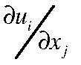 , the deformation tensor, and
various thermodynamic state functions like the temperature. That is, we assume
the deviatoric stress 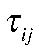 depends only on the spatial distribution of velocity near the element under consideration. The stress-rate of strain relation is local. Note that we are not assuming that the stress depends only on the rate of strain tensor at this point and we are including the entire deformation tensor, including the antisymmetric part (the vorticity).
2) We assume the fluid is homogeneous in the sense that the relationship between stress and rate of strain is the same everywhere. There is a spatial variation in the only insofar as there is a spatial variation of the deformation tensor
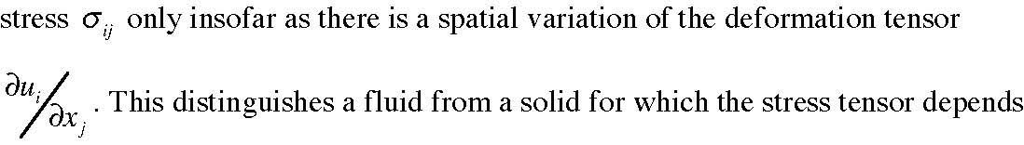
on the strain itself.
3) We assume that the fluid is isotropic, i.e. that there is no preferred direction in space insofar as the relation between stress and rate of strain is concerned. Obviously, given a particular rate of strain, as in the example of the preceding section, there will be a special direction for the stress but only because of the geometry of the strain field not because of the structure of the fluid. This is true for air or water but is not true for certain fluids with long chain molecules in their structures for which rates of strain along the direction of the chains give stresses different than in other directions. It is possible to argue that this isotropy eliminates the vorticity as a contributor .
These assumptions define what is called a Stokesian Fluid (after Stokes, 1845). It is not difficult to show, that as a consequence of the above assumptions, that the principal axes of the stress and rate of strain must coincide even if the relation ship between stress and rate of strain is nonlinear. That will be left as an exercise for you.
We now make one further assumption. We assume that the relation between stress and rate of strain is linear. This defines a Newtonian Fluid and both air and water experimentally satisfy this assumption. This implies that we are searching for the general relation between the deviatoric stress and the deformation tensor of the form
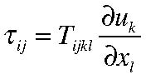
(3.7.1)
where the proportionality tensor (note it is fourth order) satisfies the conditions of homogeneity and isotropy. In particular the last condition, isotropy, implies that the relationship (3.7.1) and thus the proportionality tensor 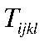 is independent of orientation
in space. If there is a spatial structure to the stress it must reflect the spatial structure of the deformation. So, in general, we need to find the most general fourth order tensor that is isotropic, i.e. the same in all rotated coordinate frames. For a second order tensor the most general isotropic tensor is the Kronecker delta 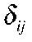 , which as we have seen is
invariant under coordinate transformation. The issue we face here is to find its fourth order equivalent. There are several constructive proofs that yield the result we are looking for and the simplest, I think, is as follows.
Consider the scalar constructed by taking the inner product of
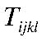 with the four
vectors 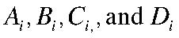 ,
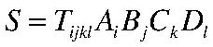
(3.7.2)
This scalar depends linearly on the magnitude of each of the vectors and their relative orientations in space. However, since
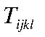 is an isotropic tensor the absolute directions of four vectors should not affect the scalar S but only the orientations of the vectors with one another. Hence, S should depend only on the cosine of the angles between those vectors, or equivalently, only on the dot products of the vectors. Thus,
Other products like
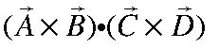 add nothing new. Rewriting (3.7.3) in index
notation,
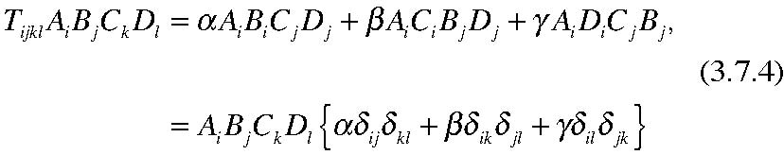
Since the four vectors are arbitrary the condition that (3.7.4 ) is always satisfied yields the form for 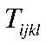 , namely,
(3.7.5)
This is the most general fourth order isotropic tensor. We can see immediately that since
each Kronecker delta is invariant under a linear orthogonal coordinate transformation
the tensor
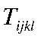must also be invariant. However, we have an additional constraint to
impose since we know that the stress tensor is symmetric and so under an
interchange of the i and j suffixes. Applying this to (3.7.5) it follows that,
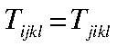
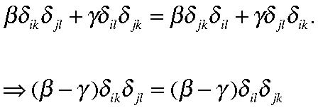
(3.7.6)
For this to be satisfied for each value of i,j,k andl we must have,
(3.7.7)
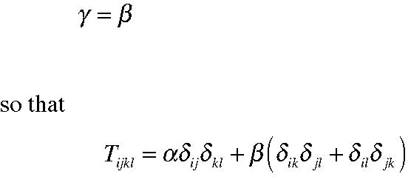
(3.7.8)
from which it follows that the stress tensor has the form,
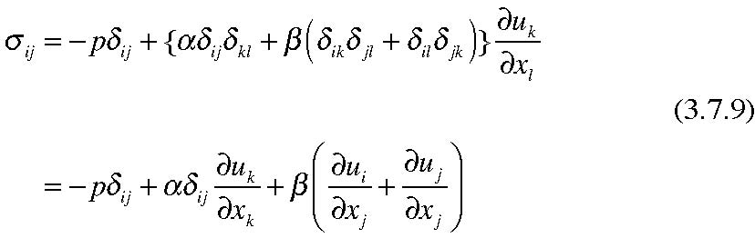
The traditional notation uses µ for β and λ for α, so that finally we have,
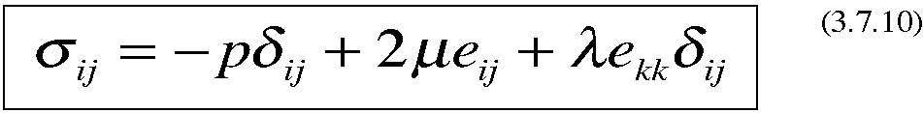
Note that the stress tensor depends only on the pressure, and the rate of strain tensor and not on the antisymmetric vorticity terms. The final term on the right hand side of (3.7.10) is proportional to the divergence of the velocity field, i.e. on the rate of volume change. Generally speaking, in the dynamics of interest to us, the deviatoric stress becomes important when the shear is large, usually near boundaries, and typically dominates the relatively small divergence term. Of course, for a nondivergent fluid, the term is zero.
As we have written it, the stress tensor depends on three scalars, p,µ and λ. The real question we have to confront is what we mean by the pressure. There are two obvious definitions and they need not be the same. From a mechanical point of view we can define the pressure as the average normal stress. That leads to a definition of p that we will momentarily label with an overbar i.e.
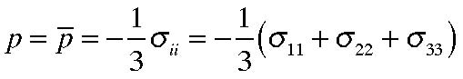
(3.7.11)
as it is in a fluid at rest. Note that even with the fluid in motion this definition of the pressure is independent (invariant) of the coordinate system since the trace of σij is an invariant scalar. If the pressure is defined this way it implies that the trace of the deviatoric stress must be zero, or,
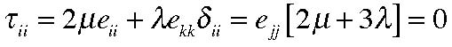
(3.7.12)
and this relates the two coefficients λ and µ.
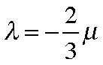
(3.7.13)
and this relation is often used in texts, for example Kundu’s excellent book. However, if the pressure is defined by (3.7.11) we can no longer insist that the pressure be the same as the equilibrium thermodynamic pressure. How can this be possible? It is probably useful to remember that the equilibrium thermodynamic pressure, for example in a gas, is related to the translational kinetic energy of the molecules when the gas, in equilibrium, has reached an equipartition of energy between all its degrees of freedom. For a monoatomic gas whose only degree of freedom is that of the translation velocity of its atoms the pressure will always be the equilibrium thermodynamic pressure. For more complex molecules possessing, say , rotational or vibrational degrees of freedom, it is possible that under abrupt changes of volume there will be a lag between the equilibration of the rotational or vibrational degrees of freedom and the translational. The mechanical pressure is related only to the translational motion of the molecules but there may be a lag before the pressure comes into equilibrium with other thermodynamic variables that require the equipartition of energy to occur. So in general, if we want to write our equations (as we will have to) in a way to link the mechanics and the thermodynamics we will want to introduce the equilibrium thermodynamic pressure pe. That will differ from the mechanically defined pressure by an amount depending on the deformation tensor
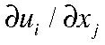 . In an isotropic medium that difference in the two scalar definition of pressure must be related by a second order isotropic tensor, or,
(3.7.14)
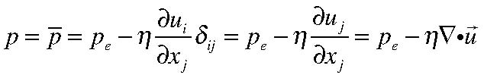
so that the stress tensor becomes
On the other hand, we could just define the pressure as the thermodynamic pressure in
(3.7.10) in which case,
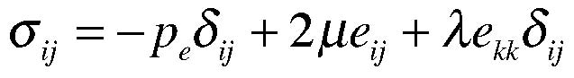
(3.7.16)
It is clear that in either approach we get the same set of equations and the relation
between the two formulations is just that 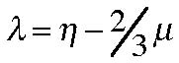 . For a monoatomic gas , we can
take η =0, and the thermodynamic pressure is the average normal pressure. If the fluid is incompressible (or nearly so) these extra terms are inconsequential.
This form of the stress tensor was derived in the first part of the nineteenth century, largely by the French school of fluid dynamicists. The first to have done so was Navier in 1822. He was a military engineer and was more noted for his construction of bridges but he had a rather complex imaginary model of the interaction of fluid molecules that he was nevertheless able to use to derive (3.7.10) without the divergence term. Other derivations followed by Cauchy (1828), St. Venant (1843), Poisson (1829) and finally, in a form more closely resembling what we have done by Stokes (1845). Partly for that reason, partly for Anglo-French parity, the resulting fluid momentum equations with the full stress tensor are called the Navier-Stokes equations.
3.8 The coefficient of viscosity µ .
Let us return to the example of the simple shear flow of section 3.6. The stress associated with the shear has only one independent component 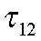 . From (3.7.10) this is
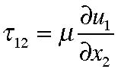
(3.8.1)
and is illustrated in Figure 3.8.1
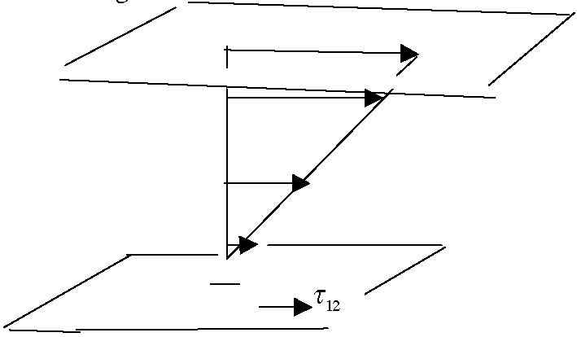
Figure 3.8.1 The shear flow and two horizontal planes on which the stress is calculated.
Keeping in mind the orientation of the normal to each of the two surfaces in the figure. The stress acts in the positive sense on the upper face of the lower plane (to drag it to the right) and that plane exerts a stress on the fluid above it that would tend to drag the fluid leftward with the same force. The stress on the fluid at the upper plane is to the right and the stress on the plane by the fluid is to the left. The coefficient that relates the velocity shear to the stress is called the viscosity coefficient µ, The stress, force per unit area, has
the dimensions of
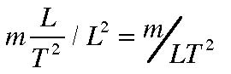 where m is a mass unit (e.g. grams) and L is a
length unit and T is a unit of time. This must have the same dimensions as
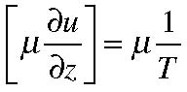
. Since the dimensions of m are just 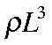 , it follows that the dimensions of
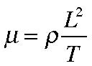
. The coefficient is a thermodynamic state variable and depends rather
nontrivially on temperature and in continuum theories it must be specified. If we were to look on the microscopic scale we would see that the basis for the existence of the shear stress is in the random motion of fluid molecules or atoms. This is most clearly seen when the fluid is a gas. Let’s consider the same shear flow as in Figure 3.8.1 but let’s add the random motion of gas molecules that have zero ensemble average; the average is what has defined our continuum velocity u. The random thermal motion of the atoms will allow a flux of atoms across a plane like the two of the above figure and shown again in Figure3.8.2.
u'2
u'1
u’1
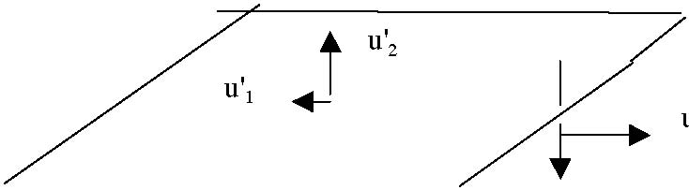
u'2
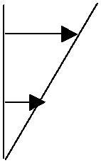
Figure 3.8.2 A fluid plane, perpendicular to the x2 axis for the linear shear flow.
As the gas molecules from below cross the plane shown in the figure they carry a flux of momentum in the 1 direction equal to 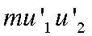 where
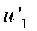 is the excess or deficit of the
velocity with respect to the macroscopic mean. Since the molecule is coming from below the plane where the macroscopic velocity is smaller and if it retains its velocity in the x1 direction (at least until it collides with another molecule) it will arrive across the plane with a deficit of velocity as shown. On the other hand gas molecules coming from above,
with a
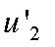 which is negative will arrive with a positive value of 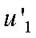 . The flux of
momentum across the plane perpendicular to the x2 axis is therefore always negative. If we can write for
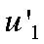
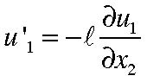
(3.8.2)
where is the distance an atom goes between collisions, then the net momentum flux will be
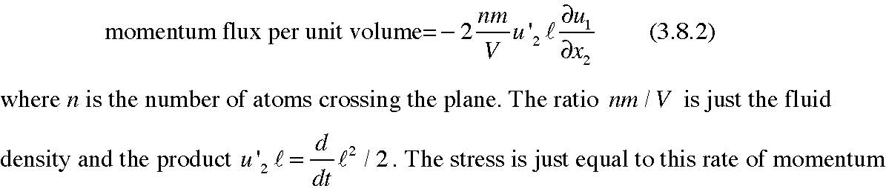
flux so that the coefficient of viscosity is:
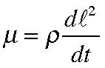
(3.8.3)
where the term 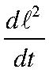 is just the rate of random dispersion of fluid atoms due to their
thermal motion. Note the dimensions of µ are just what we expected. For dilute gases it is possible to use kinetic theory to actually carry out a real calculation of the viscosity although it is not a trivial calculation. For more complicated gases or liquids it is very difficult if not impossible so we will usually consider the coefficient of viscosity as given.
It is useful to define a slightly different measure of viscosity, called the kinematic viscosity ν,
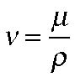
(3.8.4)
and whose dimensions are L2/T.
The following figures give the viscosity coefficient and its kinematic cousin for dry air and pure water over a range of temperature. The values are taken from Batchelor’s book, Fluid Dynamics.
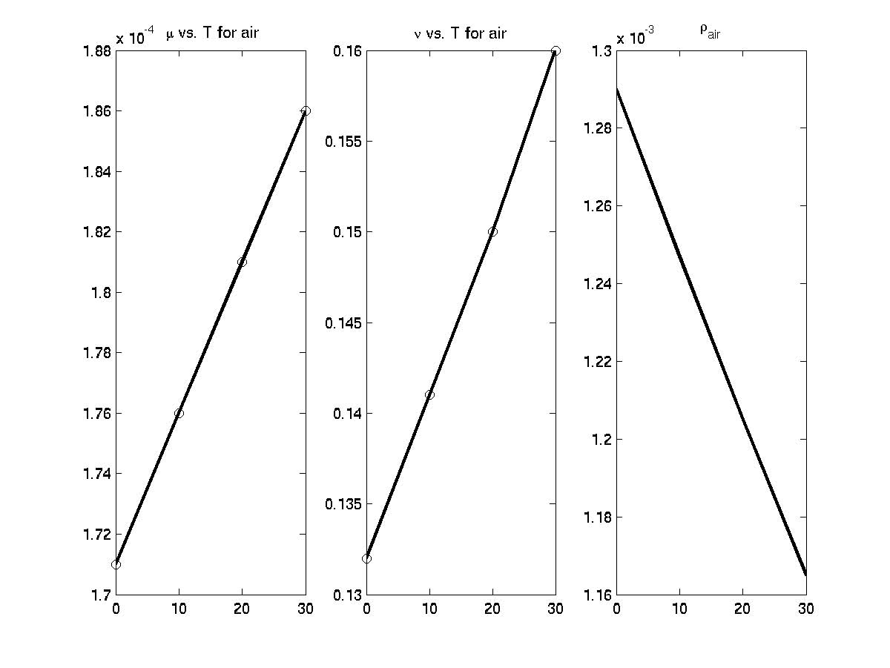
Figure 3.8.3 The coefficient of viscosity µ, for air, in the first panel, the kinematic viscosity ν in the second panel and the density of air as a function of temperature. All are in cgs units and the temperature is in degrees Centigrade
As the temperature increases the thermal motion of the air molecules increase and so the exchange of momentum by the random molecular motion increases. Note that both the viscosity µ and the kinematic viscosity ν increase with temperature.
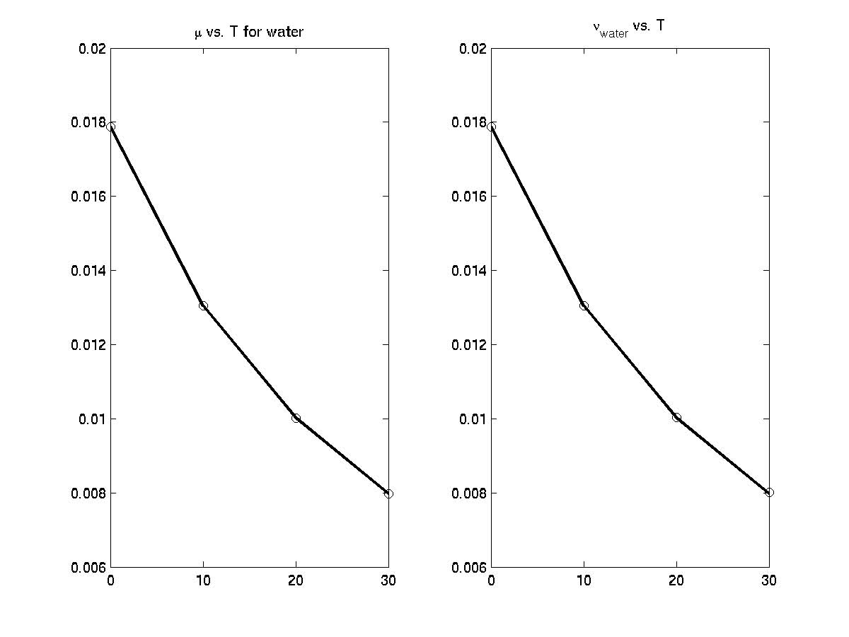
Figure 3.8.4 The viscosity (first panel) µ and the kinematic viscosity ν for water as a function of temperature.
In contrast with air, the viscosity of water decreases with temperature. The viscosity of water is related to the intermolecular forces between water molecules and increasing the temperature weakens those forces and reduces the viscosity. Note that although the viscosity , µ, of water exceeds that of air the kinematic viscosity of water is lower.
3.9 The Navier Stokes Equations
Now that we have an explicit form for the stress tensor we can write the momentum equation (2.7.6) in a form suitable for a fluid. With (3.7.16) we have In (3.9.1) and from now on, we have dropped the subscript “e” on the pressure and we are assuming it is the thermodynamic pressure and not the average normal stress. It is difficult write (3.9.1) completely in vector form but with some little looseness of notation,
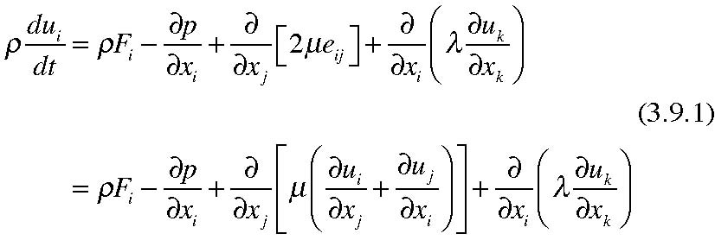
If the fluid is incompressible and if the temperature variations in the fluid are small enough so that the viscosity can be approximated as a constant the Navier Stokes equations become,
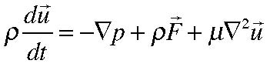
(3.9.3)
If the viscosity coefficient is small enough to tempt us to ignore friction entirely we end up with the Euler Equations,
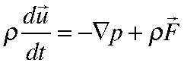
(3.9.4)
Note that in this case the order of the differential equation is reduced since the Laplacian in (3.9.3) eliminated. This is a singular perturbation of the dynamics and we will find that making what appears to be a sensible approximation to the dynamics opens up an interesting physical problem.
Let’s count, again, unknowns and equations. The unknowns are 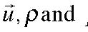p (5) while the equations are the three momentum equations plus the mass conservation equation (4) and so we are still one equation short unless there is a relationship, say, that
relates the density to the pressure field, or in the simplest case, if the density is a constant. In all other cases we will have to consider coupling the dynamical equations we have derived to continuum statements of the laws of thermodynamics.
The total time derivate contains the term 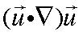 and this form is not easily expressed in other coordinate (e.g. spherical) systems. An alternative expression comes from the identity, easily proven using the alternating tensor
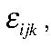
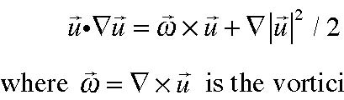
(3.9.5)
is the vorticity. The Navier Stokes equation , e.g. (3.9.3) becomes
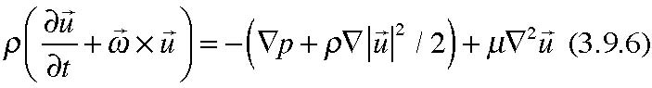
Note that
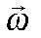 , the vorticity, is twice the local component of the fluid’s rotation. Once again , it is important to emphasize the nonlinearity of the Navier Stokes equations due to the advection of momentum by the velocity field. As an aside, note that if the fluid is incompressible, so that the divergence of the velocity vanishes you can show that,
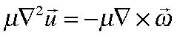
(3.9.7)
so that even though the stress is proportional to the strain and not the vorticity the frictional force in the equations, for an incompressible fluid, can be written in terms of the vorticity.
3.10 Turbulent stresses
Before we continue with our formulation of the basic laws of fluid mechanics note that if ρ is constant the system is closed. Let’s think about that case for the moment which will allow us to examine some interesting features of the equations of motion. Further, since we are decoupling the dynamics from the thermodynamics lets keep the viscosity coefficients constant and if the fluid is incompressible our system of equations is,
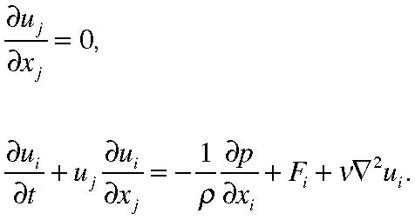
(3.10.1 a, b)
The incompressibility condition ((3.10.1a) allows us to write the momentum equation,
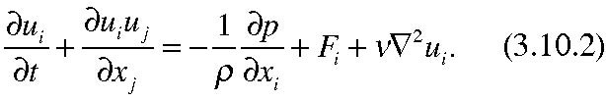
We are often confronted with the situation in which the motion field is very complex, full of eddies and essentially random macroscopic motions at length scales and time scales much shorter than the scales of the motion we are interested in. For example, if we are interested in the atmospheric general circulation, with scales of thousands of kilometers how do we take into account the turbulent motions on scales that are much smaller, like the wispy eddies we see evidence of in the effluent of smoke stacks? We might try to average the velocity in space or in time so that the velocity we consider in our equations of motion is that averaged velocity. Unfortunately, the equation for the averaged velocity contains effects of the small scale motion we had hoped to eliminate by the averaging process because of the nonlinearity of the dynamics.
Suppose we write the full velocity field as an average or mean flow plus a deviation.
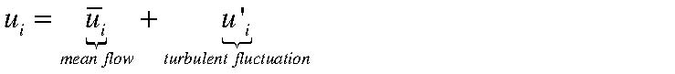 (3.10.3)
The average that defines the mean flow could be a spatial average over scales large compared to the scale of the fluctuating velocity, or it could be a time average over periods large compared to the time scale of the fluctuations, or it could be an ensemble average over a large set of realizations of the same flow configuration differing only in the fluctuations. Defining the averaging process is not trivial but we imagine it is
possible to do and for consistency it implies that the average of the fluctuation is zero,
i.e.
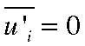
(3.10.4)
If we apply this averaging operation to the momentum equation the average of a linear term will contain only the average quantity, e.g.
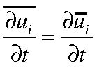
(3.10.5)
On the other hand when we take the average of
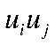
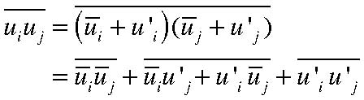
(3.10.6)
Since the average of the average just reproduces the average and the average of the primed variables is zero, 0 0
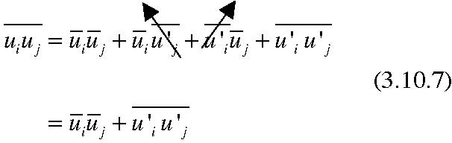
The last term in (3.10.7) is not zero even though each fluctuating term has zero average in the same way that cos(ωt) has a zero time average but (cos(ωt))2 has a non zero time average. Therefore, the equations for the time mean flow contain terms that have their origin in the small scale motions we may not be in a position to describe in a deterministic fashion since (3.10.2), when averaged yields, The last term on the right hand side has the form of the divergence of a stress tensor (per unit mass), called the Reynolds Stress,
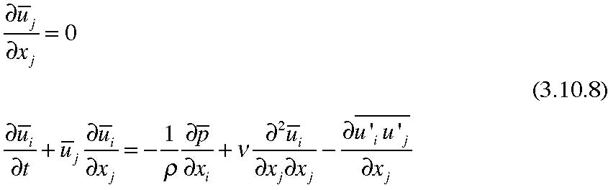
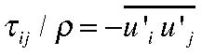
(3.10. 9)
and affects the flow in much the same way as we argued that gas molecules did in giving rise to our viscous stresses in the fluid. Except that here, instead of microscopic momentum being carried by the random motion of molecules around the macroscopic mean, we are talking about a macroscopic random motion around a large scale mean flow. The analogy has sometimes been made that the presence of viscosity, in a gas, can be thought to be analogous to two trains passing each other at different velocities. On the fast train the passengers throw oranges through the windows of the slow train; the passengers on the slow train simultaneously throw oranges through the windows of the fast train. Each set of oranges initially possesses the speed along the track of the train it left. The fast moving oranges slightly speed up the slow train and the slow moving oranges slow down the fast train. This is microscopic friction in the fluid. In the turbulent case, whole macroscopic eddies of fluid play the role of the momentum transfer agents. In this case the passengers have ripped up the seats and are flinging them through the trains and the expectation is that the effect will be greater.
In order to close the system (3.10.8) one is tempted to continue the analogy and try to express the turbulent stresses in terms of the averaged fields,
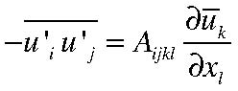
(3.10.10)
except that now the space is hardly isotropic dynamically, (e.g. turbulent transfers across a density gradient or across a mean jet could be different than in other directions), and it
is not at all clear that the momentum of great chunks of fluid will be preserved while the chunks move from place to place in analogy with molecules—there is no mean free path. Still, in desperation, one often supposes that,
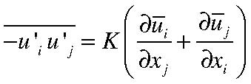
(3.10.11)
leading to an equation for the averaged flow,
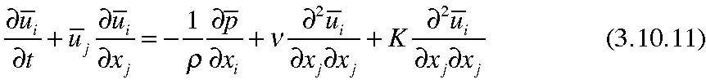
where usually K >> ν.
It is important to understand the very shaky dynamical foundation o f (3.10.11). In some cases, for example the role of weather-scale eddies on the atmospheric general circulation, it is found that the turbulent field can actually sharpen rather than smooth out the velocity gradients. Even when the representation (3.10.11) is qualitatively acceptable there is no deductive way to determine the size of K. Nevertheless, the use of (3.10.11) or some more sophisticated form of the same representation is quite common in both oceanography and meteorology in the absence of a better alternative.

