Chapter 4 Rotating Coordinate Systems and the Equations of Motion
1. Rates of change of vectors
We have derived the Navier Stokes equations in an inertial (non accelerating frame of reference) for which Newton’s third law is valid. However, in oceanography and meteorology it is more natural to put ourselves in an earth-fixed coordinate frame, rotating with the planet and hence, because of the rotation, a frame of reference that is not inertial. It is necessary , therefore, to examine how the equations of motion must be altered to take this into account.
The earth rotates with an angular velocity Ω which we will take, for our purposes to be constant with time although including a time variation for Ω is not difficult and may be necessary for dynamics on very long geological time scales. The Earth’s rotation rate is 7.29 10-5 sec -1 (once per day). The radius of the Earth, R, is about 6,400 km. This gives an equatorial speed of about 467 m/sec or 1050 miles/hr. There is no current or wind system on the Earth that approaches speeds of that magnitude. To the lowest order the ocean and atmosphere are moving with the rotation rate of the planet and all the currents and winds that we observe are very small departures from the solid body rotation of the Earth. It is therefore sensible that we want to describe the winds and currents that we see from within a coordinate frame that removes the basic rotation and shares with us the observational platform of the rotating Earth.
Of course not everyone makes the transition to a rotating coordinate system with ease (see below) so we will take it one step at a time.

We start by considering two observers ; one fixed in inertial space, an inertial observer, and one fixed in our rotating frame, a rotating observer. Consider how the rate of change of a vector , fixed in length, e.g. a unit vector, will appear to both observers if the unit vector rotates with the rotation of the Earth. The situation is shown in Figure 4.1.1
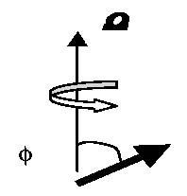
Figure 4.1.1 The unit vector i rotates with angular velocity Ω. The angle
i
between the vectors is φ.
In a time Δt the unit vector swings in under the influence of the rotation and is moved at right angles to itself and to the rotation vector as shown in Figure 4.1.2a .
Ω
i at t0+Δt
i at t0
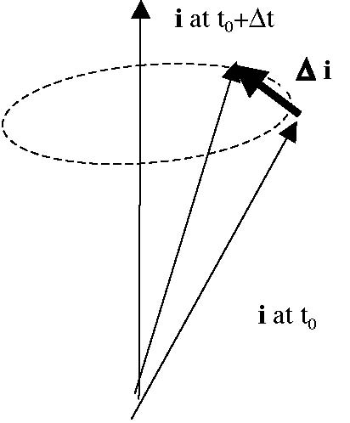
Figure 4.1.2a The unit vector “swings” from its position at t = t0 to its new position at t =t0+Δt.
The difference between the two vectors , Δi can be calculated, for small Δt as the chord generated in that time by the perpendicular distance from the rotation axis to the tip of the unit vector. With reference to Figure 4.1.2b, that perpendicular distance is just sinφ. See also Figure 4.1.2b which shows the situation in plan view.
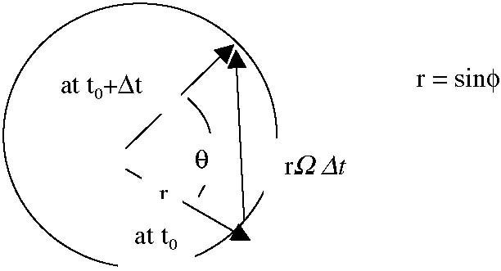
Figure 4.1.2b The rotated unit vector at t0+Δt projected onto the plane perpendicular to the rotation vector. The angle of the swing is θ=ΩΔt
The in the time at Δt the change in the unit vector is
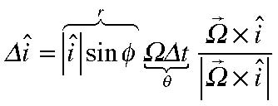
(4.1.1)
The final term in (4.1.1) is a unit vector perpendicular to both the unit vector and the rotation vector since the change in the unit vector can not change the length of the vector only its direction which is at right angles to both 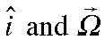 . Note also that,
Thus, in the limit Δt • 0,
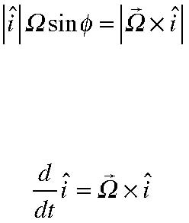
(4.1.2)
(4.1.3)
This is the rate of change as seen by the inertial observer; the observer rotating with Ω sees no change at all.
Now consider the rate of change of an arbitrary vector A. It can be represented as Figure 4.1.3 The vector A and the three unit vectors used to represent it in a coordinate frame rotating with angular velocity
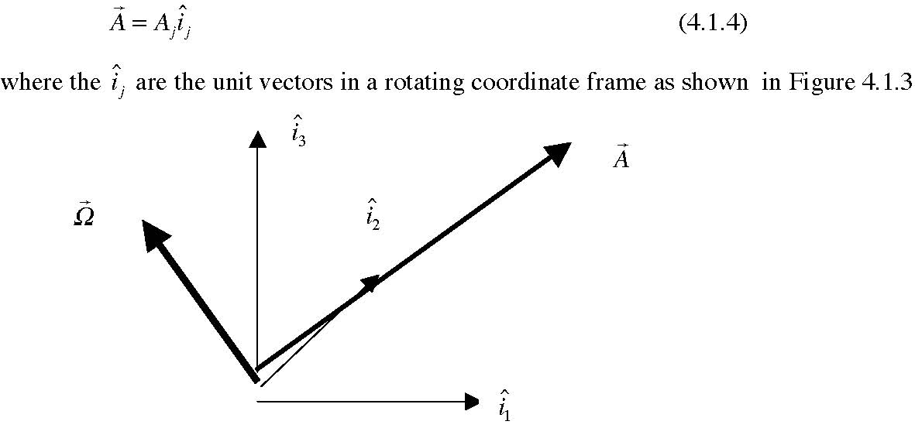
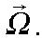
The individual component of the vector each coordinate axis is the shadow of the vector cast along that axis and is a scalar whose value and rate of change is seen the same by both the inertial and rotating observers. The inertial observer also sees the rate of change of the unit vectors. Thus for the inertial observer,
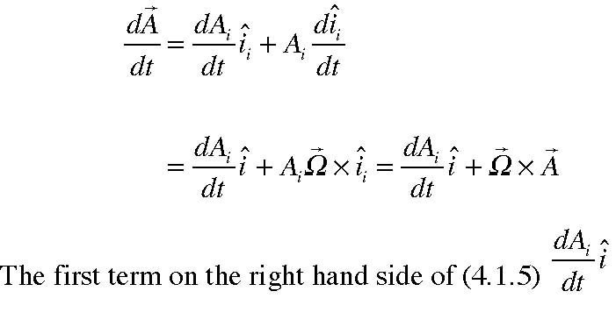
(4.1.5)
is just the rate of change of the
vector A as seen by the observer in the rotating frame. That rotating observer is aware of only the increase or decrease of the individual scalar coordinates along the coordinate unit vectors that the observer sees as constant. For the inertial observer there is an additional term 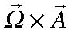 . The rotating observer only sees the stretching of the components of A and not the swinging of A due to the rotation. So the general relation of the rates of change of vectors seen by the inertial and rotating observers is
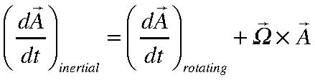
(4.1.6)
Although we are considering only constant rotation vectors note that the two observers would agree on the rate of change of Ω.
If x is the position vector of a fluid element,
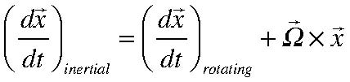
(4.1.7)
so that the relation of the fluid element’s velocity as measured in the two frames is
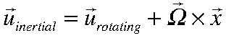
(4.1.8)
Now let’s choose 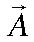 to be the velocity seen in the inertial frame 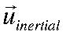 . Applying (4.1.6) to (4.1.8),
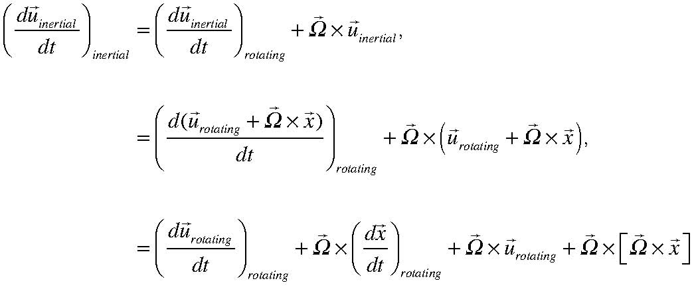
(4.1.9)
(again, we have assumed a constant rotation vector. ) Since,
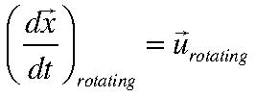
(4.1.10)
The rate of change of the inertial velocity, as seen in inertial space, (and this is what Newton’s equation refers to) is related to the acceleration as seen in the rotating coordinate frame by
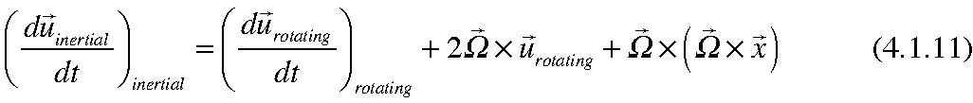
The first term on the right hand side o f(4.1.11) is the acceleration that an observer in the rotating frame would see. The third term is the familiar centripetal acceleration. This term can be written as the gradient of a scalar,
(4.1.12)
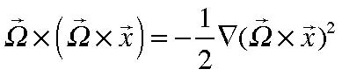
The really novel term is the second term , 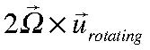 . This is the Coriolis acceleration✪ .
It acts at right angles to the velocity (as seen in the rotating frame) and represents the acceleration due to the swinging of the velocity vector by the rotation vector. The factor of 2 enters since the rotation vector swings the velocity 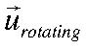 but in addition, the
velocity 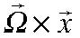 , which is not seen in the rotating frame, will increase if the position
vector increases, giving a second factor of 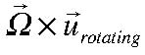 . It is the dominance of the Coriolis
acceleration that gives the dynamics of large scale, slow motions in the atmosphere and the oceans their special, fascinating character. The Coriolis acceleration , like all accelerations, is produced by a force in the direction of the acceleration as shown in Figure 4.1.4.
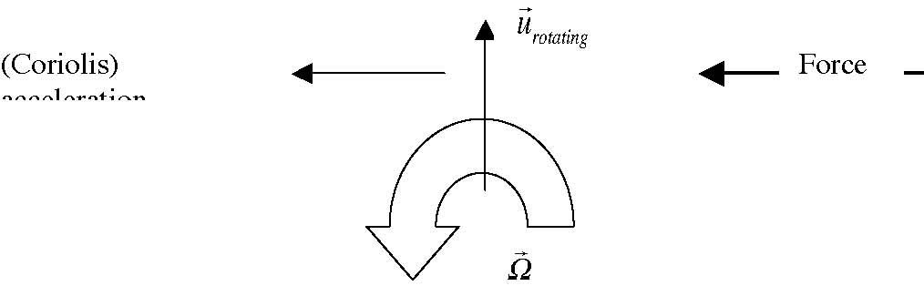
Figure 4.1.4 The relationship between the rotation, an applied force and the velocity giving rise to a Coriolis acceleration .
Note if we have uniform velocity seen in the rotating system so that there will be no acceleration perceived in that system , in order for the flow to continue on a straight path, as in Figure 4.1.4, a force must be applied at right angles to the motion. If the rotation is counterclockwise the force must be applied from the right. If that force is removed, the
✪
Coriolis (1792-1843) was much more famous for his work on hydraulics and turbines than anything to dowith rotating fluids.
fluid element can no longer continue in a straight line and will veer to the right and this gives rise to the sensation that a force (the Coriolis force) is acting to push the fluid to the right. Of course, if there are no forces there are no accelerations in an inertial frame.
We are now in a position to rewrite the Navier Stokes equations in a rotating frame. In fact, we will always use the rotating frame and unless otherwise stated the velocities we use will be those observed from a rotating frame and so we will dispense with the subscript label “rotational”. If we wish to use an inertial frame we need only set Ω to zero. Rewriting (3.9.2)
(4.1.13)
It is important to note that spatial gradients are the same in both frames so the pressure gradient is unaltered. The viscous terms are proportional to gradients of the rate of strain tensor or the divergence of the velocity , each of which is independent of rotation and so those terms are invariant between the two system. If the Coriolis acceleration were moved to the right hand side of (4.1.13) it would appear as the Coriolis force. It should be emphasized that there is nothing fictitious about any of these forces or accelerations. They are real; it is only that they are not recognized as accelerations by an observer in the rotating frame.
The body force we most frequently encounter is due to gravity. If Φ is the gravitational potential so that 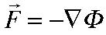 , then the momentum equations (for the case of constant viscosity coefficients) becomes,
The combination of the gradient of the gravitational and centrifugal potentials is what we experience as gravity, i.e.
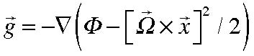
(4.1.15)
The equation of mass conservation is the same in rotating frame, i.e.
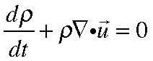
(4.1.16)
since it involves only the divergence o f the velocity and the rate of change of a scalar.
4.2 Boundary conditions
As important as the equations of motion are, the boundary conditions to apply are just as important. In fact, there are important physical problems, like the physics of surface waves on water, in which the fundamental dynamics is contained entirely in the boundary conditions. A similar thing occurs in the theory for cyclogenesis, the theory for the explanation of the spontaneous appearance of weather waves in the atmosphere. There again, the boundary conditions are dynamical in nature and are an essential ingredient in the physics. Their correct formulation is critical to understanding the physical phenomenon. It is important to keep in mind that the formulation of a problem in fluid mechanics requires the specification of the pertinent equations and the relevant boundary conditions with equal care and attention.
4.2.a Boundary condition at a solid surface
The most straightforward conditions apply when the fluid is in contact with a solid surface. See Figure 4.2.1
n
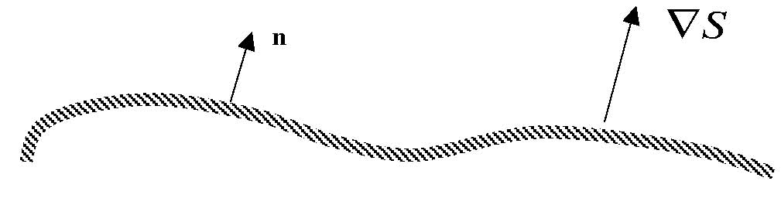
Figure 4.2.1 A solid surface and its normal vector n. 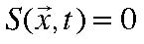 is the equation for the surface.
If the surface is solid we must impose the condition that no fluid flow through the surface. If the surface is moving this implies that the velocity of the fluid normal to the surface must equal the velocity of the surface normal to itself. If fluid elements do not go through the surface, a fluid element on the surface remains on the surface, or, following the fluid,
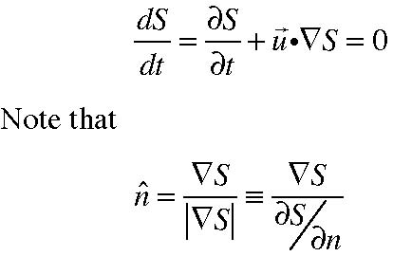
, on S=0 (4.2.1)
(4.2.2)
where n (not the vector) is the distance coordinate normal to the surface. Substituting
(4.2.2) into (4.2.1) we obtain,
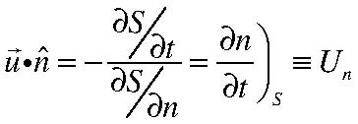
(4.2.3)
where Un is the velocity of the surface normal to itself. Of course, if the surface is not moving (4.2.3) just tells us that the normal velocity of the fluid is zero. Otherwise, it takes on the normal velocity of the solid surface. This condition is called the kinematic boundary condition.
In the presence of friction, i.e. for all µ different from zero, we observe that the fluid at the boundary sticks to the boundary, that is, the tangential velocity is also equal to the tangential velocity of the boundary. The microscopic explanation, easily verified for a gas, is that as a gas molecule strikes the surface it is captured by the surface potential of the molecules constituting the material of the boundary. The gas molecules are captured long enough before they escape to have their average motion annulled and their escape velocity is random, completely thermalized by the interaction so that the molecule leaves with no average velocity, i.e. no macroscopic mean velocity. For gases that are very rare, whose density is quite low, this thermalization may be incomplete. Except in those cases, the appropriate boundary condition is ,
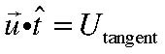
(4.2.4)
where Utangent is the tangential velocity of the surface. In the 19th century, during the period of the original formulation of the Navier Stokes equations, the validity of this condition was in doubt. Experimental verification was uncertain and Stokes himself, who felt the no slip condition was the natural one, was misled by some experimental data on the discharge of flows in pipes and canals that did not seem to be consistent with the no-slip condition. Later, more careful experiments have shown without question the correctness of this condition.
It is important to note that the condition (4.2.4) is independent of the size of the viscosity coefficient for the fluid even though the condition is physically due to the presence of frictional stresses in the fluid. We might imagine that for small enough values of µ , that the viscous terms in the Navier Stokes equations could be ignored. However, we see from (4.1.14) for example, that eliminating the viscous terms lowers the order of the differential equations so that they are no longer able to satisfy all the boundary conditions. This is one of the factors that puzzled workers in fluid mechanics in its first 5 or 6 decades and the resolution of this apparent paradox forms an interesting and important part of the dynamics we shall take up in the example of the next chapter.
4.2 b Boundary conditions at a fluid interface
The boundary conditions at the interface between two immiscible fluids is rather more interesting. Properties in the upper fluid are labeled with a 1, those in the lower layer, 2.
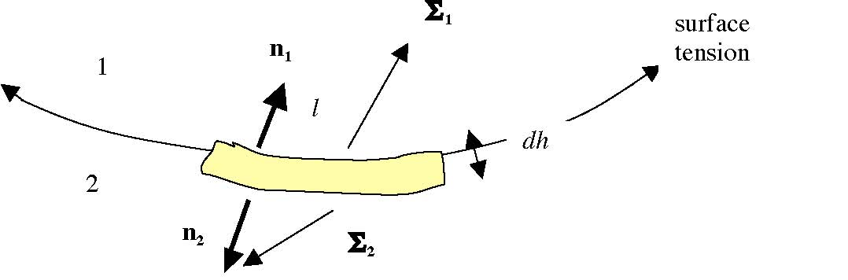
Figure 4.2.2 The “pillbox” constructed at the fluid interface to balance the surface forces.
The boundary conditions are of two types; kinematic and dynamic. Kinematic: a) The velocity normal to the interface is continuous across the interface. This assures us the fluid remains a continuum with no holes.
b) The velocity tangent to the interface is continuous at the interface. This is a consequence of a non zero viscosity. A discontinuous tangential velocity would imply an infinite shear and hence an infinite stress at the interface and this would immediately expunge the velocity discontinuity. An idealization of a fluid that completely ignores viscosity can allow such discontinuities and again the relationship between a fluid with small viscosity and one with zero viscosity is a singular one that has to be examined.
Dynamic:
If we construct a small pillbox, as shown in Figure 4.2.2 and balance the forces on the mass in the box and then take the limit as dh • 0, all the volume forces will go to zero faster than the surface forces on the little box and in the limit the surface forces must balance, except for the action of surface tension forces, i.e.
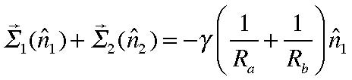
(4.2.5)
where Ra and Rb are the radii of curvature of the surface in any two orthogonal directions and γ is the surface tension coefficient. (For small surface displacements this term is proportional to the Laplacian of the surface displacement).
by our definition of the surface force, the
dynamic boundary condition is
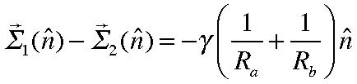
(4.2.6)
In terms of the stress tensor,
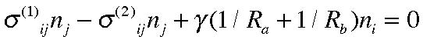
(4.2.7)
In the direction normal to the surface,
Using the expression for the stress tensor (3.7.16),
or
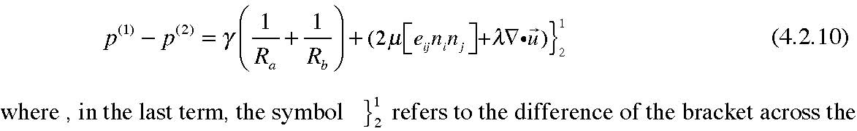
two sides of the interface. Typically, this term is very small and of the order of µ∂u3/∂x3. The first term on the right hand side is also usually negligible unless we are small enough scales (so that the radii of curvature are small) appropriate for capillary waves (the small “cats paws” one sees on the surface of the water when the wind comes up). Normally, for
larger scales the condition of the continuity of normal stress force reduces to the continuity of the pressure across the interface.
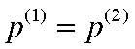
(4.2.11)
For the tangent component of (4.2.8),
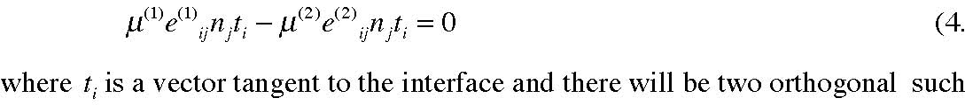
(4.2.12)
vectors.
If the surface is nearly flat and perpendicular to the x3 axis this condition is,
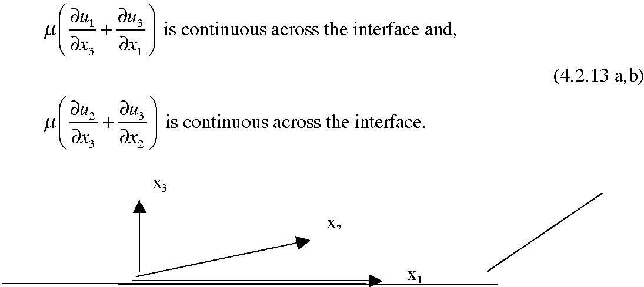
Figure 4.2.3 The coordinate frame in a nearly flat interface.
Again, typically, it is the velocity in the plane of the interface that varies rapidly in the direction normal to the interface, so that the condition (4.2.13) usually reduces to the statement that the shear of the velocity is continuous across the interface. You should keep in mind though that the complete condition in the general case is (4.2.12).
If the viscosity is completely ignored, as is done in some problems for which the effect of viscosity is deemed to be of minor importance, both the tangent velocity and the shear can be discontinuous as the interface.
Note too, that if we define the interface by
(4.2.14)
the condition that fluid elements remain on the interface is,
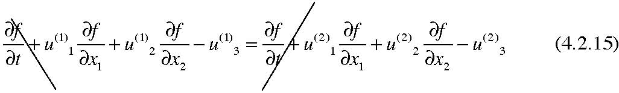
so if the tangential velocities are not continuous, the vertical velocity need not be continuous if the interface is sloping. It is only the velocity normal to the interface that needs to be continuous. The figure below makes this clear.
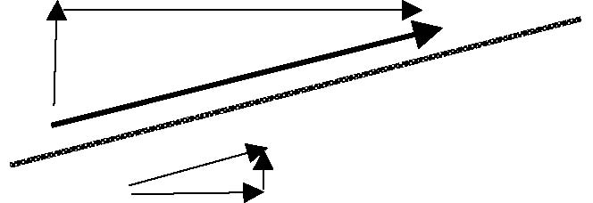
Figure 4.2.4 Here the tilted interface is stationary and the velocity is parallel to the interface so the normal velocity is trivially continuous across it. Note that since the tangential velocity is discontinuous in this case without friction, the “vertical” velocity (in the x3 direction) is not continuous.
We will have to examine the small friction limit to see how this result squares with the continuity conditions imposed by friction.

