Chapter 8
Potential Vorticity
8.1 Ertel’s theorem
The vorticity equation describes the vector dynamics of the vorticity in a clear way. It is not, generally, a conservation statement. Kelvin’s theorem comes closer to being a conservation statement (in restrictive circumstances) but it is an integral theorem and requires knowledge of the evolution of the contour on which the circulation is calculated and it relates only to a single scalar attribute of the vorticity field. The following theorem is due to Ertel (1942) (published in German in the Meteorological Zeitung 59, 271-281) although Rossby (1940, Q.J.Roy. Met. Soc., 66,Suppl. 68-87) had an earlier, slightly less general derivation).
We start with the vorticity equation (7.7.7) and after using the mass conservation equation to eliminate the divergence term on the right hand side we obtain,
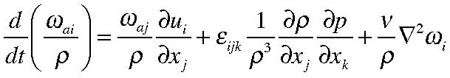
(8.1.1)
Let us now suppose there is a property of the fluid, λ, that satisfies an equation of the form,
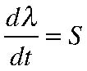
(8.1.2)
where S is a source term for λ. For example, λ might be the entropy for an atmospheric fluid element, it could be the potential density for the ocean. In those cases the source
term S would be the collection of non adiabatic contributions to the heat equation. Or, λ could be one of the components of the Lagrangian tag for a fluid element in which case S would be zero. We will have occasion to use several different properties.
Before proceeding we need to do a simple calculation, that is,
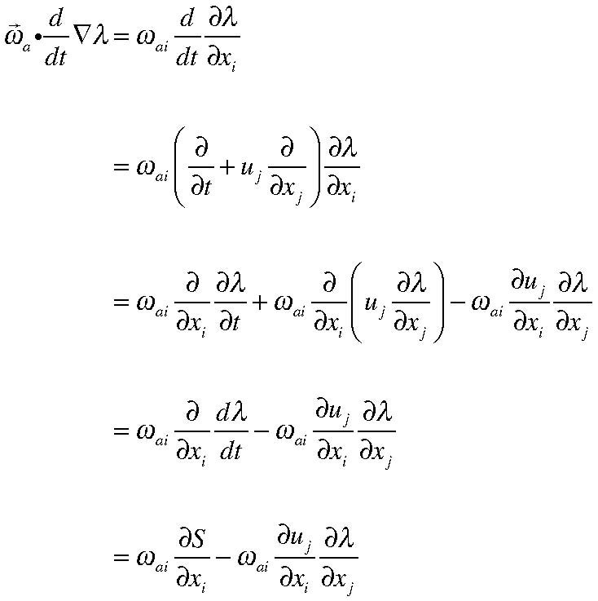
(8.1.3)
and, dividing by ρ and rewriting in vector notation,
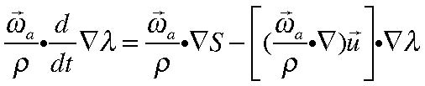
(8.1.4)
and we note that the last term on the right hand side is exactly the vortex tilting term in the vorticity equation, ( 8.1.1). Thus, is we take the dot product of the 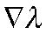 with (8.1.1) we obtain,
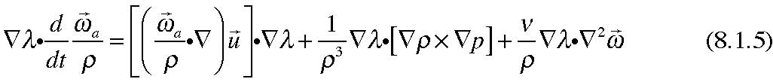
If (8.1.4) and (8.1.5) are added together,
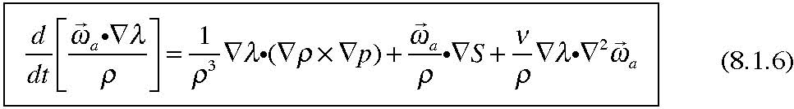
Ertel’s theorem recognizes the result of the following conditions placed on the right hand side of (8.1.6).
If:
1) λ is a conservative quantity following the fluid motion so that S =0,
2) the motion is inviscid ( so the friction term can be neglected)
3) and either
a) the fluid is barotropic
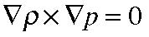
or
b) the property λ is a thermodynamic function of p and ρ , i.e. λ=λ(p, ρ). then:
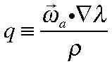
is conserved following the fluid motion. The quantity q (sometimes Π) is called the potential vorticity. We shall have to see in what sense it is a potential vorticity.
The first two conditions are fairly obvious for the validity of the theorem. But let’s examine the third condition that allows the fluid to be baroclinic as long as the property λ is a function of pressure and density (or indeed, as we shall see, any two thermodynamic state variables). If that is the case we can write,
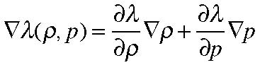
(8.1.7)
from which it follows that the dot product of 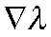 with the baroclinic vector is exactly zero. Hence, Ertel’s theorem is valid for a baroclinic fluid.
It is hard to exaggerate the importance of the theorem for understanding the large scale dynamics of both the atmosphere and the ocean. Indeed, in certain limiting and natural approximations that we will discuss, it actually becomes the governing equation of motion. The dynamics of cyclone waves in the atmosphere, synoptic scale eddies in the ocean and the very structure of the oceanic gyres is based on potential vorticity (pv) dynamics. That being the case it is worth while spending a little time trying to understand the physical basis for the theorem and what it means. That is best done by demonstrating its connection to Kelvin’s theorem.
8.2 The relation between Ertel’s and Kelvin’s theorems.
Consider an inviscid fluid for which the property λ is conserved (e.g. S =0) but which is baroclinic. Think about the surface λ = constant as shown in Figure 8.2.1
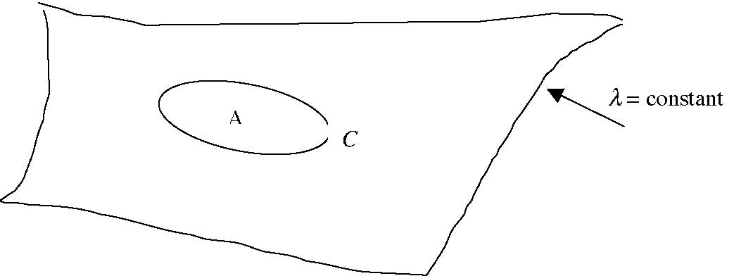
Figure 8.2.1 A portion of the surface on which λ = constant. The contour C lies in the surface and encloses the area A.
If C is a contour moving with the fluid and if λ is a conserved quantity, which implies that the surface on which it is a constant moves with the fluid, then the contour C remains in the same surface as the fluid moves for all time. The equation for the absolute circulation is then,
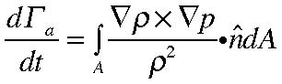
(8.2.1)
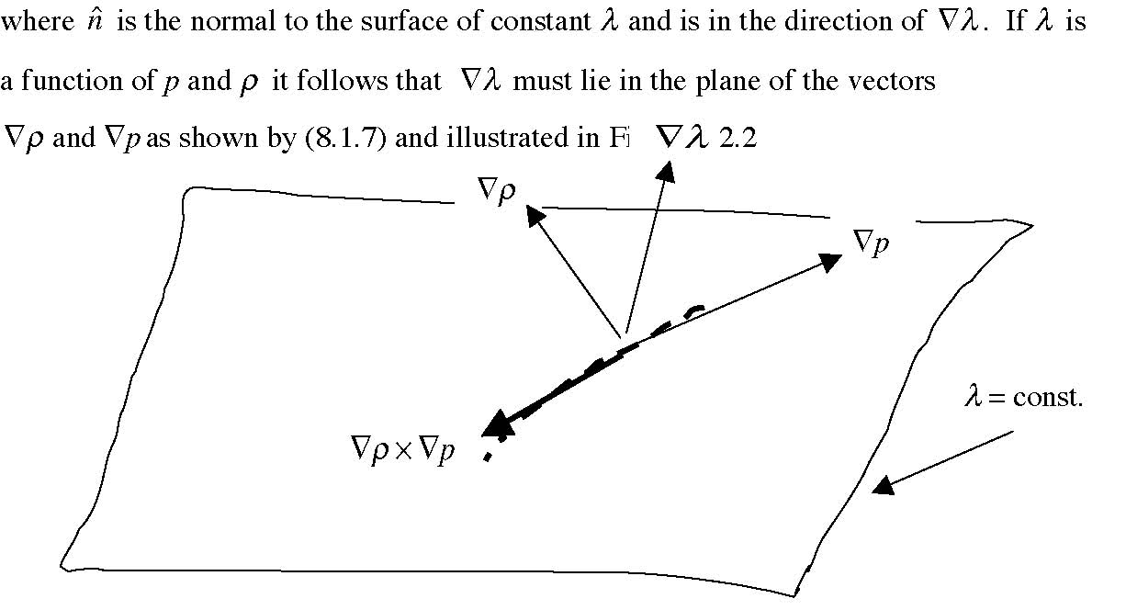
Figure 8.2.2 The vector 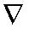λ is perpendicular to the surface and lies in the plane of ρ and 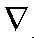p.
Since 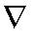 λ lies in the plane of 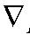p and ρ it follows that the cross product of those two vectors
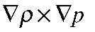 must be perpendicular to 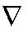λ and hence must lie in the surface λ = constant as shown in Figure 8.2.2. That implies that the integral term on the right hand side of (8.2.1) is identically zero. We have shrewdly chosen a contour C for which the baroclinic term makes no contribution to the circulation integral even though the fluid is baroclinic. Of course, if the fluid were barotropic the term would be identically zero. In either case then, the absolute circulation is conserved, e.g.
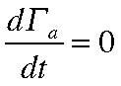
(8.2.2)
Now let the contour C in Figure 8.2.1 shrink until the area A is the infinitesimal area δ A. In that case the absolute circulation is just
(8.2.3)
Consider an adjacent λ surface as shown in Figure 8.2.3.
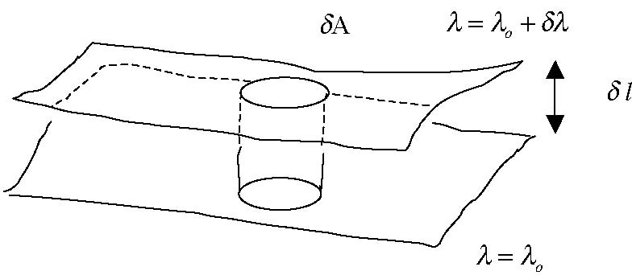
Figure 8.2.3 Two surfaces of slightly different values of λ and the infinitesimal cylinder whose upper surface is the area δ A enclosed by the contour C.
The mass contained in the little cylinder shown in Figure 8.2.3 is
(8.2.4) while
(8.2.5)
and since
it follows that
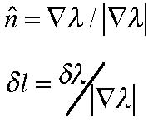
(8.2.6)
Using (8.2.5) and (8.2.6)we can solve for δA,
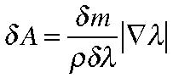
(8.2.7)
so that the circulation in (8.2.3) is
(8.2.8)
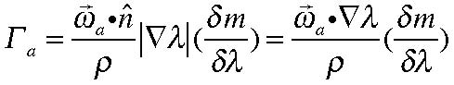
Since the circulation is conserved and since both δm and δλ are conserved following the
fluid motion we must have the potential vorticity,
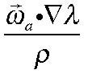 , conserved.
Ertel’s theorem is then a differential statement of Kelvin’s theorem where the
Kelvin contour is chosen in a surface for which the baroclinic vector 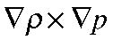 lies in the surface and makes no contribution to the change in the circulation. We see from Figure 8.2.3that if the λ surfaces are pried apart so that 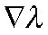 decreases, the area contained in the contour C (divided by the density) must shrink and the consequence of that vortex tube stretching is that the absolute vorticity must increase, at least in the direction of the normal to that surface, i.e. as
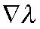 decreases that part of
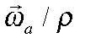 parallel to
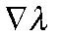 must increase. In that sense q is a “potential” vorticity since vorticity can be produced by stretching apart (or compressing) the spacing of the λ surfaces. In large scale flows for which the planetary vorticity is ever present, changes in the spacing of the λ surfaces can produce relative vorticity.
8.3 Examples
a. Two dimensional motion.
Suppose the motion of the fluid is two dimensional, i.e. suppose w=0,
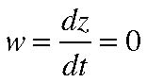
(8.3.1)
If the fluid is barotropic then we are free to choose λ to be the coordinate z in which case the potential vorticity is simply
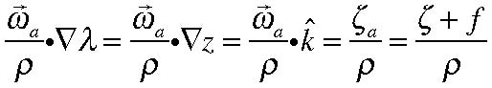
(8.3.2)
which will be conserved in the absence of friction just as we found in (7.9.13). A related but less trivial example is given next.
b. Shallow water
Consider the motion of a shallow layer of homogeneous fluid with constant density and with negligible viscosity. This is a model frequently used in both atmospheric and oceanic dynamics and indeed can be shown to be applicable to stratified fluids as well although the connection requires some more detailed analysis that is deferred to 12.802.
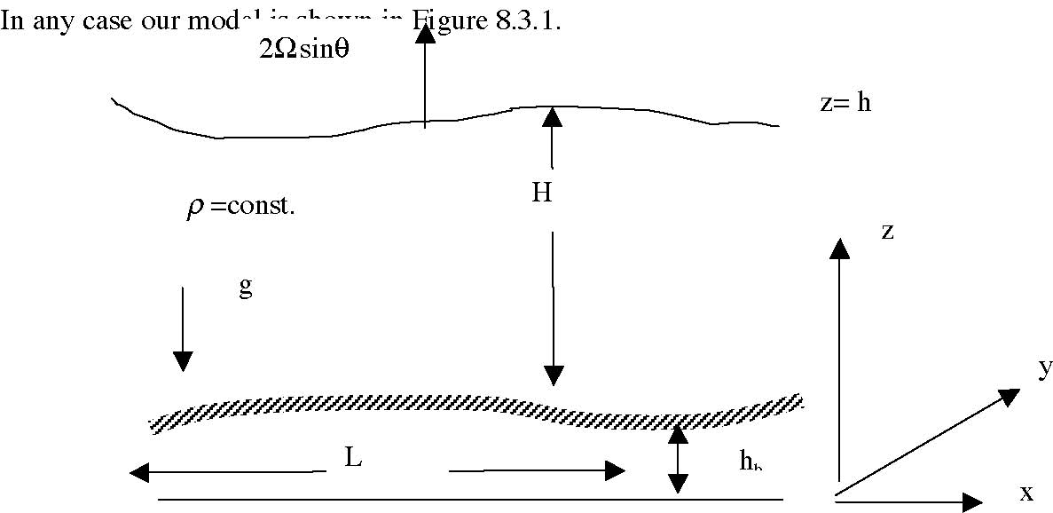
Figure 8.3.1 The shallow water model
The model deals with a fluid of constant density so the equation for mass conservation is just the absence of divergence of velocity, or in a Cartesian frame,
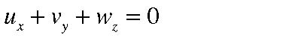 (8.3.3)
where subscripts here denote differentiation.
On z =h, the upper free surface, the motion of the fluid defines the motion of the surface,
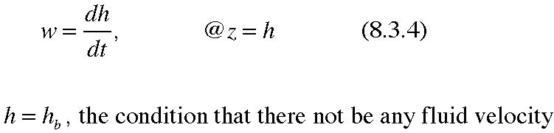
(8.3.4)
while on the lower surface,
through the surface, i.e. that the velocity normal to the surface be zero is,
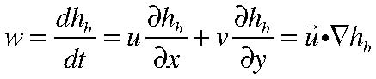
(8.3.5)
The vertical scale of the motion is of the order of the thickness of the layer, H, while we suppose the horizontal scale of the motion is of the order L where H<< L. Under these conditions we expect the vertical velocity to be small and from strictly geometrical considerations we expect
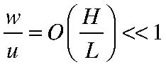
(8.3.6)
For the shallow layer of constant density fluid we suppose the horizontal velocity is independent of depth. This turns out to be an excellent approximation if viscous boundary layers are excluded. Then , integrating (8.3.3) in z yields,
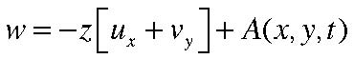
(8.3.7)
where the function A(x,y,t) is an arbitrary “constant” of integration. To determine A we apply the boundary condition (8.3.5) on z =hb to yield,
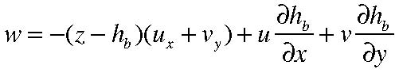
(8.3.8)
However, we must still satisfy (8.3.4) on the upper surface. Applying (8.3.4) at z=h in
(8.3.8) we obtain
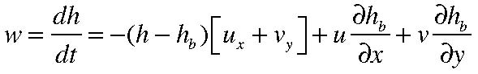
(8.3.9 a)
i.e. with
or
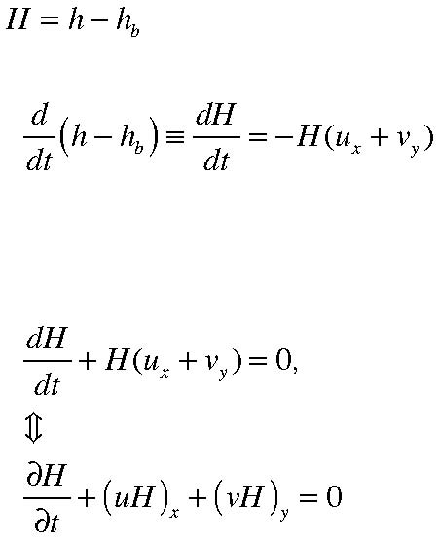
(8.3.9 b)
(8.3.10 a, b)
so that using (8.3.10 a) to eliminate the divergence in (8.3.8)
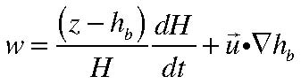
(8.3.11)
Now consider the function
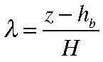
(8.3.12)
The function λ measures the relative height with respect to the bottom of a fluid element in a column. One might think of it as the status of any fluid element. Let’s consider its rate of change. If we use (8.3.11),
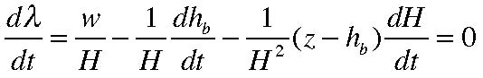
(8.3.13)
For a fluid of constant density the status function is a proper candidate for use in defining the potential vorticity.
Now the absolute vorticity vector is,
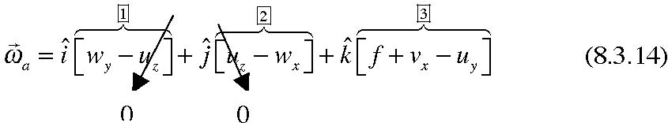
since the horizontal velocities are independent of z. The remaining contributions to the terms labeled (1) and (2) are proportional to the vertical velocity and they are small by an order (H/L) compared to the horizontal velocities. Hence to that good order of approximation♦ only the third term is important. In which case our potential vorticity becomes, ignoring the factor of constant density,
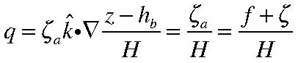
(8.3.15)
and this must be conserved following the motion of fluid columns in the layer. As the fluid column shrinks, perhaps by being squeezed into shallower water, the total vertical component of the vorticity must decrease. The opposite must be true if the column is stretched. The intuitive connection with Ertel’s theorem is clear.
8.4 The thermal wind.
Let’s return for a moment to the vorticity equation (7.7.7)
where we have been explicit in writing the absolute vorticity as the sum of the planetary plus relative vorticity. We will now examine the consequences of the balances required
by (8.4.1) when the relative vorticity is small compared to the planetary vorticity, i.e. the vorticity due to the rotation of the frame. In the atmosphere and the ocean we have to be especially careful because of the thinness of the fluid layers involved that leads to special considerations that we will take up in later sections. For now, let us think of the rotation vector Ω as perpendicular to the lower surface and antiparallel to gravity as shown in Figure 8.4.1
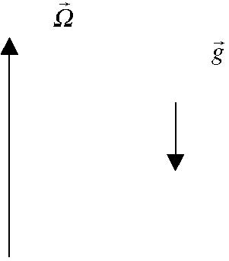
Figure 8. 4,1 The rotation vector Ω and the gravitation are antiparallel in the discussion of this section.
Suppose the following conditions are valid for the flows we are considering:
1) The time scale is long compare to the rotation period of the frame. Formally, we can consider steady flows but all we need to require is that the frequency of the
motion is small with respect to Ω so that the time derivative 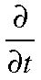 can be neglected
compared to Ω. That eliminates the first term on the left hand side of (8.4.1).
♦ For the ocean a synoptic scale eddy has a horizontal scale of order 50 km and a verticalscale of order 1 km.
Chapter 8 12
2) The motion is inviscid, i.e. ν is zero. Really we only require that the dissipative time scale is long compared to rotation period. This also clearly implies that we are outside any viscous boundary layer (such as the Ekman layer).
3) The relative vorticity is small compared to the planetary vorticity, i.e. that
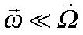 . If U is a characteristic horizontal velocity and L is a characteristic horizontal length scale we can estimate the vorticity as U/L. This has to be examined more carefully in the case where the fluid is in a thin layer where the vertical scale, D, is small compared to L, but we will defer such consideration of anisotropy till later.
The condition then is that the nondimensional parameter,
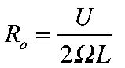 is small. This
parameter is the Rossby number.
Neglecting these small terms reduces the vorticity equation to the balance,
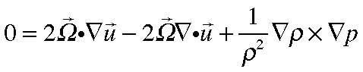
(8.4.2)
With the rotation vector in the z direction (the vertical), the two horizontal components of (8.4.2) are,
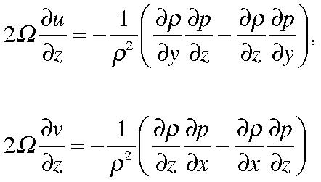
(8.4.3 a, b)
These equations can be thought of as a balance between the baroclinic production of relative vorticity balanced by the tilting of the planetary vorticity (see Figure 8.4.2) to avoid the production of large amounts of relative vorticity to maintain condition (3).
vortex tilting by theΩ shear of u
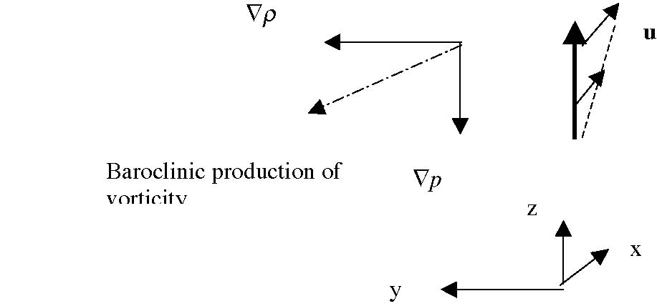
Figure 8.4.2 The baroclinic production of vorticity balanced by the tilting of the planetary vorticity vector.
The shear 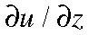 tends to tilt planetary vorticity filaments in the plus x direction and this tendency is balanced by the baroclinic production of vorticity in the negative x direction. (Note that for the Ekman layer it is the tilting of planetary vorticity that balances the diffusion of vorticity and so allows a steady solution which is not possible in the non rotating case).
The baroclinic term can be rewritten more compactly,
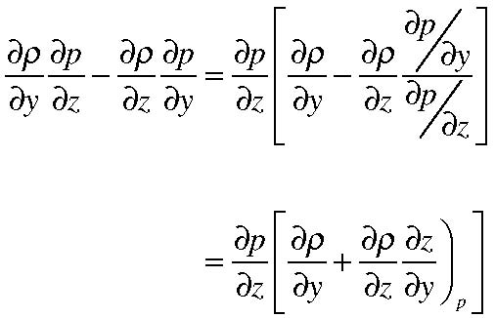
(8.4.4)
We can consider the density either as a function of x, y and z or equally well, as a function of x, y and p. This is familiar in meteorology where variables are presented on particular pressure surfaces (e.g. the 500 mb surface) and in oceanography where pressure is a frequently used depth coordinate. In the case where pressure is used as a vertical coordinate the height of a pressure surface becomes a dependent variable. The relation between them is easy to describe. We consider
(8.4.5) so that ,
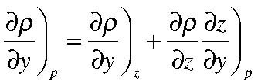
(8.4.6)
so that (8.4.3) can be concisely rewritten,
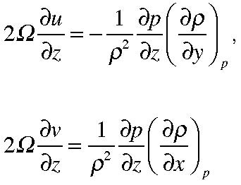
(8.4.7 a,b)
The variations along the rotation axis of the velocity perpendicular to that axis (the horizontal velocity) is proportional to the density variations in a pressure surface at right angles to both the rotation axis and the velocity. In both the atmosphere and the oceans, on scales large enough so that (8.4.7 a, b) would be valid, it is also a good approximation in the vertical direction to consider the vertical pressure gradient balanced by the buoyancy, the so-called hydrostatic approximation,
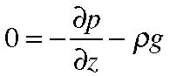
(8.4.8)
so that (8.4.7) becomes,
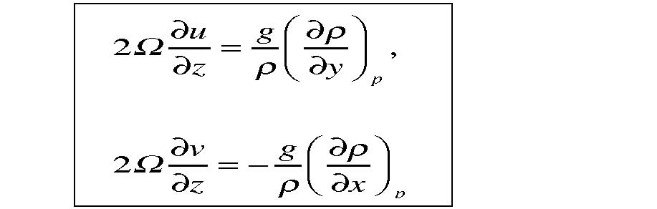 (8.4.9 a, b)
In this form these approximate equations are called the thermal wind equations. They diagnostically relate the vertical shear of the wind (or ocean currents) to the horizontal density (or temperature) gradients. So, for example, in the atmosphere the increase of the westerly winds with height in mid-latitudes is consistent with the increase of density northwards. Similarly, the northward flowing Gulf Stream is characterized by inshore cold water and warmer offshore water or a density that decreases eastward. In the oceanic case the distinction between the density gradient on horizontal as opposed to pressure surfaces is negligible.
It is natural to ask why we don’t consider the constraint on in the vertical direction implied by (8.4.2). However in this case ,
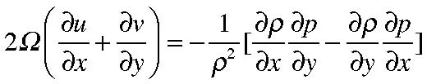
(8.4.10)
the terms on the right hand side are so small (both being proportional to the motion) that the approximations allowing the neglect of the nonlinear terms is no longer valid. In the derivation of (8.4.9) the vertical pressure gradient is proportional to the gravitational force and does not depend at lowest order on the motion.
8.5 The Taylor Proudman theorem.
Suppose all the conditions of the previous section are valid and, in addition, the fluid is barotropic. A simple example would be a fluid of constant density. Then the baroclinic term would be exactly zero. The implications are rather startling. If correct, it would imply that the horizontal velocity would be independent of the direction parallel to the rotation axis, or in our notation,
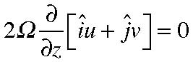
(8.5.1)
This constraint follows from the physical statement that there is nothing in the vorticity equation that is large enough to balance the tilting of the planetary vorticity in the absence of baroclinicity, friction or nonlinearity. The motion is constrained to be two dimensional. If the conditions of the theorem are truly satisfied (8.4.10) would also imply that the motion is horizontally non divergent. For an incompressible fluid this would further imply that
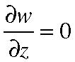
(8.5.2)
so that all three components of velocity would be independent of the direction parallel to the rotation axis. This is the Taylor-Proudman theorem.
Now imagine that in such a case we consider a flow field impinging on an obstacle, like a bump on the bottom of the fluid, as in Figure 8.5.1.
U
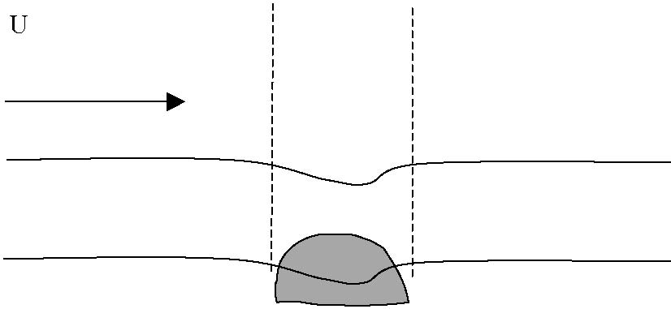
Figure 8.5.1 An oncoming flow avoids an obstacle at the base of the fluid. The Taylor Proudman theorem predicts that fluid above the obstacle will avoid a ghost-like upper extension of the bump.
At the level of the bump on the bottom the streamlines of the flow have to move around the bump. If the Taylor Proudman theorem is correct and the flow is independent of the direction parallel to the rotation axis, the streamlines of the flow above the bump must make a detour around an upward projection of the bump indicated by the dashed lines in the figure. The fluid avoids a cylindrical column composed of essentially static fluid. One of the great fluid dynamicists of the 20th century was so taken with the predictions of the theory that he decided to test it in the laboratory. You will enjoy reading his paper “Experiments on the motion of solid bodies in rotating fluids”, G.I. Taylor, 1923, Proc. Roy. Soc. A 104, 213-218. The paper starts with his description of the theoretical prediction due to Proudman and describes three possible outcomes of the experiment. (1) the flow may never become steady, (2) that the nonlinearities near the body are always so large that they can’t be neglected, or (3) that the prediction of the theorem is correct. After describing why the first two objections are unlikely to be true, he remarks on the possibility that the motion will be really two-dimensional as described above by saying “This idea appears fantastic”. His experiments confirmed the theory and the resulting columnar structures are called Taylor Columns (or less often Proudman Pillars). The pictures in the paper are a bit unclear, but about 40 years ago Harvey Greenspan decided to redo the experiments in preparation for his monograph , “The theory of rotating fluids”. (H.P. Greenspan, 1968 Cambridge Univ. Press. pp337). His approach was ingenious. As we have seen the spin –up time for a rotating fluid is generally long compared to a rotation period. Harvey placed a molded clay hemisphere on the base of a filled cylinder of water and waited for the rotating flow to come into solid body rotation. He then slightly increased the rotation rate of the cylinder. For the period of time of the order of the spin-up time that produced a relative flow of the fluid with respect to the cylinder and hence the bump on the bottom. The flow contained aluminum flakes that tend to align themselves with the shear in the fluid and , when aligned, are visible when a beam of light is shone through the fluid. If the configuration o f Figure 8.5.1 is realized the boundaries between the inner and outer fluid of the Taylor column will be regions of high shear and will be illuminated brightly by the beam of light. The experiment was conducted in an informal laboratory Greenspan set upon the 3rd floor of the math department at MIT, conveniently near the men’s room’s water supply. A Polaroid photo of the result is shown in Figure 8.5.2.
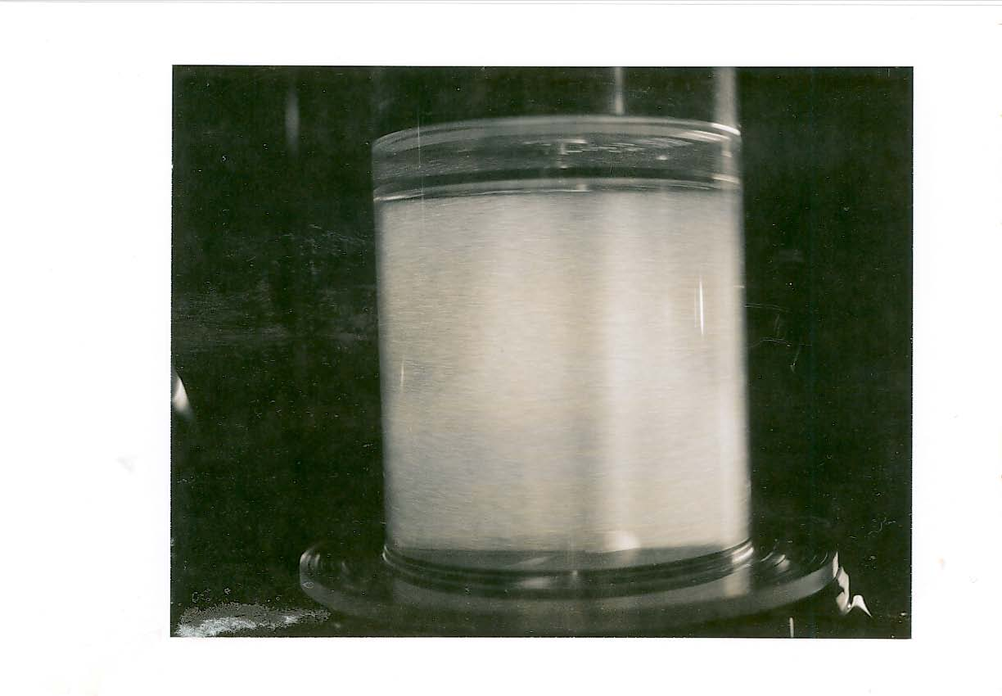
Figure 8.5.2 The Taylor Proudman column. Note the small white hemisphere on the bottom of the cylinder and the illuminated Taylor column extending upwards from the base to the upper surface of the cylinder.
This is surely one of the most dramatic examples of the special character of the dynamics of rotating fluids. In the atmosphere and oceans there are several effects that enter to vitiate the pure realization of Taylor columns. Nevertheless, the tendency towards the vertical coherence of the motion is prevalent in the both systems. The ability of mountains in the atmosphere to affect the wave patterns of atmospheric flows at very great altitudes above the mountains and the tendency for many oceanographic flows to follow the contours of oceanic bathymetry are all reflections of the same basic dynamics that leads, in the ideal state, to the remarkable columnar dynamics we see here.

