Chapter 14 Weakly nonlinear instability theory and chaos

14.1 Introduction:

We have examined several linear stability problems and have found normal mode solutions that grow exponentially when the basic flow is unstable. Obviously, such exponential growth cannot continue indefinitely. When the perturbation amplitude is no longer infinitesimal, the reservoir of energy, which seems infinite to the tiny perturbation, becomes depleted and the structure of the mean flow, which remains equal to the basic flow to order amplitude squared, will begin to noticeably change affecting the further evolution of the perturbation. That being the case we can ask whether those changes will eventually halt the growth of the wave and if so, at what amplitude level? And, if the amplitude does reach a saturation value what subsequently happens? Does the amplitude remain fixed at that value or is there further dynamical variations? These are difficult questions to answer in general and we will discuss in this chapter a very simple model in which the amplitude remains small but no longer infinitesimal. This allows us to construct a theory for the equilibration of the perturbation while still allowing us to use an expansion method to find explicit solutions. We will examine a very simple problem, namely, the two layer Phillips model without beta but in the presence of Ekman friction. In Chapter 10 we derived the stability condition.

For our purposes it turns out to be simpler to consider the parameter F as the critical parameter asking what value of F is necessary for instability for a given shear. Clearly, this yields,
(14.1.1)
as shown in Figure 14.1

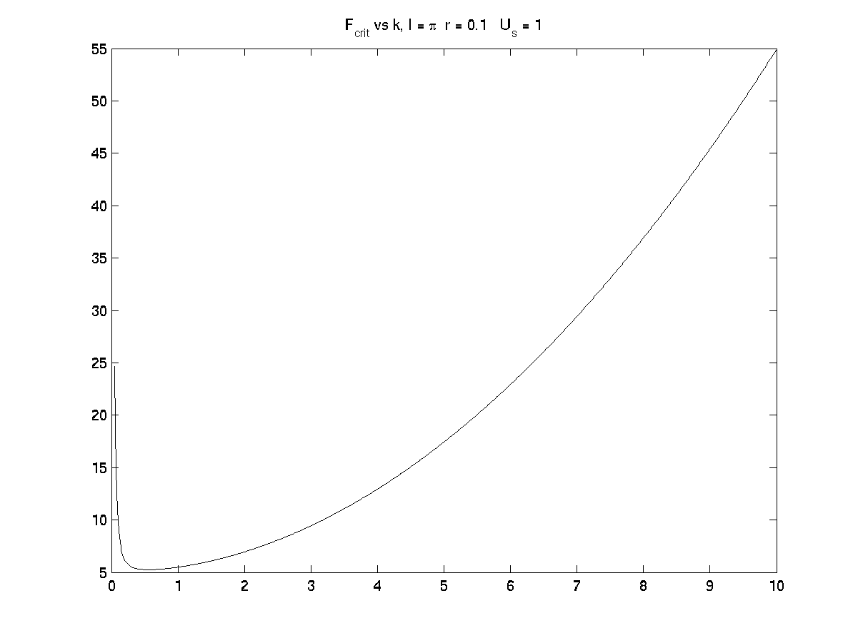
Δ
Figure 14.1 The curve of F_{crit} vs. k.

We now imagine that we are considering a value of F that is slightly greater than the critical value at that wavenumber k. So we write,
(14.1.2)
The nature of the nonlinear dynamics depends very much on the relative importance of frictional to inertial forces and we will be interested, as indicated in the figure, for wavenumbers on the inviscid branch of the curve where friction is not the defining stability condition so that the second term in (14.1.2) is small with respect to the first term. In particular, we will be interested in the limit where the second term in (14.1.2) is of the same order as the third term. This will ensure that the frictional time scale (essentially the spin-down time) is of the same order as the inviscid estimate of the inviscid e-folding time of the instability. If we assume that ordering, equation (10. 4.12) allows us to calculate the growth rate and find

(14.1.3)
Hence for small Δ and for r² =O(Δ) the growth rate will be of order Δ^{1/2}. This further implies that the time for growth will be long, much longer than the advective time L/U that we have used for the time scale for the quasi-geostrophic equations. We will exploit this fact by considering that all dependent variables are explicitly functions of two times: one is the advective time whose variable is t and variables, like the geostrophic streamfunctions will also be evolving on with the slow time variable T=Δ^{1/2} t. In particular this implies that all variables are functions of both time variables, i.e.

(14.1.4)

time derivatives in the original quasi-geostrophic equations will be replaced by,

(14.1.5)
We will also explicitly scale the amplitude of the geostrophic perturbation stream functions in (10.2.5), i.e we write

(14.1.6)
where ε measures the perturbation amplitude and we shall see that we will get a balance between the linear destabilization process and a nonlinear equilibration process by determining that ε =O( Δ^{1/2}).

14.2 The mathematical formulation

Let’s use a Galilean transformation and choose the basic flow to have equal and opposite velocities in the two layers. In that case, linear theory tells us that in the absence of a vertically averaged basic flow the real part of the frequency on the marginal curve will be zero. That allows us to search for solutions in which the fields are functions of only the slow time T. It is not difficult to handle cases in which both times explicitly are present but the algebra is a bit simpler if we choose the above configuration. Then
(14.2.1)

and the quasi-geostrophic equations for the perturbations are:
(14.2.2 a,b)
where

(14.2.3)

We now simply expand in the asymptotic series,

(14.2.4)

and use the fact that

(14.2.5)

At O(1) from (14.2.2) we obtain the equations for the lowest order perturbation stream function (recall that ). These yield the solutions when Δ=0, right on the marginal curve at infinitesimal amplitude, i.e.

(14.2.6 a,b)

From which it follows that for wave perturbations of the form

(14.2.7)
that
(14.2.8)
just as in the linear problem on the marginal curve.
Note that the amplitude of the perturbation is an, as yet, unknown function of the slow time T. Our goal is to develop evolution equations for the amplitudes on the slow time. What we accomplished by considering a separation of time scales is that we have been able to solve for the lowest order spatial structure independent of the development process on the long time scale and this will allow us to obtain an evolution equation for the perturbation that focuses on the development only in time. The next order problem is the problem at order . At this order we obtain the problem for , namely,

(14.2.9 a, b )

Since each of the lowest order solutions is a plane wave the Jacobian of each wave with its relative vorticity (Laplacian) is identically zero so that the nonlinear terms on the right hand side of (14.2.9 a , b) are identically zero.
If we put in the form of the order one solutions as given by (14.2.7) and search for solutions of the O(ε) perturbation fields as,

(14.2.10)
we find that, the two equations above are redundant and each give

(14.2.11)
The first term on the right hand side gives us a solution at O(ε) which reproduces the O(1) solution in its horizontal and vertical structure. We can normalize our solution and insist that all terms with that structure are contained already in the O(1) solution otherwise we are only redefining A. The second term however is very significant. It provides the solution with a phase shift between the two layers that is proportional to both the rate of increase of the wave amplitude and to the friction in the model. This may become clearer if we write out the solution we have obtained to this point.

(14.2.12)

The terms in A are precisely the vertical structure we would obtain from the linear two layer model in the vicinity of the marginal curve if we were to write . The above expression would give us vertical structure of the slightly unstable wave as affected by the exponential growth and the shear. If we were to assume exponential growth, of course, the game would be over for then we would be frozen into an exponential increase of the amplitude which is precisely what we are trying to avoid. The use of the slow time variable allows us to represent the phase shift due to growth (or decay) of the wave amplitude without specifying a priori the nature of the time behavior. We will solve for that as part of the nonlinear problem.
Notice that we have added to each perturbation an order amplitude squared () function that is only a function of y and the slow time T. Since the linear operators on the right hand involve x derivatives of the function we can always, at each order, add such functions as homogeneous solutions. We will shortly see that these corrections, which represent corrections to the zonal mean flow at O() are the first corrections that are required. We should have anticipated this on the basis of the iterative calculation we did for the Eady problem where we calculated the correction to the mean flow. The disadvantage of doing it in an iterative way in which the total linear solution is used, is that the correction as well as the perturbations themselves continue to grow exponentially.
So, at this stage we still need to find equations governing the evolution of the amplitude A of the lowest order solution and equations governing the change in the mean flow. As we shall see these equations are coupled. If we go back to our original equations, (14.2.2 a, b) we note that the increment of F above the critical value, i.e. terms of O(Δ or δ) have not yet entered the problem. That is, to this order, the physics doesn’t realize we are actually supercritical and that the linear perturbations would grow. We clearly need to include that physics and so we will push on to the next order in ε. At this third order problem the supercriticality will enter and it is at this order that the equations for the wave amplitude and the mean flow corrections will be determined.
It is first convenient to define the function,

(14.2.13)
If we now go to the third order problem for we obtain:

(14.2.14 a,b,c)
Carrying out the calculations indicated in the right hand side of the above equations is tedious and lengthy. The important point is that the Jacobian terms do not vanish. Indeed they yield two different types of forcing terms for the problem. One set of interactions, between the lowest order eigenfunctions and the potential vorticity of the next order correction that is wavelike, i.e. the terms coming from the function X₂⁽¹⁾ contribute to a forcing term on the right hand side of the above equations that is independent of x, i.e. a forcing term for a correction to the zonal mean flow, much as we calculated when we examined the nonlinear correction to the Eady problem. That forcing term, if left unbalanced, would produce a term in that would linearly grow in x according to (14.2.14). We need to balance it with the slow time derivative of the correction to the mean flow that is indicated in the first term on the right hand side. Doing so leads to the following equations for the mean flow correction:

(14.2.15)

This is just the x-averaged potential vorticity equation in which the correction to the potential vorticity is being forced by the potential vorticity flux in the developing wave. We found something similar in the Eady problem except that we did not include friction and we were already committed to a wave field that was growing exponentially in time. Now, the slow growth of the wave is still undetermined and might even be zero (in a steady wave state). Note, consistent with the general theorems of wave-mean flow interaction, the potential vorticity flux of the waves vanishes if there were no friction acting on the wave or if the wave amplitudes themselves were steady. It also follows from the form of (14.2.15) that the correction to the mean flow will be purely baroclinic.
The equation above is a partial differential equation and it requires boundary conditions on y =0 and y=1. We noted before that in the inviscid problem the proper boundary condition for the correction to the mean flow was . It is not difficult to show that this still holds true when Ekman friction is added and we will use that in the solution o f(14.2.15). Now we need to obtain and equation governing the amplitude A.
There are a group of terms on the right hand side that will either have the form, or project on the form of the O(1) eigenfunctions. We can find those terms by multiplying the right hand side of (14.2.14) by and integrating from y =0 to y=1. We are then left with two algebraic equations for the amplitudes of the O(ε³) eigenfunctions. Those equations will have as their left hand sides a matrix times the wave amplitudes of the O(ε³) terms. The determinant of the coefficients of that matrix will be zero and the condition that the forcing terms on the right hand side that project on the matrix will vanish yields an equation for A. This is nothing more than the usual removal of secular terms in an asymptotic expansion. The details are lengthy and you can find a discussion in Chapter 7 of GFD or in Pedlosky and Frenzen (1980, J. Atmos. Sci. 37, 1177-1196). The final equation for A becomes;

(14.2.16 a, b, c)

so that the equation for the mean field correction becomes simply,

(14.2.17 a)

It should be clear from (14.2.16a) that nonlinearity will be of the same order as the linear destabilization term (the third term on the left hand side of the equation) if. Indeed, by choosing ε wisely and slightly rescaling the slow time we could eliminate nearly all parameters in the above equations except γ and a². The rescaling for the time involves writing and choosing σ_{O} to make the inviscid growth rate unity so that in (14.2.17a) and (14.2.17b) (below) so it is truly the ratio of the growth time for the inviscid disturbance to the spin-down time.
The details of that exercise will be left to the student. Before doing so however it is important to note that the first three terms on the left hand side of (14. 2. 16 a) alone would reproduce the equation for the growth rate seen in (14.1.3). We shall concentrate on the qualitative aspects of the resulting dynamics and so carrying out the rescaling indicated above we end up with, after a integration by parts in the last term in (14.2.16 a) with

(14.2.17b)
so that we have rescaled the slow time so that the growth rate for the inviscid problem is exactly one if γ is zero. The nonlinear system we have to deal with is then the coupled system (14. 2. 17 a, b) in which the growing wave interacts with the mean flow correction. It is that interaction that will affect the growth of the wave and it is that interaction that will allow the growth to halt. Note also that the correction to the mean flow is going to be of order of the square of the wave amplitude so for small amplitudes linear theory will be valid, as we have assumed in the course to this point. When the amplitude becomes large the mean flow changes and that change enters the equation for the wave amplitude modifying the linear dynamics. Let’s see how that works.

14.3 The viscous equilibration

When γ is large, the second term in (14.2.17 b) will dominate the first term and we are tempted to drop the first term. We recognize that this will be a singular perturbation that will not allow us to satisfy initial conditions on both A and dA/dT. However, we can deal with that in the usual way by defining new time variables to deal with the short time interval near T=0. We will skip that subtle part of the problem and concentrate on the ultimate fate of the growing disturbance. From (14.2.17 a) the dominant balance for the mean flow correction is:

(14.3.1 a)
so there is a instantaneous relation between the wave amplitude and the mean flow correction. Inserting this into:

(14.3.1b)

yields the first order evolution equation for A,

(14.3.2)
Without loss of generality we have assumed A is real. (Check the case of complex A). Note that the steady solution o f(14.3.2) is simply A=±1. It is not difficult to find the full solution of (14.3.2) and it is:

(14.3.3)
Here A _{o} is the initial value of the amplitude. For small T this gives exponential growth with the linear growth rate (in this limit of large γ). But for large T the amplitude asymptotes to plus or minus one as shown in the figure and is independent of the initial condition. The dissipation has eliminated the memory of the initial data.

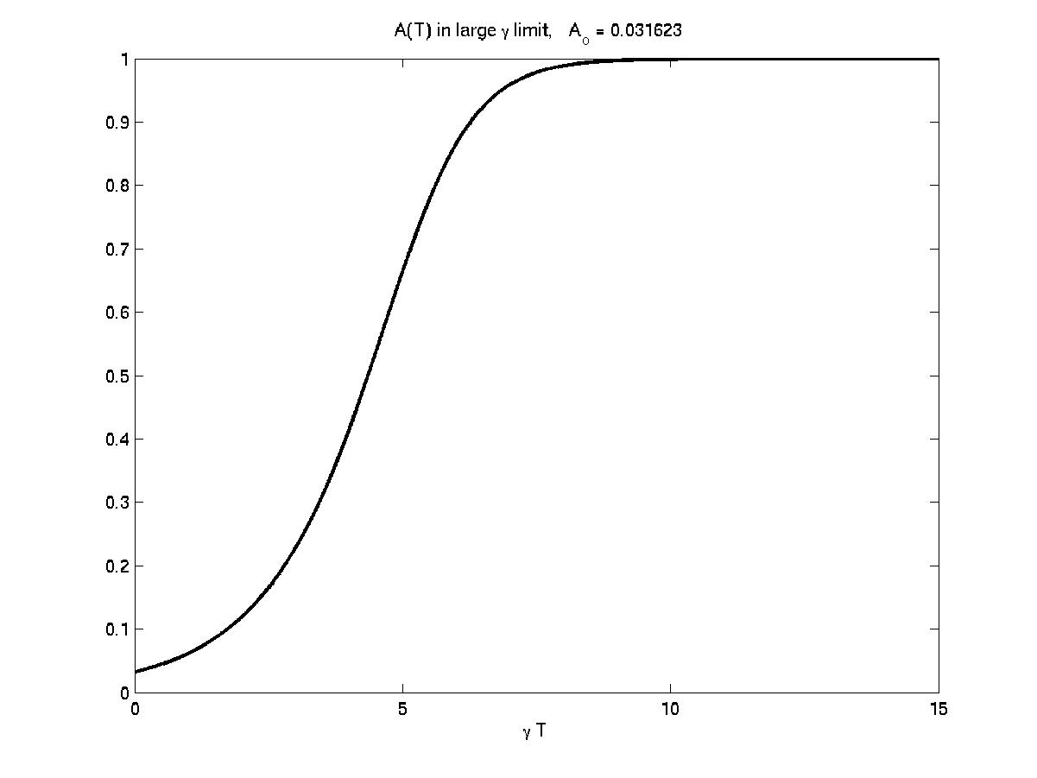
Figure 13..1 The time history of the amplitude for the large γ case.
The solution starts with an exponential growth but then equilibrates at a steady amplitude. At that amplitude the energy extracted from the basic flow just balances the energy dissipated by friction just as in the marginal stability case for the linear problem. The same holds true here for the supercritical flow but the nonlinearity has halted the growth at a completely steady value in which the energy balance occurs. There is no oscillation of the wave amplitude.

14.4 The inviscid limit

Now let’s consider the other extreme limit in which friction is so small that we can let γ go to zero. In that limit the equation for the mean flow correction is:

(14.4.1)

and this can be integrated in time immediately to yield,

(14.4.2)
where again A_{O} is the initial value of the amplitude. Note that again there is an instantaneous relation between the wave amplitude and the mean flow correction but that now the initial value of the wave amplitude remains an important parameter of the problem. In addition, the solution of (14.4.2) in y will yield a form that is exactly the same as the structure we obtained in examining the nonlinear correction to the mean flow in the Eady problem (compare with (7.2.3, 7.2.4) except for the crucially important difference that where in the iterative solution we had A already exponentially growing in time. Now we have been able to find the relation between Φ and A without specifying the time behavior. The solution of (14.4.2) is,

(14.4.3)
so that the correction to the mean vertical shear has the same profile in y as in the Eady case. The amplitude equation for γ =0 can then be rewritten in terms of A alone using (14.4.3) in
to obtain,

(14.4.4 a, b)

Where
Note that the amplitude equation is now reversible in time, it is unchanged by the transformation T-→ -T.
It is easy to see the qualitative nature of the solutions from the form of the equation. It is the equation for a funny kind of mass spring oscillator. For small amplitude displacements the “spring constant” is –1 so the “spring” rather than being a restoring force accelerates the mass away from the origin (this is the linear instability). For large amplitude the nonlinear spring becomes restoring and the mass will be brought back to the origin. It is easy to develop this analogy quantitatively by multiplying (14.4.4) by A. In the case when A is real the resulting equation can be put in the form:
(14.4.5)
where E is a constant of the motion depending on the initial conditions. Figure 14.4.1 shows the potential and the energy level for the case where at time T=0 dA/dT =kc_{i} A.

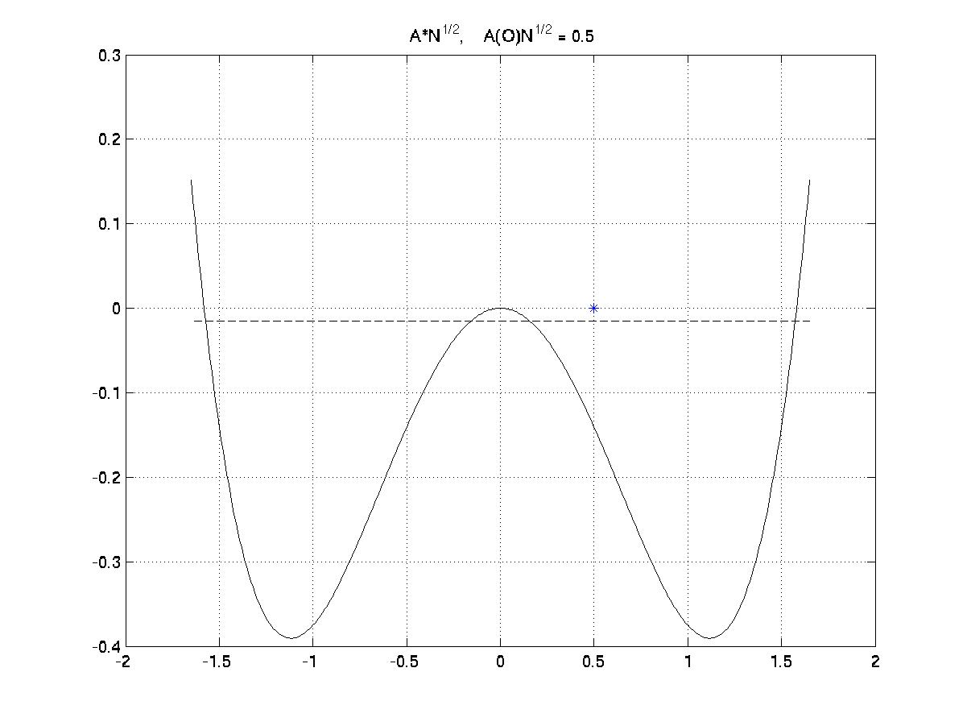
Figure 14.4.1 The “potential well” for the inviscid problem,

The solution will perpetually oscillate back and forth between the limits defined by the “energy”, E which is determined by initial conditions. There is a maximum amplitude of the order of but in analogy with the oscillator the solution does not asymptote to that limit. Rather it oscillates back and forth between those limits. Figure 14.4.2a shows an example. In the case shown we have given the initial rate of change of the amplitude equal to the linear growth rate times the amplitude only the unstable mode is initially excited. We see that the amplitude oscillates back and forth, without changing sign since it is capture in the “negative” energy part of the potential well.

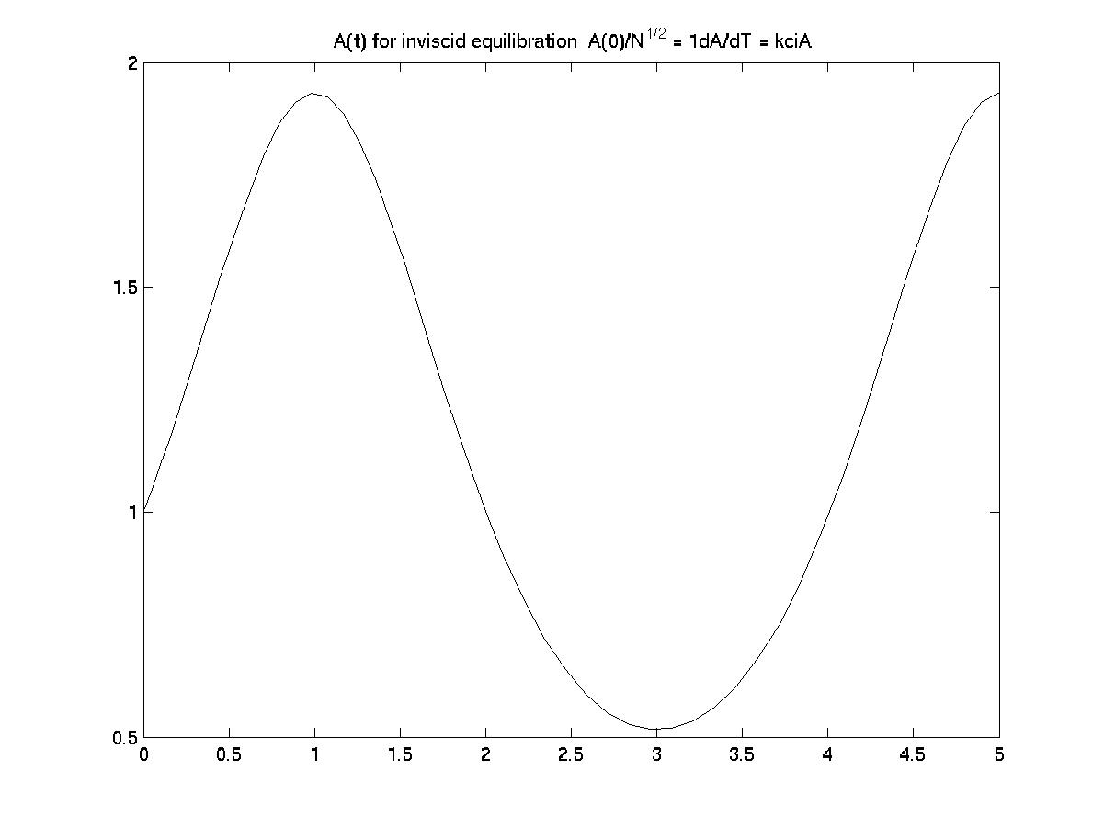

Figure 14.4.2 aThe amplitude vs. time for γ =0. The oscillation is perpetual and depends on the initial data.

We can also examine the oscillation in the phase plane of dA/dT vs. A and that is shown in Figure 14.4.2b.

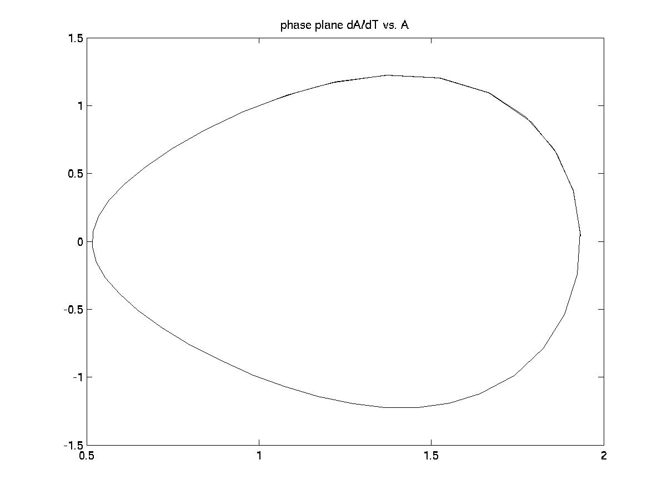
Figure 14.4.2b The inviscid “negative energy” oscillation viewed in the phase plane (A, dA/dT).
If instead we make the initial value of dA/dT larger, the “energy’ will be positive and the solution will pass through zero as shown in the Figure 14.4.3a, b .

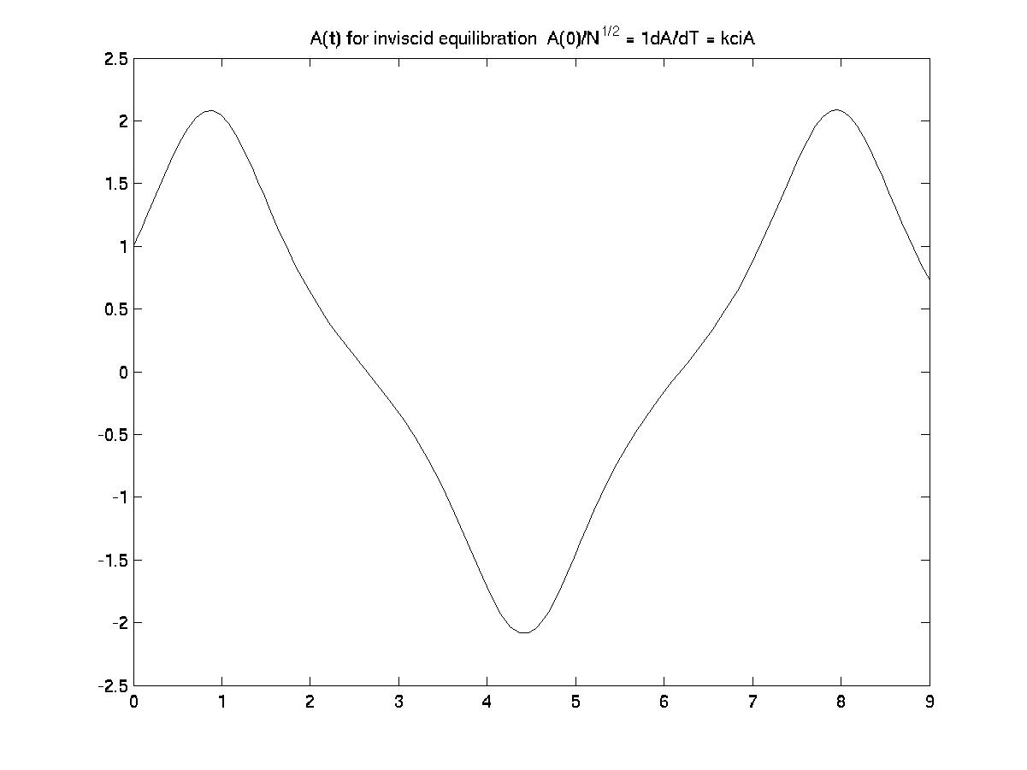
Figure 14.4.3 a The oscillation of the amplitude when the initial value of dA/dT is large enough to render the energy positive.
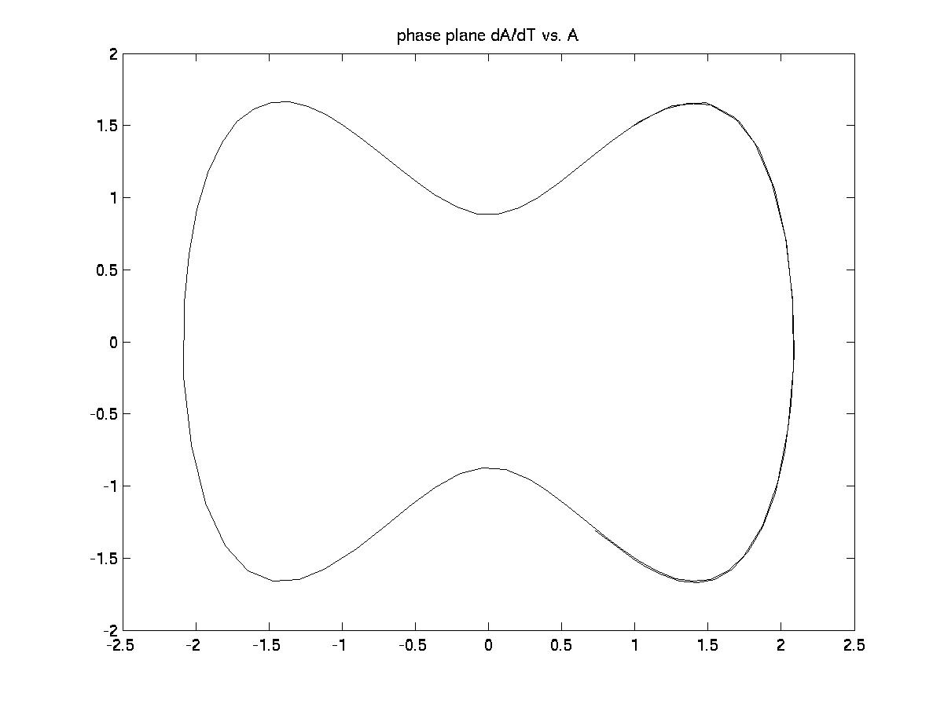
Figure 14.4.3 b The phase plane for the oscillation in Figure 14.4.3 a

The amplitude oscillation in Figure 14.4.3 has a large enough energy to pass through the zero point. In each of these cases the long term behavior of the finite amplitude solution depends on the initial amplitude and the initial rate of change of the amplitude. The latter, as we see from (14.2.12) is equivalent to specifying the initial vertical phase of the wave. We might expect that this dependence on initial data would be expunged if we considered even a small amount of friction for then, with time, the system’s memory would be dissipated. So, let’s return to our initial system (14.2.17 a , b) and restore γ different from zero but not large enough to dominate the amplitude development.

14.5 The appearance of chaos

Now let us consider the full equation (14.2.17 a, b). If γ is neither zero nor very large we can not integrate the equation for the mean field correction directly so that our system remains third order in time. In the large friction limit and in the zero friction limit the system is either first order (large friction) or second order (zero friction). In either case fundamental theorems from differential equations (e.g. Poincare`-Bendixon) the solutions must either eventually converge to a steady state or a limit cycle, a periodic solution whose portrait in the phase plane is like figures 14.4.3b or 14.4.4b. What the appearance of moderate friction does is to maintain the third order nature of the problem.
To solve (14.2.17 a) we expand in a sine series for the derivative of Φ , i.e.

(14.5.1)
since this automatically satisfies the boundary conditions on y =0 and 1. It turns out to be necessary to include only the odd integers in (14.5.1) because of the symmetry around the mid-point of the channel. It also turns out to be convenient to write

(14.5.2 a,b)

which leads to the following set of ordinary differential equations;

(14.5.3 a,b,c)
In the above equations J_{max} ( around 30) is the upper limit used in the calculation.
You should check the following important points.
- If the series for U_{j} is truncated after the first term then the set (14.5.3 a,b,c) becomes equivalent to the Lorenz equations ( Pedlosky and Frenzen. 1980, J.Atmos. Sci. 37,1177-1196)
- If the series is truncated after a single term it is also equivalent to the model problem we studied in the first lectures of this course.
In the above cited J.A.S. article a series of calculations were done for selected values of a/π and γ. Here we will briefly review the behavior found.
For very small γ the solution obtained resembled one of the periodic inviscid solutions. However, the solution ends in a limit cycle, an oscillation independent of initial conditions. Instead of initial data the “energy” is selected by an integral over one period of the solution of (14.2.17 a, b). In the limit of small friction the solution is independent of the friction but exists only because γ is not zero. An analytic representation of the limit cycles can be found in (Pedlosky 1972, J.Atmos. Sci. , 29, 53-63). The phase plane for the solution is shown in Figure 14.5.1 for γ =0.12 and a/π = (2)^{1/2} (i.e. for k=l).

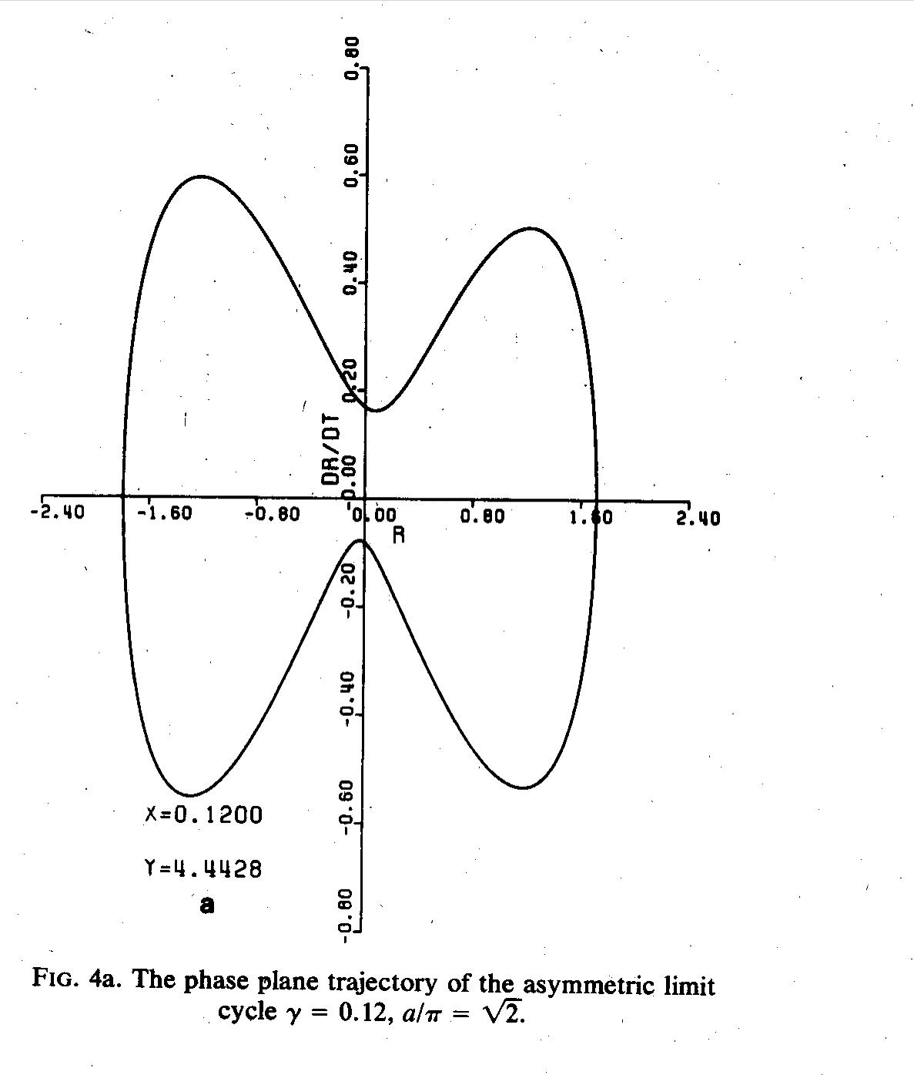
Figure 14.5.1 a The phase plane of the nearly inviscid limit cycle
The oscillation itself is shown below

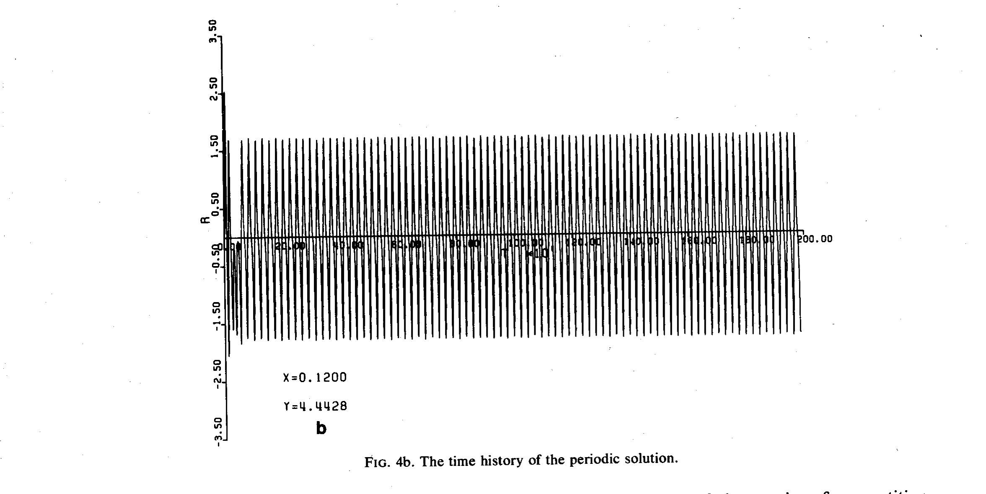
Figure 14.5.2b The amplitude as a function of time for the inviscid limit cycle.

As γ is slightly increased the form of the oscillation barely changes until γ reaches a critical value 0.1295. Now the oscillation must go through two periods before its amplitude repeats, or more accurately, the period of the oscillation has suddenly doubled. This can be seen most clearly in the phase plane portrait.

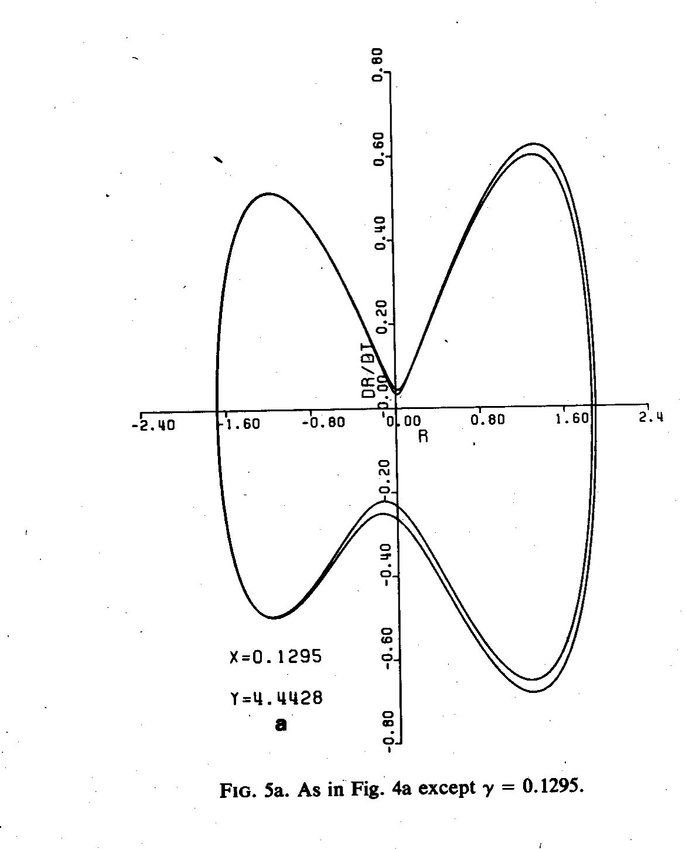
Figure 14.5.3 The double period limit cycle

The oscillation has a slightly different value of the maximum amplitude on each of the two swings around the limit cycle varying between slightly larger and smaller values of the maximum amplitude. This cycle is maintained until we reach γ = 0.1305 where a second period doubling occurs (this is really hard to see but is obvious examining the numerical output in detail).

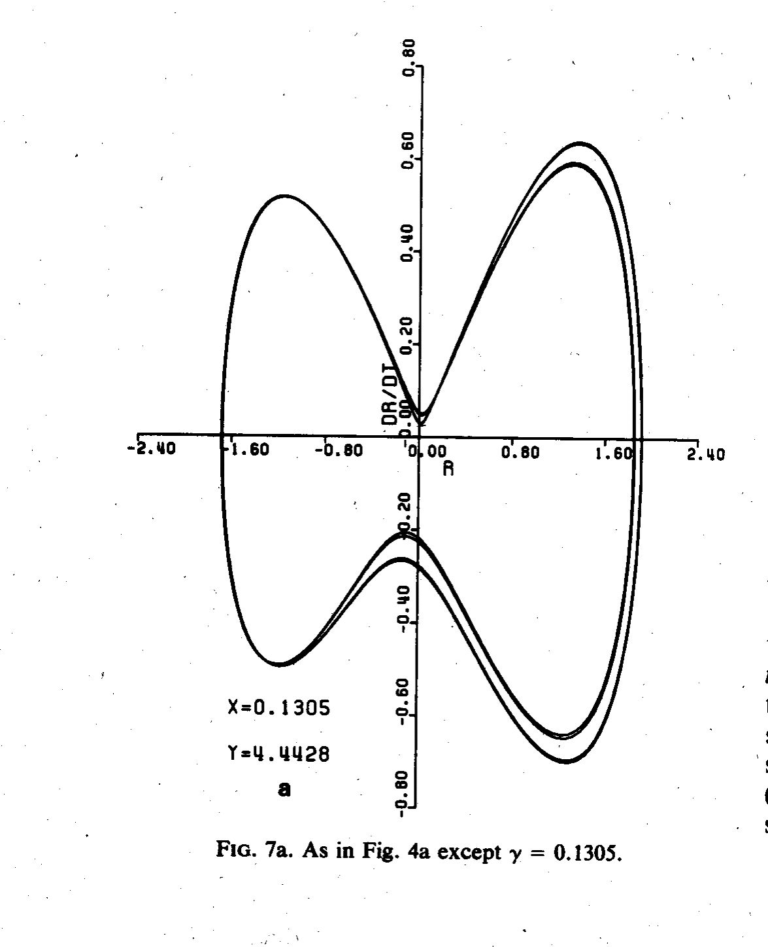
Figure 14.5.4 The quadruple period limit cycle.

There is a beautiful theory developed by J.J. Feigenbaum (J. Statistical Physics 1978, 19, 25-52) for the period doubling sequence for the logistic, or population map
(14.5.1)

that serves as a simple model for population variation from the k^{th} to the k+1st generation. Studies of that simple system reveal oscillations of the population and the number of generations required to return to the same population level vary with the parameter a in (14.5.1). It is an interesting system to play with and you may enjoy seeing the remarkable behavior as a is increased from 2 to 4. Feigenbaum predicted that the intervals between values of the control parameter required for period doubling would shrink for the higher doublings according to a universal relation:

(14.5.2)
In principle (14.5.2) is supposed to hold asymptotically, for large j. However if we think of it as a difference equation for _{j} we can solve to obtain,
(14.5.3)
so that these threshold values reach a limit point as n-→ ∞

(14.5.4)

If we use ₁ = 0.12295 and ₂ =1.305, we obtain the limiting value for of 1.307725. Assuming that is true, what happens for slightly larger ? At = 0.133 we obtain the amplitude evolution shown below.

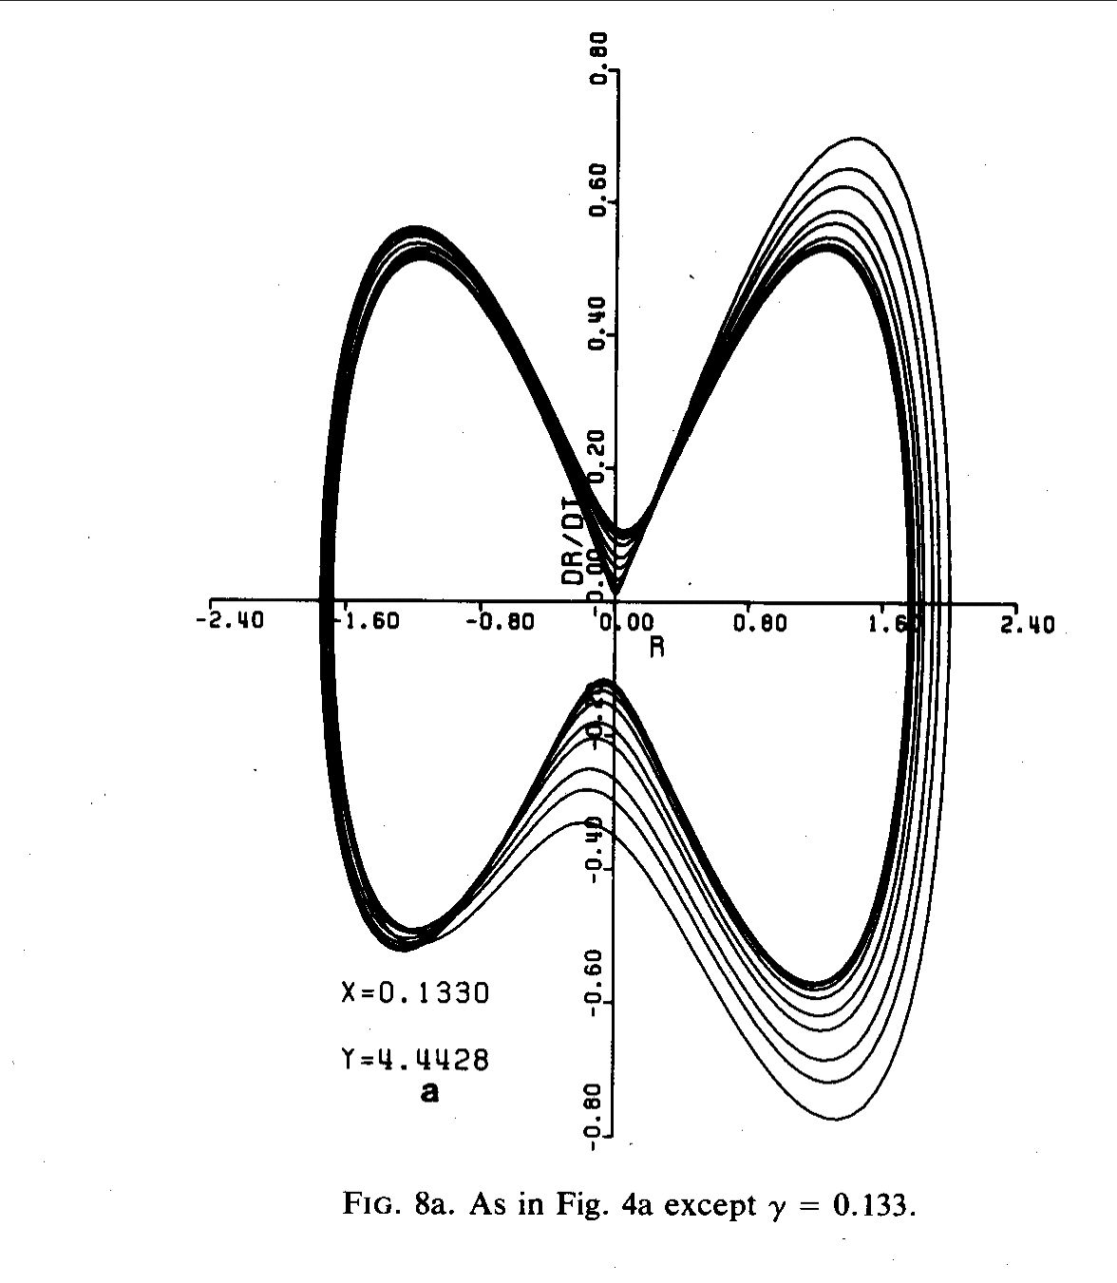

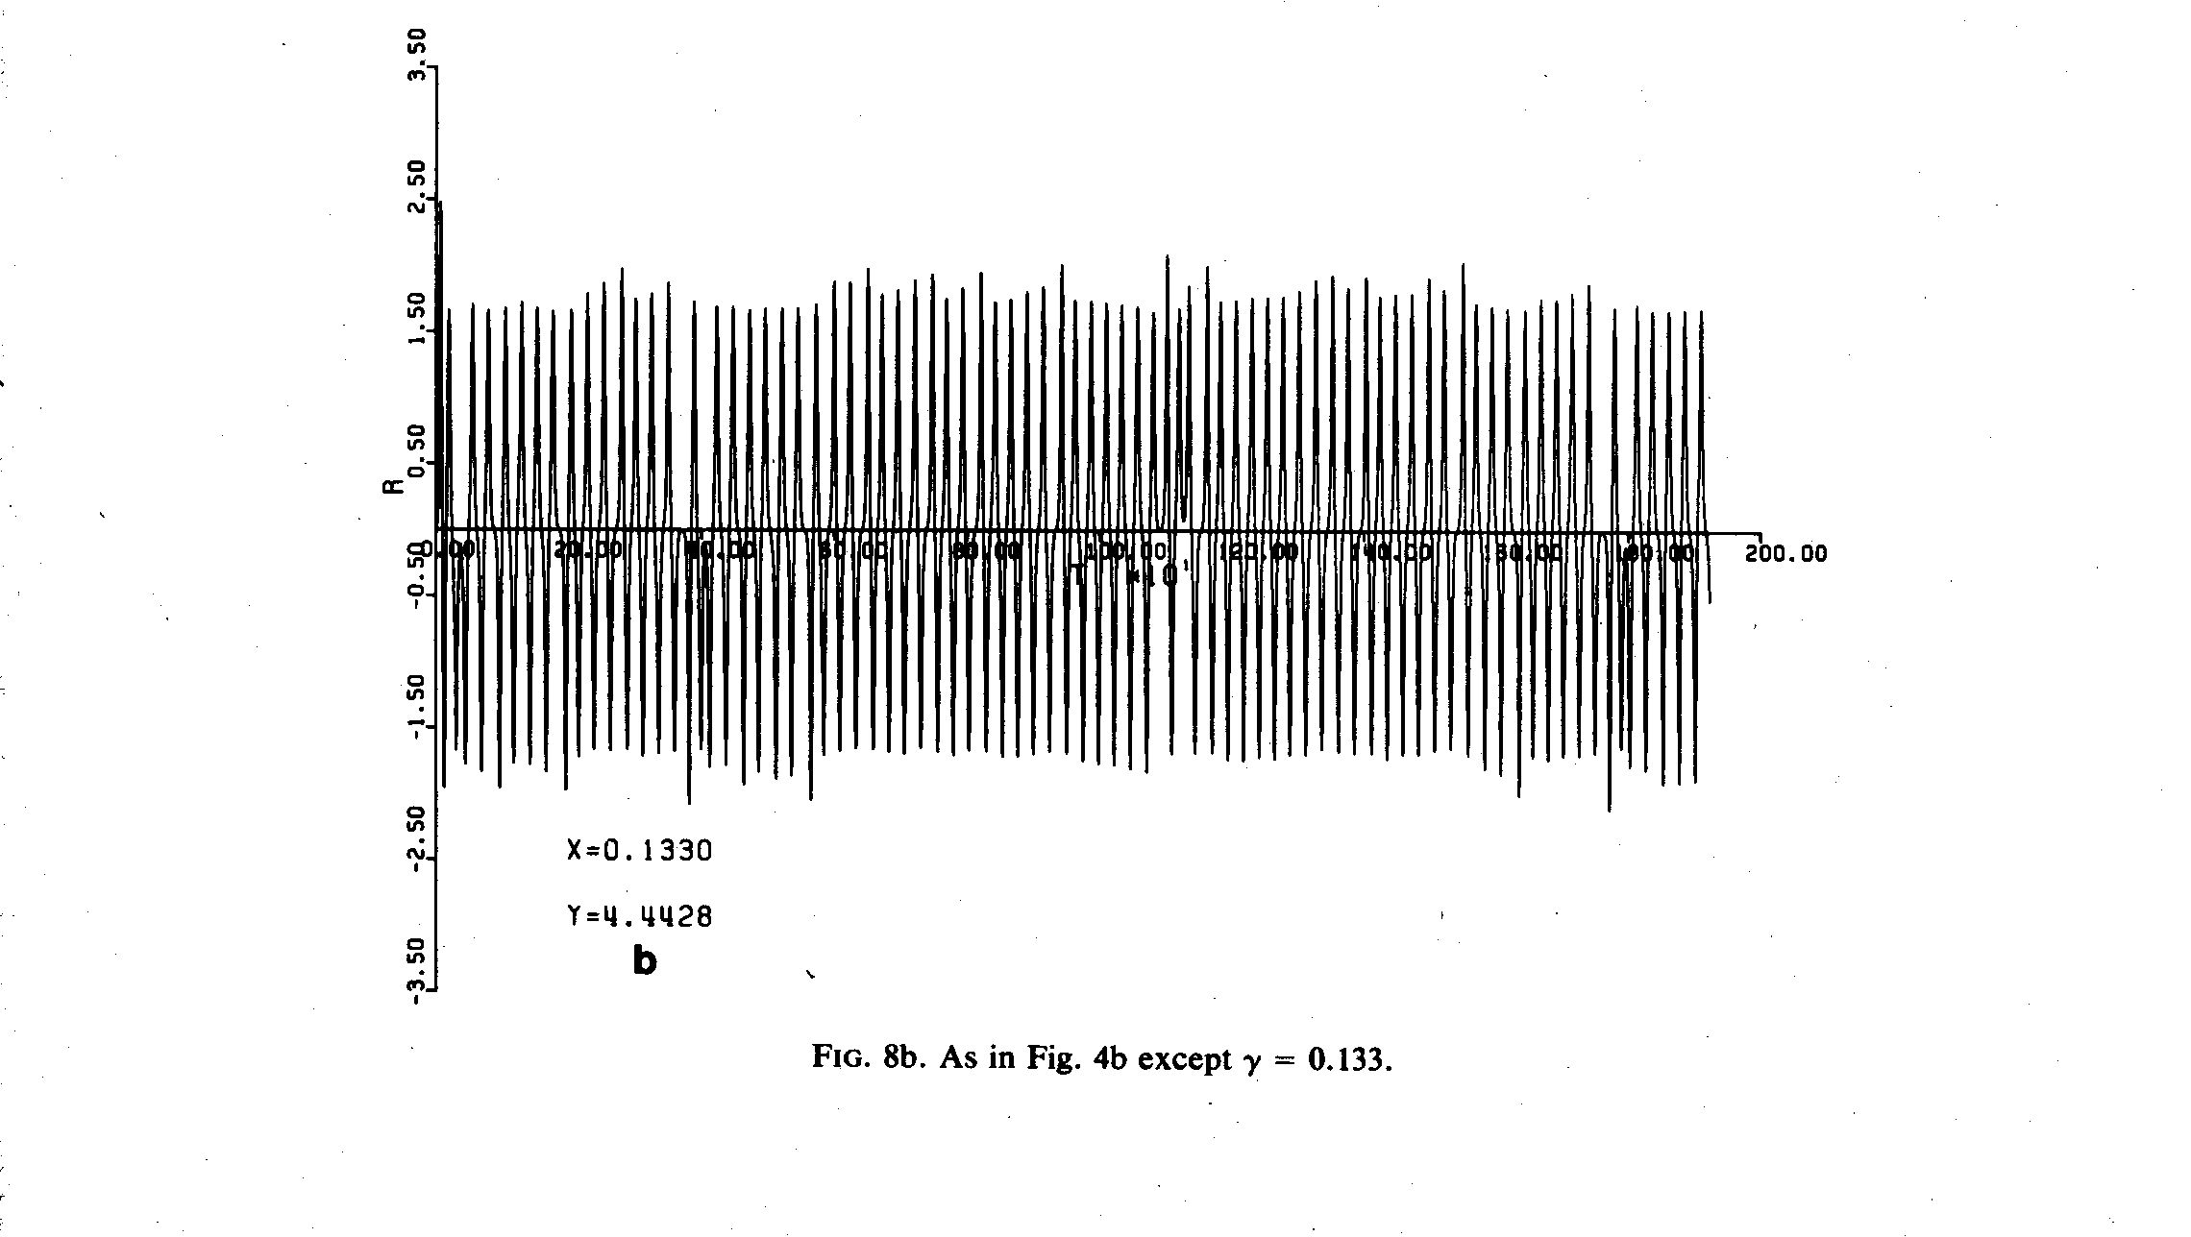
Figure 14.5. 4 a, b The phase plane and the time history of the amplitude for =0.133

The motion observed is aperiodic, i.e. it never exactly repeats and in the common definition it is chaotic. That is, it is not possible to predict with accuracy the amplitude at a much larger time unless your initial values of A and dA/dT and the method of calculation are perfectly without error. Any departure from the true state will amplify with time.
At larger the solution becomes even more chaotic, as shown below for the case where=0.17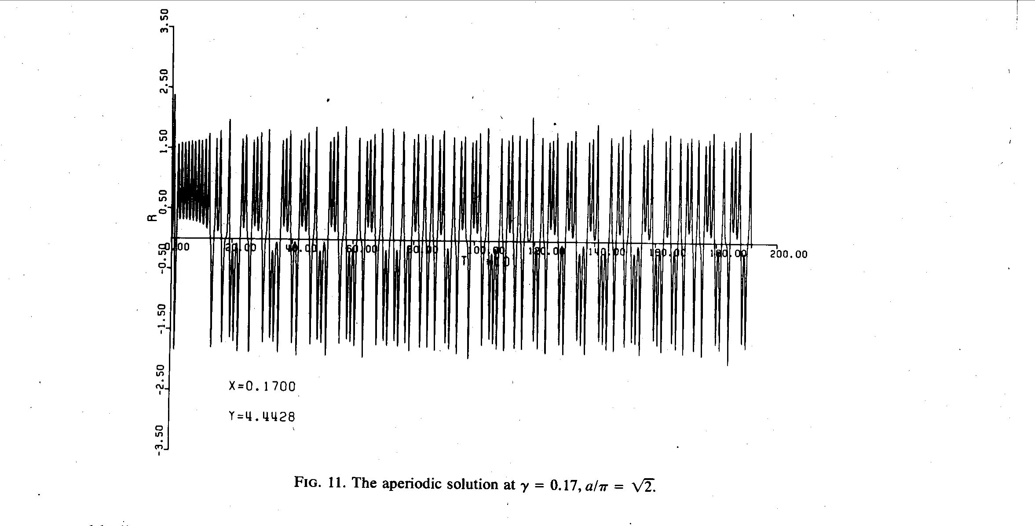
Figure 14.5.5 The aperiodic solution at =0.17
For larger the solution appears chaotic for a lengthy period of time but eventually equilibrates at one of the steady solutions of (14.2.17 a, b). Note that the steady solutions are identical to the solutions obtained at large ,

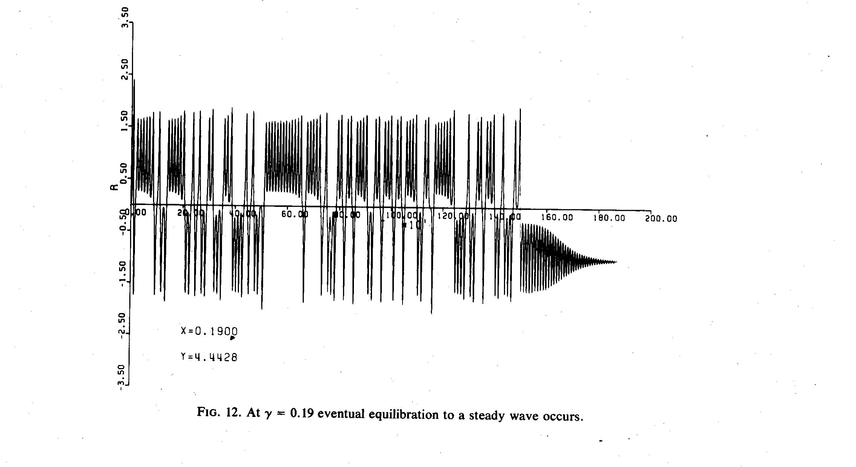
Figure 14.5. 6 A temporarily aperiodic solution converging to a steady solution at =0.19
At other values of a similar behavior occurs, e.g. at 0.21 but at a/π =6^{1/2} the solution is strongly aperiodic.

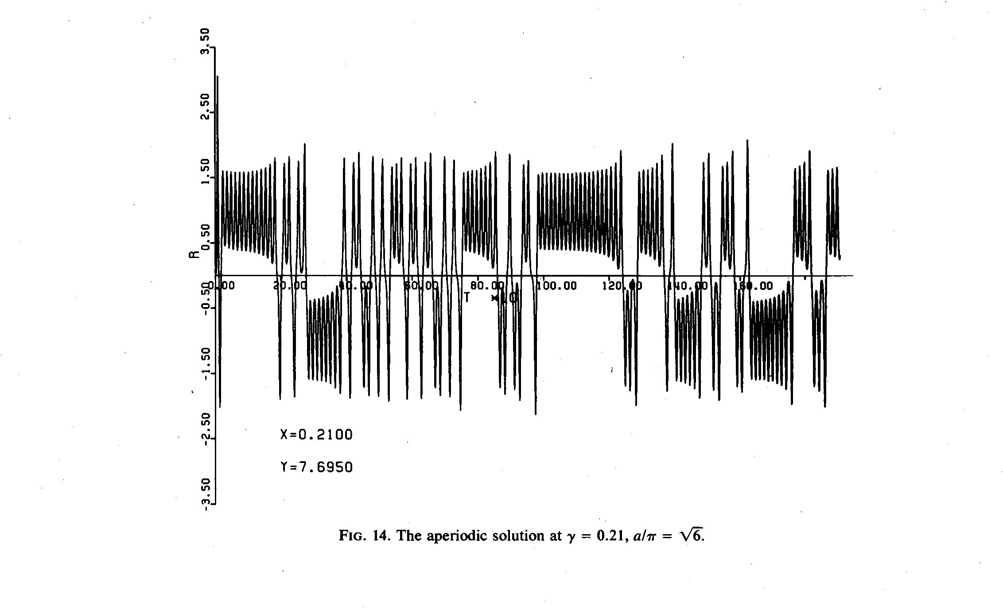
Figure 14.5.7 The chaotic solution at =0.21, a/π =6^{1/2}.

For even larger values of we return to the rapid equilibration without oscillation as we found in Section 14.3. A rough regime diagram showing the behavior of the numerically calculated behavior is shown below

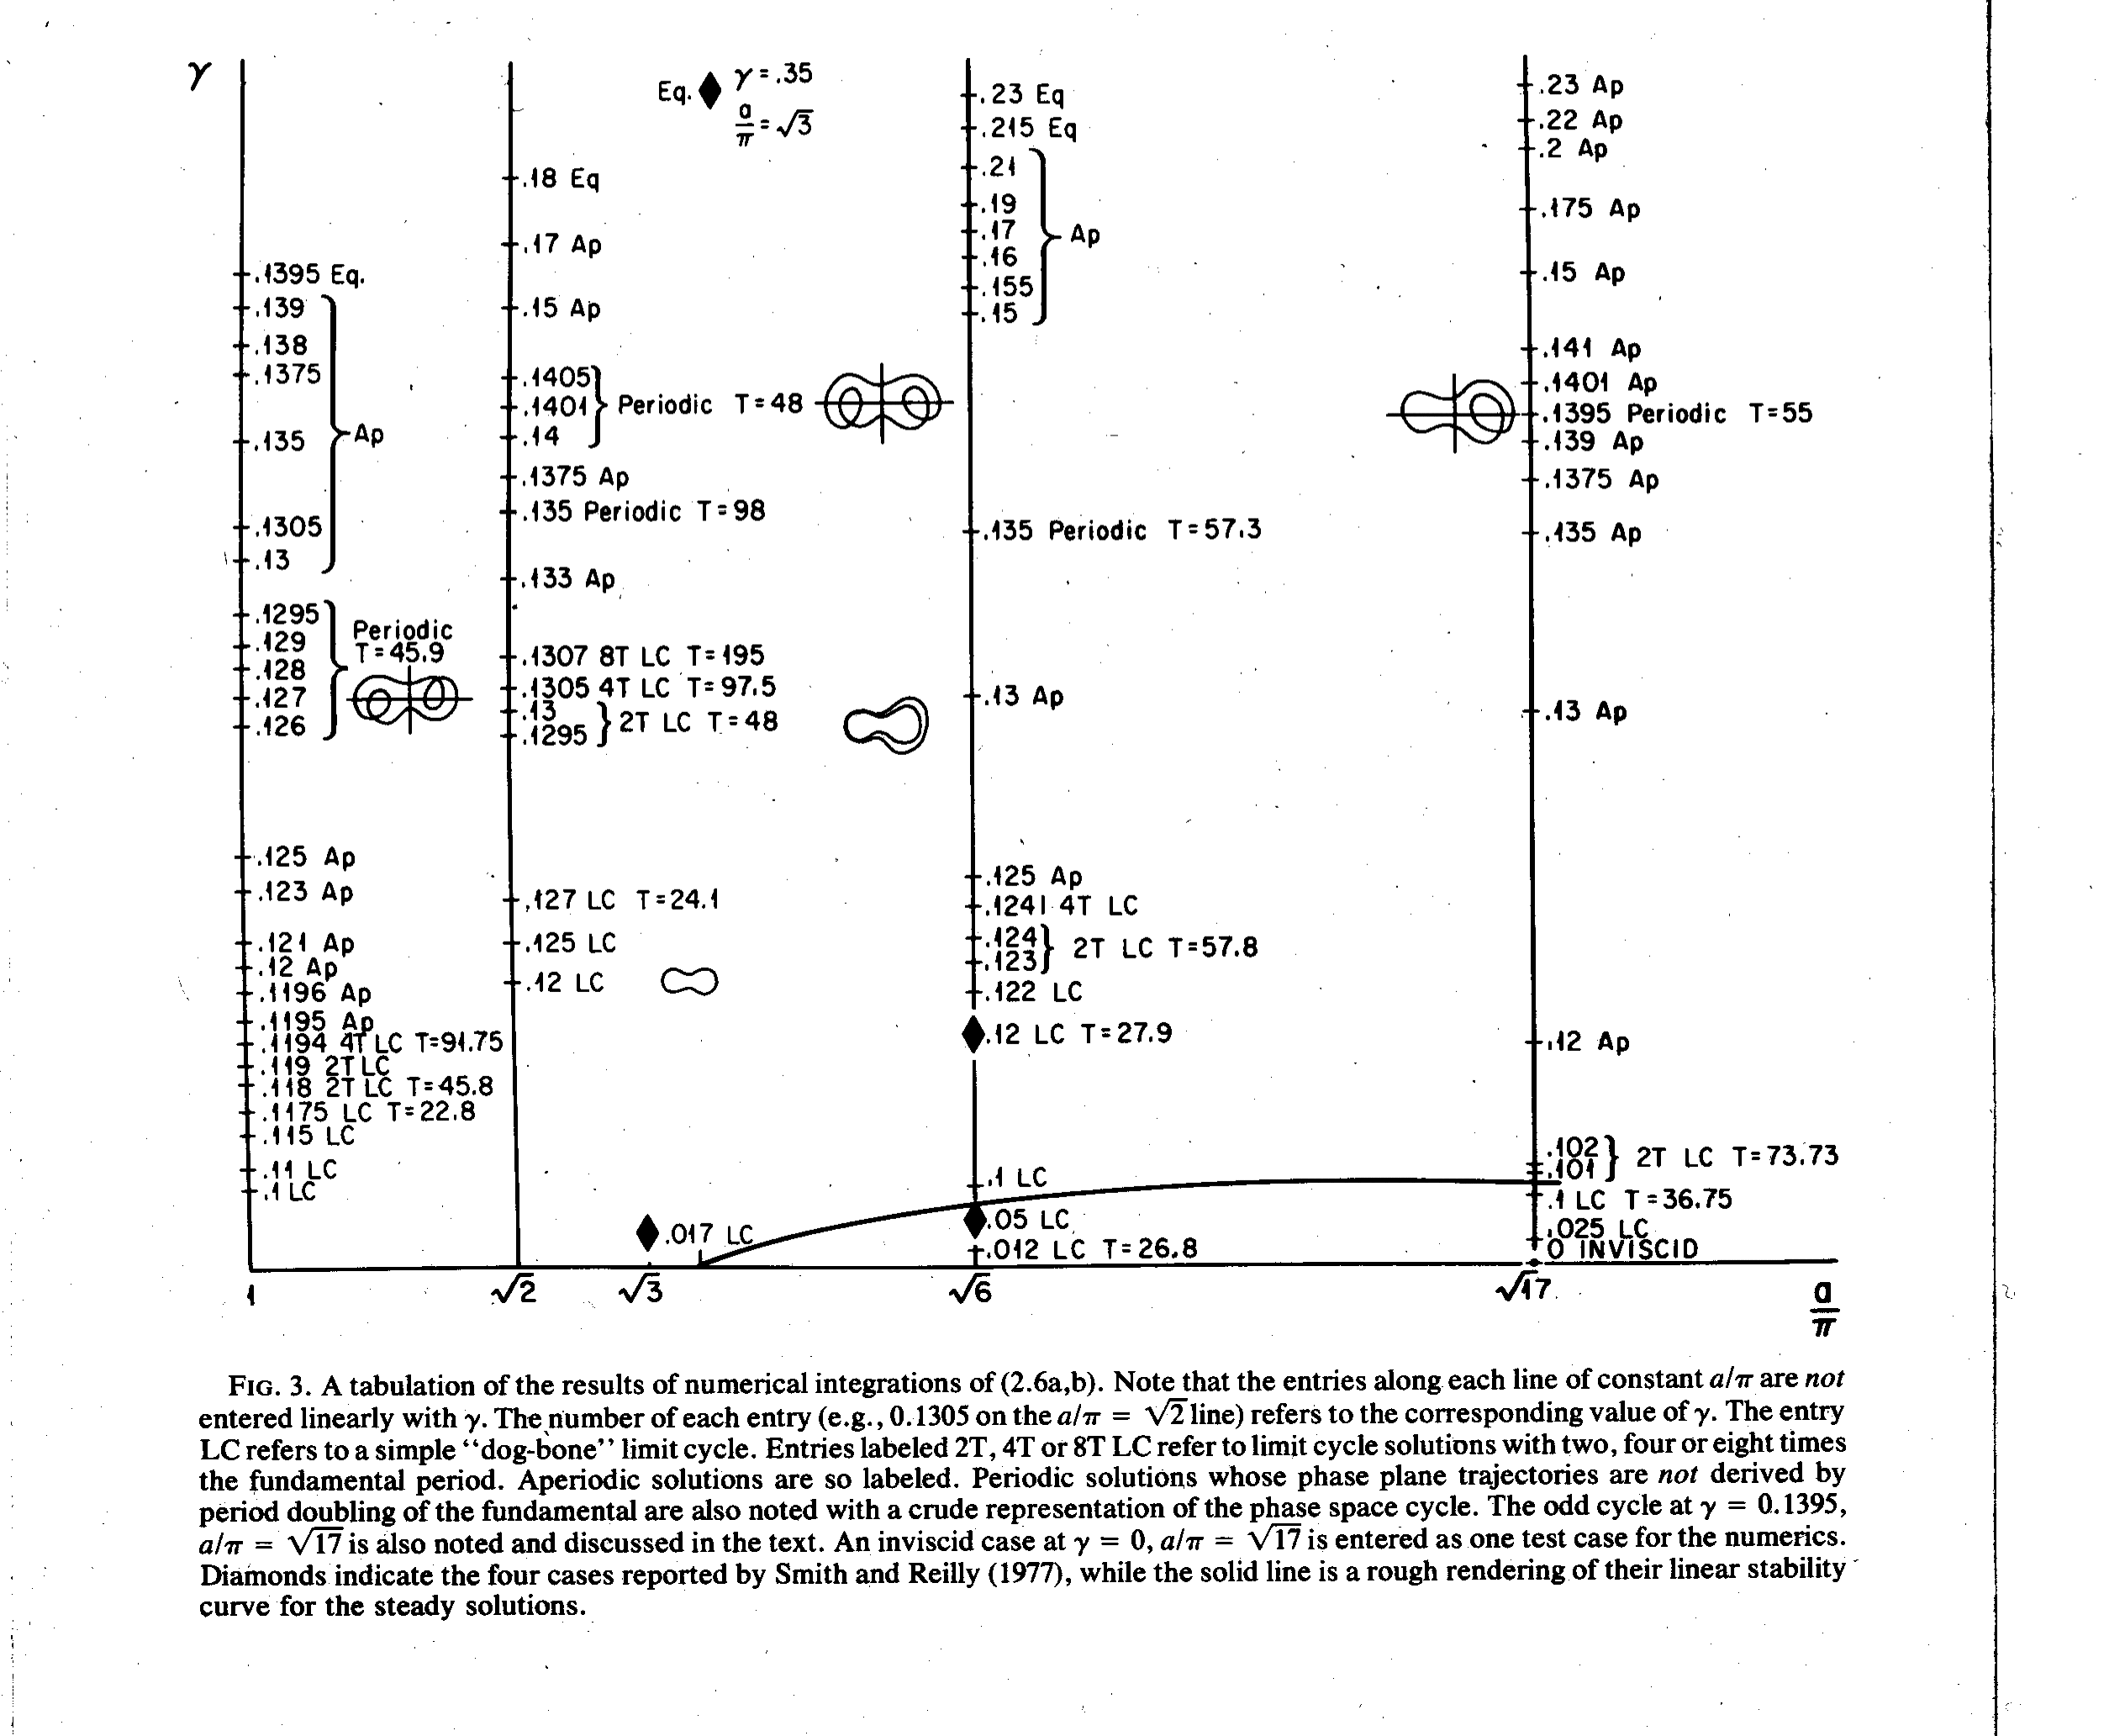
Mixed in with the aperiodic solutions there are “islands” in the interval with elegant periodic solutions of character that are different than those obtained by direct period doubling of the basic low- oscillation. An example is shown below at =0.14 and a/π=2^{1/2}.

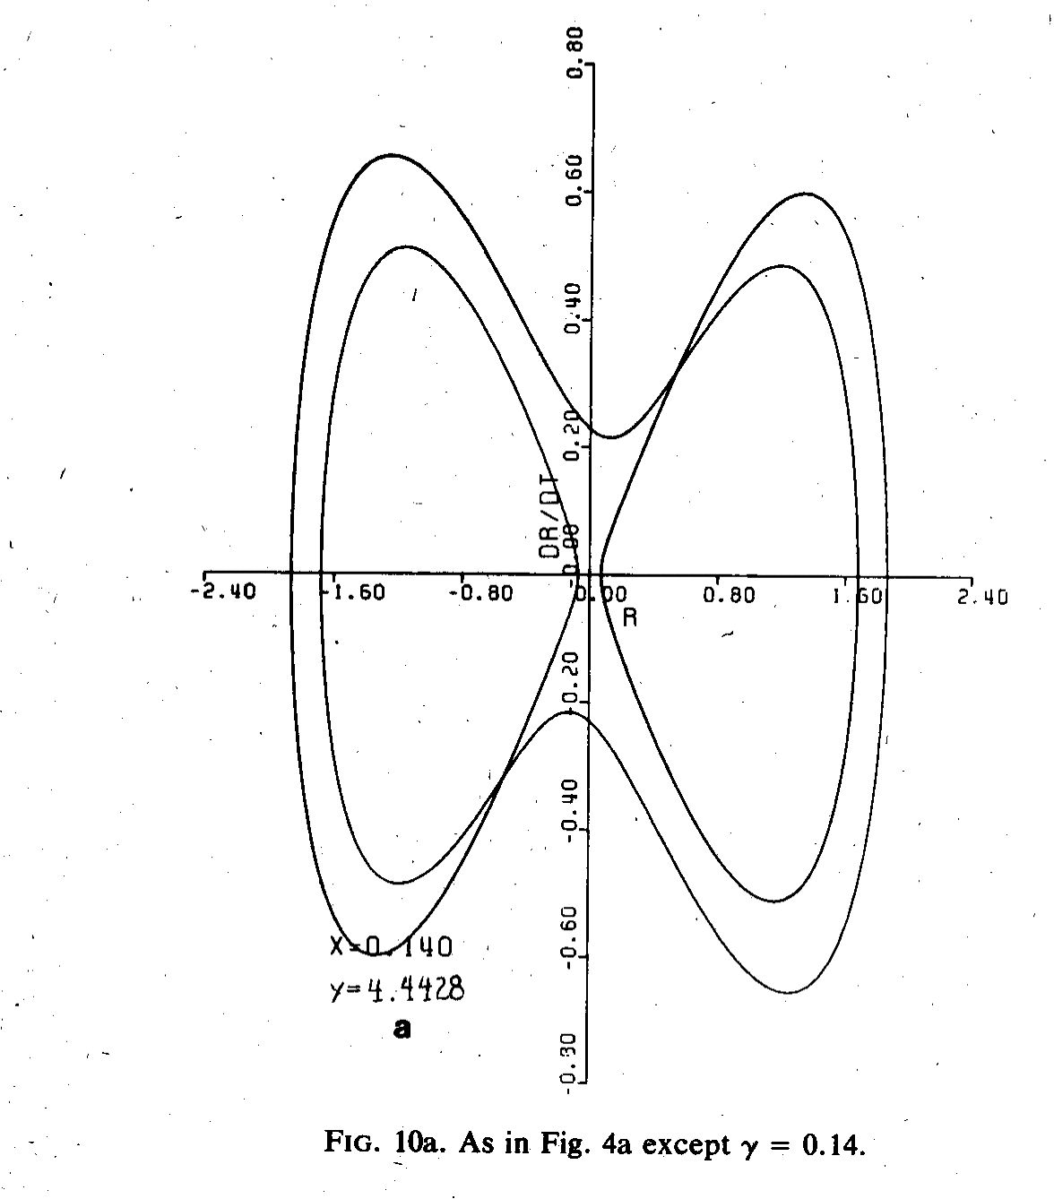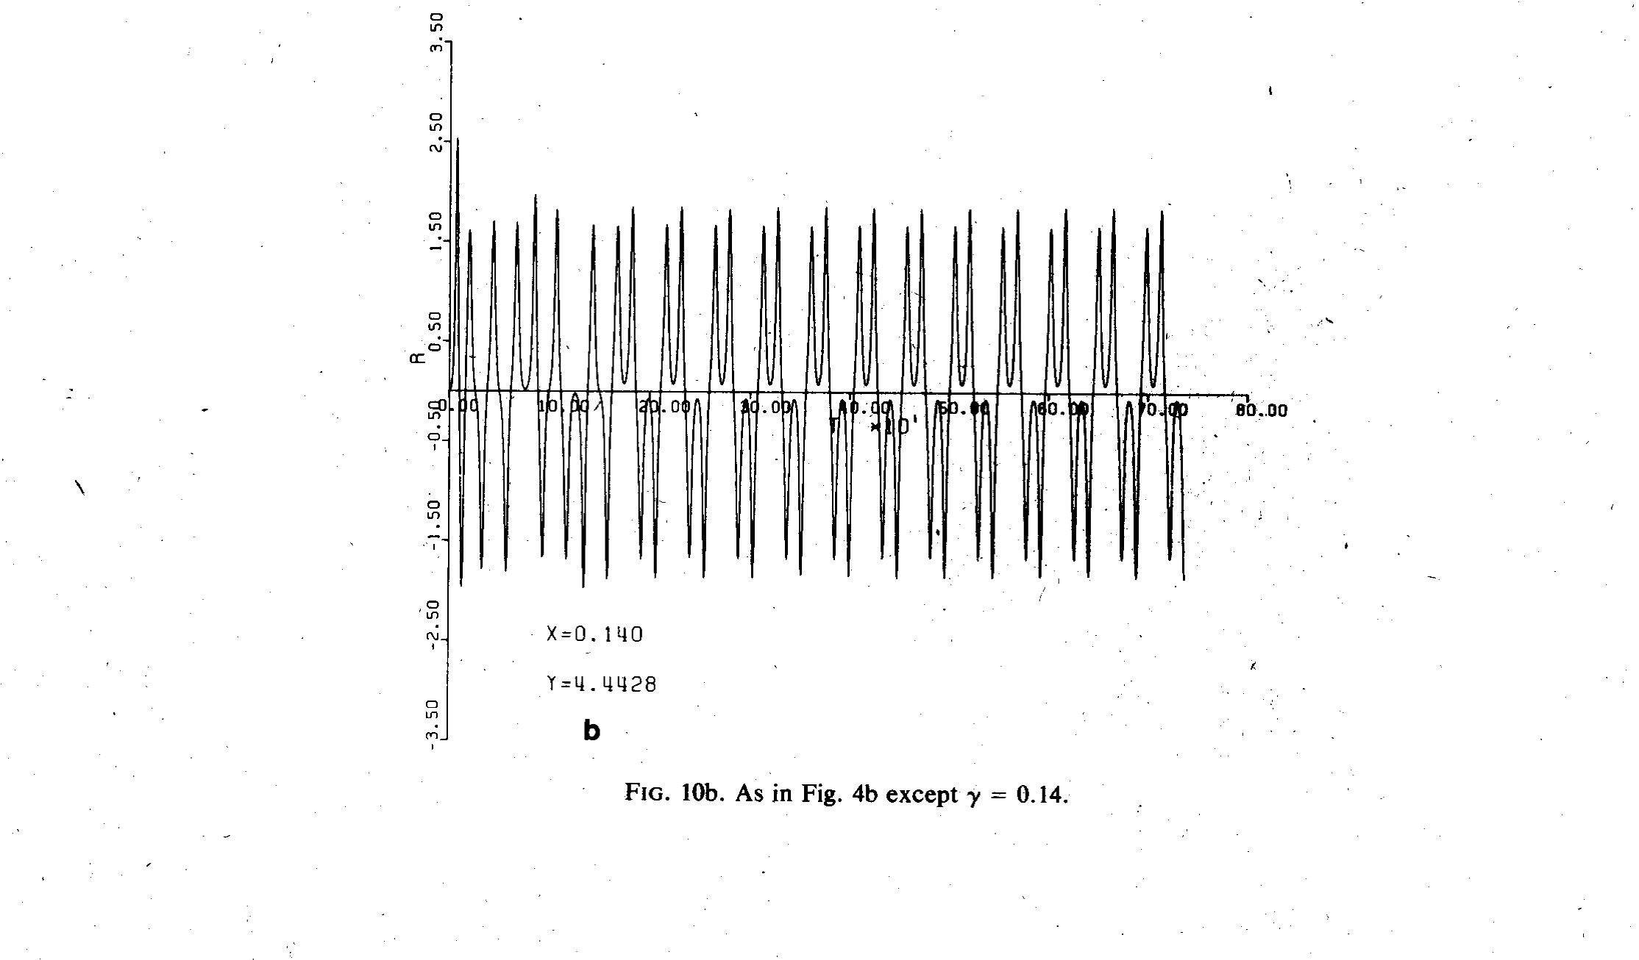

Figure 14.5.7 a,b The phase plane and the time history of the amplitude oscillation . The solution at =0.14 is perfectly periodic and is an isolated periodic solution in the interval in which chaotic solutions are found.
This interesting behavior shows us that the dynamics of the linear instability problem is just a peek into the richness of the dynamics of unstable systems when finite amplitude effects are considered. It is important to note that here we have considered only weakly non linear instabilities. That is, we have restricted attention to slightly supercritical states. Nevertheless, the amplitude equation for A is strongly nonlinear. The weakness of the nonlinearity has enabled us to separate the problem for spatial structure from the temporal evolution of the amplitude. At larger supercriticality that is no longer possible and we must consider a fully turbulent flow in which the spatial structure becomes as rich as the temporal behavior.
It is also important to recall that we obtained these amplitude equations by an asymptotic analysis and not by a brute force truncation of the equations of motion in a finite series of arbitrarily chosen representation functions ( like a sine series). The latter method is the traditional one and the one used to originally obtain the Lorenz set. We have not had to make such a truncation here.

